**3GPP SA4 #130 S4-241906**

**Orlando, US, November 18 - 22, 2024**

|  |  |  |  |  |  |  |  |  |
| --- | --- | --- | --- | --- | --- | --- | --- | --- |
| *CR-Form-v12.0* | | | | | | | | |
| **PSEUDO CHANGE REQUEST** | | | | | | | | |
|  | | | | | | | | |
|  | **26.822** | **CR** | pseudo | **rev** | **-** | **Current version:** | **1.0.0** |  |
|  | | | | | | | | |
| *For* [***HE******LP***](http://www.3gpp.org/3G_Specs/CRs.htm#_blank)*on using this form: comprehensive instructions can be found at* [*http://www.3gpp.org/Change-Requests*](http://www.3gpp.org/Change-Requests)*.* | | | | | | | | |
|  | | | | | | | | |

|  |  |  |  |  |  |  |  |  |
| --- | --- | --- | --- | --- | --- | --- | --- | --- |
| ***Proposed change affects:*** | UICC apps |  | ME | **x** | Radio Access Network |  | Core Network |  |

|  |  |  |  |  |  |  |  |  |  |  |
| --- | --- | --- | --- | --- | --- | --- | --- | --- | --- | --- |
|  | | | | | | | | | | |
| ***Title:*** | **[FS_5G_RTP_Ph2] On the definition of time to the next data burst** | | | | | | | | | |
|  |  | | | | | | | | | |
| ***Source to WG:*** | Qualcomm Incorporated | | | | | | | | | |
| ***Source to TSG:*** |  | | | | | | | | | |
|  |  | | | | | | | | | |
| ***Work item code:*** | FS_5G_RTP_Ph2 | | | | |  | ***Date:*** | | | 11/18/2024 |
|  |  | | | |  | |  | | |  |
| ***Category:*** | **B** |  | | | | | ***Release:*** | | | Rel-19 |
|  | *Use one of the following categories:* ***F*** *(correction)* ***A*** *(mirror corresponding to a change in an earlier release)* ***B*** *(addition of feature),* ***C*** *(functional modification of feature)* ***D*** *(editorial modification)*  Detailed explanations of the above categories can be found in 3GPP [TR 21.900](http://www.3gpp.org/ftp/Specs/html-info/21900.htm). | | | | | | | | *Use one of the following releases: Rel-10 (Release 10) Rel-11 (Release 11) Rel-12 (Release 12)* *Rel-13 (Release 13) Rel-14 (Release 14) Rel-15 (Release 15) Rel-16 (Release 16)*  *Rel-17 (Release 17)*  *Rel-18 (Release 18)* | |
|  |  | | | | | | | | | |
| ***Reason for change:*** | | One aspect of Key issue #12: Enhancements of Data Burst Marking  Time to the next data burst (TTNB) may be defined in different ways, each with its own advange and disadvantage. The definitions need to be discussed. | | | | | | | | |
|  | |  | | | | | | | | |
| ***Summary of change:*** | | Compare different definition of TTNB. | | | | | | | | |
|  | |  | | | | | | | | |
| ***Consequences if not approved:*** | | The data burst design may not be as useful as intended. | | | | | | | | |
|  | |  | | | | | | | | |
| ***Clauses affected:*** | |  | | | | | | | | |
|  | |  | | | | | | | | |
|  | | **Y** | **N** |  | | | |  | | |
| ***Other specs*** | |  |  | Other core specifications | | | | TS/TR ... CR ... | | |
| ***affected:*** | |  |  | Test specifications | | | | TS/TR ... CR ... | | |
| ***(show related CRs)*** | |  |  | O&M Specifications | | | | TS/TR ... CR ... | | |
|  | |  | | | | | | | | |
| ***Other comments:*** | |  | | | | | | | | |
|  | |  | | | | | | | | |
| ***This CR's revision history:*** | |  | | | | | | | | |

.

* * * * 1st change (all new) * * * *

## 6.x Solution #x: Definition of the time to the next data burst

### 6.x.1 Key Issue mapping

This maps to Key Issue #12.

### 6.x.2 Possible definitions and a comparison

The starting time of the time to the next data burst (TTNB) can be defined in multiple ways:

* Option 1: the starting time is the departure time of the first packet of the first PDU Set. This is shown in Figure 6.x-1 (a).
* Option 2: the starting time is is the departure time of the last packet of the last PDU Set. This is shown in in Figure 6.x-1 (b).

The benefit of Option 1 is that it gives more time for a network node (e.g., base station) to prepare for the next data burst. Also, since the packet carrying the TTNB is the first packet of the first PDU Set, the delay of the transmission of the packet due to contention with other packets is minimized, thus making the indicated TTNB more accurate. The drawback is that the prediction is farther into the future and hence a larger prediction error.

The benefit of Option 2 is that the prediction error can be reduced compared to Option 1 because the prediction is for a shorter time interval. On the other hand, it gives a network node less time to prepare for the next data burst, and the delay of the transmission of the TTNB-carrying packet (e.g., the packet #3 in PDU Set #(N+1)) may be large due to contention with other packets.

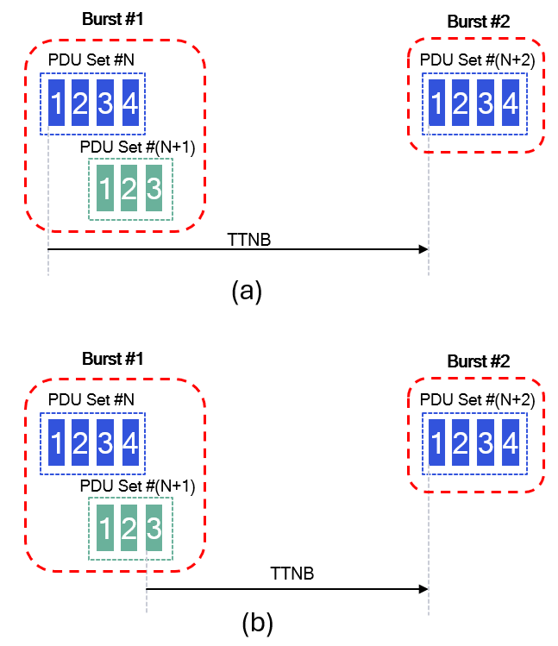

Figure 6.x-1 The starting time for the TTNB: (a) option 1: the first packet of the first PDU Set, (b) option 2: the last packet of the last PDU Set.

**Proposal:** consider one of the following definitions of the starting point of the TTNB in normative work:

* Option 1: the starting time is the departure time of the first packet of the first PDU Set.
* Option 2: the starting time is the departure time of the last packet of the last PDU Set.

NOTE: This needs to be coordinated with SA2/RAN2.

* * * * End of 1st change * * * *