**3GPP SA4 RTC #130 S4-241901**

**Orlando, FL, US, November 18-22, 2024 Revision of S4aR240085**

|  |  |  |  |  |  |  |  |  |
| --- | --- | --- | --- | --- | --- | --- | --- | --- |
| *CR-Form-v12.0* | | | | | | | | |
| **PSEUDO CHANGE REQUEST** | | | | | | | | |
|  | | | | | | | | |
|  | **26.822** | **CR** | pseudo | **rev** | **-** | **Current version:** | **1.0.0** |  |
|  | | | | | | | | |
| *For* [***HE******LP***](http://www.3gpp.org/3G_Specs/CRs.htm#_blank)*on using this form: comprehensive instructions can be found at* [*http://www.3gpp.org/Change-Requests*](http://www.3gpp.org/Change-Requests)*.* | | | | | | | | |
|  | | | | | | | | |

|  |  |  |  |  |  |  |  |  |
| --- | --- | --- | --- | --- | --- | --- | --- | --- |
| ***Proposed change affects:*** | UICC apps |  | ME | **x** | Radio Access Network | **x** | Core Network | **x** |

|  |  |  |  |  |  |  |  |  |  |  |
| --- | --- | --- | --- | --- | --- | --- | --- | --- | --- | --- |
|  | | | | | | | | | | |
| ***Title:*** | **[FS_5G_RTP_Ph2] Control-Plane Solution to the Key Issue on Enhancements of Data Burst Marking** | | | | | | | | | |
|  |  | | | | | | | | | |
| ***Source to WG:*** | Qualcomm Incorporated | | | | | | | | | |
| ***Source to TSG:*** |  | | | | | | | | | |
|  |  | | | | | | | | | |
| ***Work item code:*** | FS_5G_RTP_Ph2 | | | | |  | ***Date:*** | | | 11/18/2024 |
|  |  | | | |  | |  | | |  |
| ***Category:*** | **B** |  | | | | | ***Release:*** | | | Rel-19 |
|  | *Use one of the following categories:* ***F*** *(correction)* ***A*** *(mirror corresponding to a change in an earlier release)* ***B*** *(addition of feature),* ***C*** *(functional modification of feature)* ***D*** *(editorial modification)*  Detailed explanations of the above categories can be found in 3GPP [TR 21.900](http://www.3gpp.org/ftp/Specs/html-info/21900.htm). | | | | | | | | *Use one of the following releases: Rel-10 (Release 10) Rel-11 (Release 11) Rel-12 (Release 12)* *Rel-13 (Release 13) Rel-14 (Release 14) Rel-15 (Release 15) Rel-16 (Release 16)*  *Rel-17 (Release 17)*  *Rel-18 (Release 18)* | |
|  |  | | | | | | | | | |
| ***Reason for change:*** | | This addresses Key Issue #12: Enhancements of Data Burst Marking  XR traffic may be periodic with relatively infrequent updates of the traffic periodicity, e.g., by changing the frame rate from 30 FPS to 60 FPS.  The data burst information can be carried along with the XR data, but it may not be efficient. It is beneficial to investigate the control-plane approach.  Comments received during SA4 129-e meeting were addressed.  According to R3-244844 “Response LS to SA2 on FS_XRM Ph2”, 3GPP TSG-RAN WG3 Meeting #125, August 2024, from RAN3 perspective, the control plane solution TSCAI is feasible. TSCAI can be further enhanced using SA4 defined PSSN and PSN.  Addressed comments from Huawei and Nokia received at the SA4 RTC Ad Hoc Meeting on October 23, 2024. | | | | | | | | |
|  | |  | | | | | | | | |
| ***Summary of change:*** | | Added the design option 1 with TSCAI indicating only periodicity.  Addressed the comment on the PSSN remapping issue.  Addressed the latency of the control plane signaling.  Corrected typos. | | | | | | | | |
|  | |  | | | | | | | | |
| ***Consequences if not approved:*** | | Incomplete scoping of potential solutions to the key issue. | | | | | | | | |
|  | |  | | | | | | | | |
| ***Clauses affected:*** | |  | | | | | | | | |
|  | |  | | | | | | | | |
|  | | **Y** | **N** |  | | | |  | | |
| ***Other specs*** | |  |  | Other core specifications | | | | TS/TR ... CR ... | | |
| ***affected:*** | |  |  | Test specifications | | | | TS/TR ... CR ... | | |
| ***(show related CRs)*** | |  |  | O&M Specifications | | | | TS/TR ... CR ... | | |
|  | |  | | | | | | | | |
| ***Other comments:*** | |  | | | | | | | | |
|  | |  | | | | | | | | |
| ***This CR's revision history:*** | |  | | | | | | | | |

* * * * 1st change * * * *

[26.926] 3GPP TR26.926, Traffic Models and Quality Evaluation Methods for Media and XR Services in 5G Systems, V18.2.0, March 2024.

* * * * end of 1st change * * * *

* * * * 2nd change (All New, track changes are relative to S4aR240085) * * * *

6.X Sol #X Control-Plane Solution to the Key Issue on Enhancements of Data Burst Marking

6.X.1 Key Issue mapping

This maps to Key Issue #12.

6.X.2 Description

3GPP TR 26.926 [26.926] presents a periodic traffic model for XR split-rendering traffic, e.g., in Annex B.2 of [26.926]. For such traffic pattern, a potentially efficient design option is to signal the traffic pattern in the control plane.

There is an existing mechanism, Time Sensitive Communication Assistance Information (TSCAI) in 3GPP TS 23.501 and TS38.413, to signal a traffic pattern in the control plane. TSCAI carries the periodicity as a mandatary field, Burst Arrival Time, Burst Arrival time window among others as optional fields. The Burst Arrival Time is the latest possible time when the first packet of the (first) data burst arrives at either the ingress of the RAN (downlink flow direction) or the egress of the UE (uplink flow direction). According to Table 5.27.1.2-1 in 3GPP TS 23.501 the following parameters are available in TSCAI:

1) flow direction (up link or down link)

2) periodicity,

3) burst arrival time

4) survival time (time the application can survive without the burst),

5) burst arrival time window

6) capability for BAT adaptation

7) jitter information (optional),

8) periodicity range

NOTE: Parameters like burst size or other dynamic traffic characteristics are currently not available in TSCAI TSCAI is constructed by SMF based on information provided by the application to the 5G system. TSCAI can assist the RAN in scheduling. It can also support time-varying traffic patterns. When the traffic pattern changes, SMF can send an updated TSCAI to the RAN.

**Observation 1:** The current TSCAI mechanism can convey a burst traffic pattern to the RAN and, if the traffic pattern changes, can convey an update of the burst traffic pattern.

The RAN can enable UE power saving to different degrees. If the RAN does not want to enable maximum UE power saving, it is not necessary for the RAN to know when the first data burst with the new periodicity will arrive. Instead, the RAN can start detecting the arrival of the first data burst after it receives TSCAI message until it detects a change in the periodicity, as shown in Figure 6.x.2 where the periodicity changes from T1 to T2.

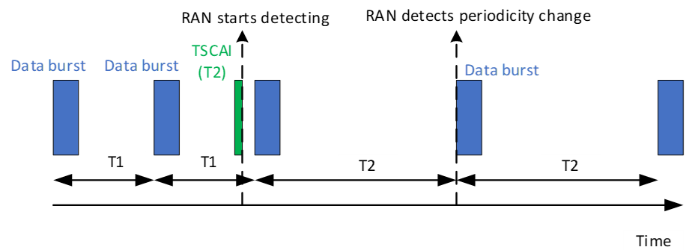Figure 6.x.2 Control plane signaling of change in traffic pattern without signaling the Burst Arrival Time

This leads to the first design option:

**Design option 1:** The TSCAI signals the periodicity to the RAN if the traffic periodicity changes, and the RAN infers the start time of the first data burst after the fact by detecting thenew periodicity based on the arrivals of data bursts after the reception of the TSCAI message.

On the other hand, if the RAN wants to enable maximum UE power saving, it needs to know when the new traffic pattern starts. TSCAI can provide the Burst Arrival time for this purpose. However, the drawback is that this requires to synchronize the clock at the application and the 5G clock, which may not be feasible for all real-world implementations. Additionally, for XR deployments, this means that the XR traffic source needs to be able to predict when the data burst will arrive at the gNB with high accuracy, which in turn requires the XR traffic source to know the delay to the gNB, which may be difficult to know in practice.

The operation 5.37.8.2 of TS 23.501 indicates how 5G System can be provided with periodicity information. The following steps are described in 5.27.8.2 of TS 23.501.

The Application Function (AF) can provide periodicity information to the PCF via NEF or directly to the PCF when the AF is trusted. If periodicity information is available at the PCF, the PCF can share this with the SMF based on operator policy including a request to the UPF to perform N6 traffic parameters measurement within PCC rules.

Upon reception of a PCC rule with Periodicity information, the SMF determines the TSCAI and forwards it to the NG-RAN. If the PCC rule indicates to perform N6 Traffic Parameter measurements, the SMF requests the UPF to monitor and periodically report the N6 Traffic Parameters (i.e. the N6 jitter range associated with the DL Periodicity and, if not provided by the AF, UL/DL periodicity) using the N4 Session Modification procedure, see clause 5.8.5.11. If the measurement of N6 jitter range associated with the DL Periodicity is required and the DL Periodicity is available at the SMF, the SMF also sends the DL Periodicity to the UPF. The UPF reports the measured N6 Traffic Parameters to SMF via N4 interface.

The way how the N6 jitter and periodicity (when it is not provided by the AF) is derived by the UPF is implementation dependent.

**Observation 2:** The current TSCAI mechanism with Burst Arrival Time requires time synchronization between the application and the 5G clock and the knowledge of the delay from the application traffic source to the RAN, and these requirements may not be always feasible.

The PDU Set based QoS framework in Rel-18 leads to the definition of the PDU Set RTP header extension which carries the PDU Set Sequence Number (PSSN) [2]. This provides an alternative to the current Burst Arrival Time. Specifically, the application can be able in some cases to indicate at which PDU Set the new traffic pattern will start, and the RAN considers the new traffic pattern starts when the PDU Set arrives. To give the RAN lead time for scheduling, a time offset may be also indicated.

NOTE: The PSSN in the RTP Header extension and the PSSN in GTP-U Header provided by the UPF to NG-RAN are not necessarily the same, as the UPF is responsible for deriving the PSSN for different PDU Sets and can modify or adapt the PSSN value from the RTP HE. This is because UPF always needs to add the PSSN in GTP-U Header, for RTP HE packets and for non RTP HE packets (also known as lone PDUs).

NOTE: The potential issue (discrepancy between the PSSN signaled in the control plane and the PSSN carried in the GTP-U packet header) is resolvable, e.g., if a predetermined value is used for lone PDUs as proposed in Solution #15 in clause 6.15.

NOTE: NG-RAN accessing the PSSN in the RTP packet is undesireable due to security concerns (NG-RAN can typically not inspect L3 or higher layer information)

An example is shown in Figure 6.x.3, where the control plane signaling conveys that “The new traffic pattern with new periodicity 16.7ms starts time_offset (in ms) after the arrival of the first PDU of the PDU Set with PSSN=8”.

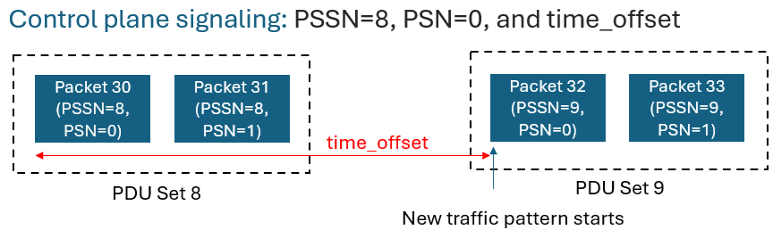

Figure 6.x.3 An example on control plane signaling of change in traffic pattern

**Observation 3:** The PDU Set Sequence Number (PSSN) could in some cases synchronize the update of a traffic pattern between the application and the 5G system.

This leads to a second design option:

**Design option 2:** The TSCAI signals the periodicity, the PSSN of the first PDU Set in the new traffic pattern and possibly a time offset. The arrival time of the PDU Set, delayed by the time offset, if present, is considered as the start of the new traffic pattern.

The traffic source may have multiple traffic flows destined to the receiver, e.g., text and video. The packets of low-latency traffic may be in PDU Sets and other packets may not. The traffic pattern is the supposition of the PDU Sets and other packets. Then the question is whether using PSSN will convey wrong information about the burst traffic pattern. This is not the case because what the RAN needs to do is to timely accommodate the bursts of low-latency traffic and can buffer the other packets (which are non-low-latency traffic) until it gets an opportunity to transmit the buffered packets to the UE. The delay from buffering is acceptable for the other packets (which are non-low-latency traffic).

**Observation 4:** The PDU Set Sequence Number (PSSN) based traffic pattern start indication can ensure the low delay for low-latency traffic while at the expense of non-low-latency traffic which is acceptable.

The periodicity may be negotiated at the session setup or updated during a session.

In an XR session, the application server may send multiple streams of media, such as a video stream and an audio stream, which are both periodic but with different periodicities. The superposed traffic pattern is not periodic. However, if the traffic source lets the RAN know the periodicities and the start times, the RAN can predict the traffic pattern accurately. This is similar to the superposition of sinusoidal signals with different periodicities, in which case knowing the periodicities and phases is sufficient to fully determine the superposed signal.

The UPF may map a PSSN in an RTP header extension to a different value in a GTP-U packet header if the UPF creates new PDU Sets for lone PDUs. In this case, the PSSN for the first PDU Set of a new periodicity signalled in the control plane may mismatch the PSSN of the GTP-U packet encapsulating the first PDU Set, and this can cause a timing error when RAN respond to the start of the new periodicity.

NOTE: Additional requirements or solutions to prevent this behaviour at the UPF are FFS. A potential solution is to use a predetermined PSSN value for lone PDUs as proposed in Solution #15 in clause 6.15. This means that the traffic source will not use the pre-determined PSSN for regular PDU Sets and the UPF will apply the PSSN value to lone PDUs. The latter involves changes to the UPF behavior. Another potential solution is to divide the PSSN space into two subspaces, one for regular PDU Sets and the other for lone PDUs. Similarly, this will involve changes to the UPF behavior.

The signaling path of the proposed TSCAI enhanced with PSSN is the same as that of the current TSCAI, and therefore the delays will be similar. The communication path of the control plane solution for sharing PSSN or time offset is as follows: UE to AF, AF to PCF, PCF to SMF, SMF to RAN.

To summarize:

**Pros:**

* For scenarios where the traffic burst pattern is periodic and the periodicity changes infrequently, the proposed control plane approach can be more efficient than the user plane approach.
* The proposed control plane approach can be implemented by slightly augmenting the existing TSCAI framework.

**Cons:** For other scenarios (i.e., frequent change in the periodicity), the proposed control plane approach is likely to be less efficient than the user plane approach. The TSCAI may have a setup time due to the different steps that may make it unsuitable for frequent and dynamically changing periodicity.

The above observations and analysis lead to the following proposal.

**Proposal:** TSCAI without the Burst Arrival Time can be used to indicate a new traffic pattern. Whether TSCAI can be enhanced by incorporating the PDU Set Sequence Number (PSSN) and possibly a time offset to indicate the start time of a traffic pattern is FFS as it is not clear PSSN can be used reliably to support this case. Also TSCAI enhancement need to be coordinated with SA WG2.

* * * * End of 2nd change * * * *