3GPP TSG-SA WG1 Meeting #108 S1-244356
Orlando, Florida, USA, 18-22 November 2024 (revision of S1-244311)

Title: Coordinated Network slicing across 3GPP and non-3GPP access networks
Agenda Item: 8.1.1
Source: CableLabs
Contact: Arun Yerra <a.yerra@cablelabs.com>

A coordinated network slicing framework enables seamless, dynamic scaling, adaptation, and network slice provisioning across 3GPP and non-3GPP domains

x.1 Coordinated Network slicing across 3GPP and non-3GPP access networks

x.1.1 Description
Network slicing introduced in 5G allowed operators to create virtual networks tailored to specific use cases or customer requirements. Each slice can be optimized for characteristics like latency, bandwidth, and security. However, in 5G, network slicing is mostly confined to the 3GPP domain, i.e., non-3GPP components require separate management and may not fully benefit from the slicing architecture. 6G can extend network slicing capabilities across both 3GPP and non-3GPP networks, creating network slices that include all relevant networks and services. For instance, a slice designed for an industrial IoT application could encompass 6G NR, Wi-Fi, and satellite connectivity, all managed under a single slice with consistent performance guarantees. In a smart healthcare environment, multiple services—remote patient monitoring, AR-assisted surgery, and emergency response—are provided using a blend of 3GPP (e.g., 5G) and non-3GPP (e.g., Wi-Fi) networks.
Consider a scenario where a subscriber that has URLLC network slice would like to have same user experience when connected through WiFi network and a seamless migration when moving across the network. Operators can support this when 3GPP network operator has a business agreement with a non-3GPP operator. 3GPP operator implements network slicing to efficiently manage the QoS for its subscriber and would like subscriber to have seamless experience while operator offloads their subscriber data traffic to non-3GPP network. 3GPP network will communicate relevant network slice information to non-3GPP network so that WiFi Access points within the non-3GPP network can broadcast the information over the air. UE can benefit from this information and connect to a SSID that provides equivalent QoS, and subscriber would get a seamless experience while connected to the WiFi network as well.
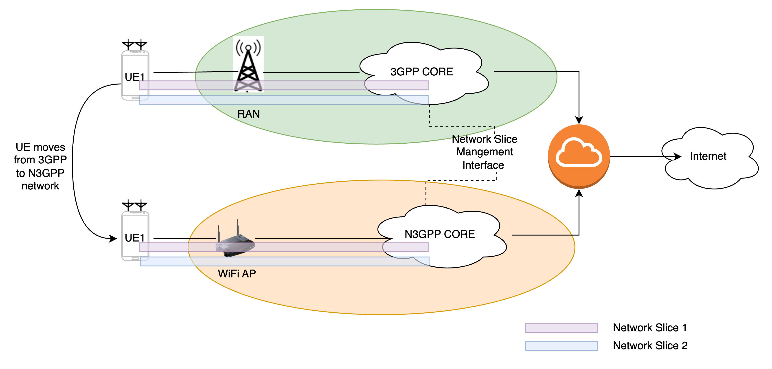

x.1.2 Pre-conditions
- The non-3GPP access network broadcasts multiple SSIDs each with a specific QoS and understanding of how a specific network slice on the 3GPP network maps to specific QoS requirements.
- Both 3GPP and non-3GPP network have architecture, framework and mechanisms in place to interwork and communicate information related to subscribed service information, related network slice attributes, and KPIs with each other.
- Defined SLAs specify the QoS, latency, and bandwidth associated with each network slice.

x.1.3 Service Flows
Service Initialization:
- The UE is initially connected to the core network via the 3GPP access and requests for a service that requires a URLCC slice.
- Network selects the NFs that allows the requested network slices and UE will setup as many PDU sessions as the required slices for providing the service to the end user and corresponding rules are provisioned in UE.
Service Migration from 3GPP to non-3GPP access network:
- When user moves into the coverage of the non-3GPP access network, the UE transitions to the non-3GPP access.
- Non-3GPP network and 3GPP network communicate so that non-3GPP network provided with relevant user subscriptions and network slice information.
- Non-3GPP network will broadcast multiple SSIDs each with distinct QoS attributes equivalent to QoS attributes of different network slices and UE will connect to a SSID that has the minimum latency.
Service Migration from non-3GPP to 3GPP access network:
- When the user moves outside the non-3GPP access coverage, the UE transitions to the 3GPP access network using the same URLCC slice.
Service Termination:
- When the user finishes up with the requested services requiring the URLCC slice, corresponding network slice is de-activated and associated network resources will be released.
- If the user then initiates a different service that requires a different slice, the UE gets provisioned with a different slice.

x.1.4 Post-conditions
- The user benefits from a consistent and seamless user experience benefiting from a specific slice and associated QoS regardless of the access network being used.

x.1.5 Existing features partly or fully covering the use case functionality
TS 22.261 clause 6.1.2.4 specifies requirements for Cross-network slice coordination. However, these requirements only cover coordinating network slices in multiple 5G networks. Below text refers to TS 22.261 clause 6.1.2.4.
The 5G system shall support a mechanism to provide time stamps with a common time base at the monitoring API, for services that cross multiple network slices and 5G networks.
The 5G system shall provide suitable APIs to coordinate network slices in multiple 5G networks so that the selected communication services of a non-public network can be extended through a PLMN (e.g. the service is supported by a slice in the non-public network and a slice in the PLMN).

x.1.6 Potential New Requirements needed to support the use case
Proposed Requirement 1:
6G shall support cross-domain communication of network slice information so that non-3GPP access networks are aware of network slices exist in 3GPP networks, facilitating a seamless user experience.
Note: How non-3GPP networks utilize network slice information is outside the scope of 3GPP.

