3GPP TSG-SA1 Meeting #108 S1-244661

18-22 Nov 2024, Orlando, US (revision of S1-244391, S1-244204)

**Source: China Telecom, ZTE, SK Telecom**

**pCR Title: Use case on Distributed Networks and PLMN**

**Draft Spec: 3GPP TR 22.870**

**Agenda item: 8.1.1**

**Document for: Approval**

**Contact: Yinglin Chen, chenyl37@chinatelecom.cn; Lijuan Chen, chen.lijuan@zte.com.cn**

*Abstract: This use case introduces a concept of distributed networks.* *S1-244152 and S1-244155 were merged in this contribution.*

**1. Introduction**

Based on the experience with 5G deployment, the 5G architecture has shown a lack of flexibility for large-scale public network operators. In addition to basic call and internet services well supported by PLMN, operators increasingly face demands for local services with specific and differentiated requirements in a defined area. The 6G network is expected to address these requests more swiftly and efficiently by offering a new service, referred to as distributed network.

The distributed network is customized with the minimum set of services and capabilities required by third parties, possibly achieved through modular network functions. It can operate independently when providing the needed local services.

Furthermore, it can rely on the PLMN of the same network operator to provide services not available in the distributed network itself, via discovering and requesting services across networks. This results in lower construction cost, higher operation and energy efficiency, and faster TTM. Distributed technologies could potentially be used to support this kind of collaboration between networks for service delivery.

This use case demonstrates the 6G network's capability to automatically customize and create a distributed network, and utilize services exposed by the PLMN.

**2. Reason for Change**

Network slicing and NPN technologies are not sufficient for flexibily providing local services with specific and differentiated requirements, for the reasons detailed in Section 5.x.5 below. It is important to consider distributed network in 6G.

**3. Conclusions**

None.

**4. Proposal**

It is proposed to study the use case in System and Operation Aspects.

* * *Start of First Change * * * *

# 3 Definitions of terms, symbols and abbreviations

## 3.1 Terms

Distributed network: a network operates independantly from the PLMN of the same network operator to provide local services (e.g. local control and local data traffic) to its subscribers, and relies on the PLMN of the same network operator to provide services not available in the network.

Editor's Note: How to name the network is FFS.

* * *End of First Change * * * *

* * *Start of Second Change * * * *

## 5 System and Operational Aspects

Editor's Note: "System and Operational Aspects" facilitates system and network operation features that underpin overall operation, covering aspects that apply across use cases and services, and those that relate to network operations. These aspects include, for example: migration scenarios, interworking with earlier 3GPP systems, interworking with non-3GPP system, roaming and interconnection, network simplification, network sharing, security, privacy, resilience, sustainability and energy efficiency, device diversity, support of legacy services

5.x Distributed Networks and PLMN

5.x.1 Description

Based on the experience with 5G deployment, the 5G architecture has shown a lack of flexibility for large-scale public network operators. In addition to basic call and internet services well supported by PLMN, operators increasingly face demands for local services with specific and differentiated requirements in a defined area. The 6G network is expected to address these requests more swiftly and efficiently by offering a new service, referred to as distributed network.

The distributed network is customized with the minimum set of services and capabilities required by third parties, possibly achieved through modular network functions. It can operate independently when providing the needed local services.

Furthermore, it can rely on the PLMN of the same network operator to provide services not available in the distributed network itself (e.g. call services), via discovering and requesting services across networks. This results in lower construction cost, higher operation and energy efficiency, and faster TTM. Distributed technologies could potentially be used to support this kind of collaboration between networks for service delivery.

Network slicing and NPN technologies are not sufficient for this usage scenario for the reasons detailed in Section 5.x.5 below. The public network operator operating one PLMN providing basic service and multiple customized distributed networks providing differentiated services holds a network of distributed networks.

This use case demonstrates the 6G network's capability to automatically customize and create a distributed network, and utilize services exposed by the PLMN.

5.x.2 Pre-conditions

Several valuable antiques were discovered in a rural area, drawing media organizations to the site to produce live news reports.

The media companies collaborate with Operator A which provides communication and network services for this event. During the period of the event, the following requirements must be met for the wireless communication network at the site:

- Since the area is small and requires no handover, mobility procedures are simplified for operation efficiency. The distributed network's control plane capabilities (e.g. QoS and traffic steering) are optimized for video traffic.

- Security monitoring to prevent excessive gathering around the antiques is provided via sensing services, which is not supported in the incumbent PLMN of Operator A covering this area.

- Intelligent fault diagnosis of network conditions services is provided.

- If its connection to PLMN fails, the distributed network continues to operate and provide service in best-effort.

- Operations and maintenance of the distributed network can be managed locally without the need to go through the operator's centralized control system.

5.x.3 Service Flows

Creation of the distributed network:

1. The incumbent PLMN intelligently analyzes received requirements and identifies that new sensing functionality is required and handover / mobility functionalities are not required. Leveraging both existing and new service capabilities, the incumbent PLMN automatically orchestrates network functions and dynamically creates a customized temporary network to provide service for this event.

AI service exposure from the PLMN to the distributed network:

1. To support intelligent fault diagnosis of network conditions, the distributed network needs to train a local model. Since the local computing resources are insufficient and the amount of available training data is small, the distributed network sends an AI service request to the PLMN to obtain the foundational model for the AI service.
2. The PLMN validates that the required parameters can be met and responds by providing the requested AI service to the distributed network.
3. The distributed network uses the fine-tuned model based on the received foundation model from PLMN to provide intelligent fault diagnosis of network conditions service for this event.

Local service provision of the distributed network:

1. A host wears a VR headset (the UE) to capture the antiques. The UE registers to the distributed network with the subscription data retrieved from the PLMN of Operator A.
2. The host approaches the antiques. Other staff members are working nearby, and the number of people exceeds the allowed limit. This is detected via the sensing service and an alarm is trigged.

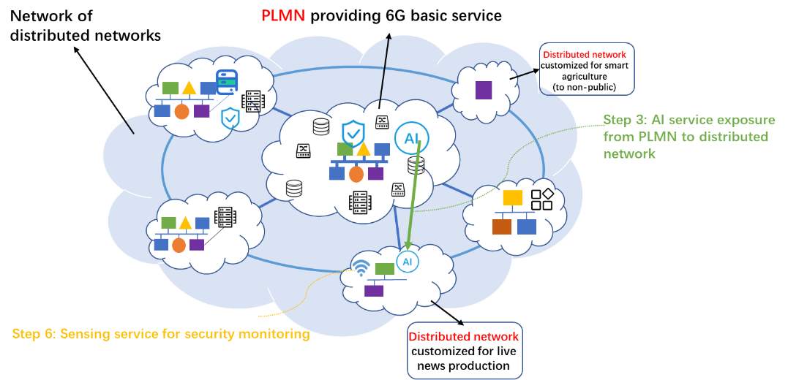

Figure X.1. A network of distributed networks consists of a PLMN and multiple distributed networks.

5.x.4 Post-conditions

When the media completes new production and leaves the scene, the distributed network is deleted. Users in the area receive services from the PLMN.

5.x.5 Existing features partly or fully covering the use case functionality

Network slicing is supported in 5G. Network operators meet differentiated service requirements by creating different network slices within a network. Each network slice can be customized based on service agreements. However, as the number of slices increases, network complexity also grows. The number of slices that can be accommodated within a single network is limited in practical deployment, which may not be sufficient given the increasing number of third parties requesting customized 6G services.

In addition, a network slice has to be a complete logical network, comprising of all network functions and NF services, configured end-to-end. System procedures in different network slices cannot be customized. The redundant network functions, NF services, and related system procedures degrade operation efficiency and increase energy consumption.

Furthermore, network slicing can only be performed based on the resources and services that have already been deployed. Temporarily adding new functions and services cannot be achieved through network slicing.

Non-public network is supported in 5G. Standalone NPN (SNPN) operates without dependency on a PLMN. This independence is favourable for third parties prioritizing local control over signaling, data, subscription management, high data security, and high resilience. However, SNPN subscribers cannot directly access PLMN services. Public network operators cannot efficiently utilize existing PLMN resources to provide basic communication services (e.g. calling) or services not deployed in SNPN (e.g. sensing) to SNPN subscribers. The high construction and maintenance costs associated with SNPN may be an obstacle for third parties.

Public Network Integrated-NPN (PNI-NPN) operates with dependency on a host PLMN. By utilizing PLMN resources, PNI-NPN is more cost-effective than SNPN. However, its reliance on the host PLMN results in lower data security and lower network resilience, which may not be able to meet third parties’ requirements. If the connection between the PLMN and PNI-NPN fails or the PLMN itself experiences failures, the PNI-NPN cannot function.

Currently, 5G supports a fixed level of isolation and collaboration between non-public networks and the PLMN once deployed as either PNI-NPN or SNPN. However, 6G is expected to support a dynamic level of isolation and collaboration which flexibly changes with third parties’ requirements and network conditions.

5.x.6 Potential New Requirements needed to support the use case

[PR 5.x.6-1] Based on operator’s policy and agreement with 3rd party, the 6G network shall support a mechanism that allows network operator to automatically manage a customized distributed network (e.g. with minimum set of services, with new services on-demand) as required.

[PR 5.x.6-5] Based on operator’s policy and agreement with 3rd party, the 6G network shall be able to support a distributed network to discover services provided by the PLMN.

[PR 5.x.6-6] Based on operator’s policy and agreement with 3rd party, the 6G network shall be able to support the PLMN to expose required services to a distributed network.

* * *End of Change * * * *