**3GPP TSG-SA WG1 Meeting #108 S1-244675**

**Orlando, Florida, USA, 18-22 November 2024** *(***revision** *of S1-244221)*

Title: Use case on sensing result validation

Agenda Item: 8.1.2

Source: ZTE Corporation

Contact: [huang.fenghe@zte.com.cn](mailto:huang.fenghe@zte.com.cn)

[xu.ling@zte.com.cn](mailto:xu.ling@zte.com.cn)

*Abstract: This contribution proposes a new use case about sensing result validation.*

---------- Use Case template ----------

## 6.x Use case on sensing result validation

### 6.x.1 Description

In V2X scenarios, vehicles communicate with other vehicles, infrastructure, and pedestrians to facilitate intelligent traffic management and Advanced Driver Assistance Systems (ADAS). This requires the transmission of various types of sensing data.These data are typically transmitted at irregular intervals, with non-fixed targets, and from multiple sources. However, due to variations in hardware performance among terminals or vehicles, the transmitted information may be unreliable. Therefore, the authenticity and credibility of the sensing information need to be ensure .

The 6G network can leverage the inherent trustworthiness of the 3GPP system to provide validation as a service, to verify the information and assist traffic management authorities in evaluating vehicle trust levels.

### 6.x.2 Pre-conditions

Vehicle A is a V2X information broadcasting node which is pre-registered with the operator O, and it has a trust level which is certificated by the traffic management department based on the performance of its onboard devices. This trust level can be used to assess the categories of information which can be broadcast.

Vehicle A can broadcast V2X information with an anonymous identity which is anonymous to other vehicle but can be recognized by trusted validation node.

### 6.x.3 Service Flows

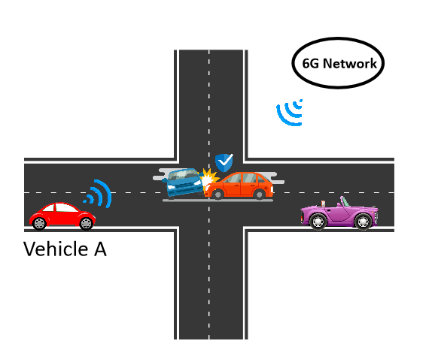

Figure 6.X.3.A sensing result validation

1. Vehicle A passes through an intersection and detects an accident ahead using its sensing hardware. It then broadcasts a traffic congestion event based on its sensing results with its anonymous identity.
2. Operator O receives the broadcast message from Vehicle A,initiates monitoring, and processes the validation of the sensing result.
3. Operator O confirms that there is an accident at the intersection and starts to broadcast a traffic congestion alert using its trusted node identity.
4. Vehicle B receives the traffic congestion alert from Operator O, then makes a decision to reroute.
5. After receiving notification from the traffic management department, Operator O cancels the traffic congestion alert broadcast, provides proof of the event, and sends it to the traffic management department.

### 6.x.4 Post-conditions

The traffic management department may rewards the owner of Vehicle A and Operator O for their actions.

The V2X/sensing capability trust level of Vehicle A can be re-evaluated base on the proof and updated to Vehicle A for further use.

### 6.x.5 Existing features partly or fully covering the use case functionality

None

### 6.x.6 Potential New Requirements needed to support the use case

[P.R.5.x.6-001]The 6G network shall be able to support validation of sensing result.

[P.R.5.x.6-002]The 3GPP system may provide a mechanism to provide a proof after validation of sensing result.

NOTE: The proof should include the validation information,such as authenticity of the sensing result and the credibility of the identity of the sensing result provider.

[P.R.5.x.6-003]The 3GPP system may provide secure means to expose the proof of sensing results after validation to trusted third parties (e.g. traffic management authorities).