3GPP TSG-SA WG1 Meeting #108 S1-244539
Orlando, United States, 18-22 November 2024 revision of S1-244117

Title: New use case on AI text-to-video generation supported by computing
Draft Spec: 3GPP TR 22.870
Agenda Item: 8.1.7
Document for: Approval
Source: China Mobile
Contact: Xiaonan Shi, shixiaonan@chinamobile.com
Zehao Chen, chenzehao@chinamobile.com

Abstract: This pCR proposes a new use case on AI text-to-video generation supported by computing.
FIRST CHANGE
The following documents contain provisions which, through reference in this text, constitute provisions of the present document.
- References are either specific (identified by date of publication, edition number, version number, etc.) or non-specific.
- For a specific reference, subsequent revisions do not apply.
- For a non-specific reference, the latest version applies. In the case of a reference to a 3GPP document (including a GSM document), a non-specific reference implicitly refers to the latest version of that document in the same Release as the present document.
[1] 3GPP TR 21.905: "Vocabulary for 3GPP Specifications".
[x] A. Singh, "A Survey of AI Text-to-Image and AI Text-to-Video Generators," 2023 4th International Conference on Artificial Intelligence, Robotics and Control (AIRC), Cairo, Egypt, 2023, pp. 32-36, doi: 10.1109/AIRC57904.2023.10303174.
[y] X. Shi, Q. Li, D. Wang and L. Lu, "Mobile Computing Force Network (MCFN): Computing and Network Convergence Supporting Integrated Communication Service", 2022 International Conference on Service Science (ICSS), Zhuhai, China, 2022, pp. 131-136, doi: 10.1109/ICSS55994.2022.00028.
[z] "5G-A/6G New Computing Plane for Coordination of Networking and Computing", Reference links for: https://cmri.chinamobile.com/thinktank/origin/file/viewer?id=3801004&moduleType=7&subModuleType=71&pos=.

SECOND CHANGE (all new text)

W.x Use case on AI text-to-video generation supported by computing

W.x.1 Description
With rapid advancements of deep learning and natural language processing (NLP) techniques in recent years, AI text-to-video generators have emerged as an advanced powerful tool that allows generation of videos from textual descriptions. The generators makes it faster for producing diverse content in proficient and economical way. However, high speed and high graphics quality AI text-to-video generation require support from a large amount of complex AI reasoning and graphic rendering [x]. Considering the limited capabilities, computing resources, and battery power of the terminal devices, these complex AI computing might not be able to run locally on the terminals with an ideal experience.
Fortunately, in addition to the terminal computing resource, there are numerous available computing resources spanning from in-network to edge and cloud [y][z]. The 3GPP network can optimize the computing tasks of AI text-to-video generation, such as determining a small amount of personalized settings or preferences based on historical data on the local device, and offloading the AI reasoning and graphic rendering, which are beyond the device’s local computing capabilities, to appropriate computing nodes and utilize the computing resources of the nodes for AI computing to guarantee the high quality text-to-video generation.
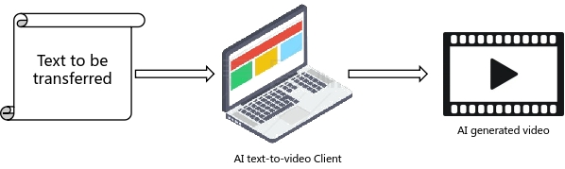
Figure W.x.1-1: AI text-to-video generation

W.x.2 Pre-conditions
John is a media worker. In his work, he often needs to make videos with various themes and styles to match different texts. For example, John might make a video tutorial for an appliance manufacturer based on a product's instruction manual, or make a humorous short video to accompany a joke for an entertainment company, and so on. Since John needs to manually edit, splice and render the videos, he is not in high efficiency.

W.x.3 Service Flows
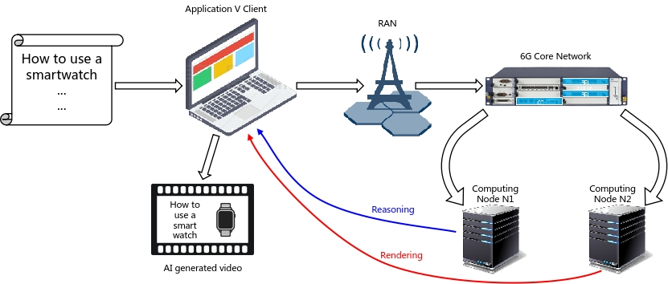
Figure W.x.3-1: Service flow of AI text-to-video generation supported by computing
1. John was given an assignment to create a how-to video based on a piece of text describing how to use a smartwatch. In order to reduce manual workload, John decided to use the AI text-to-video generation application V to help the production of this video.
2. John opens the application V on his old laptop, and inputs the tutorial text to be converted to video, as well as the video settings, such as duration=60s, resolution=1080p, frame rate=24fps, etc.
3. After receiving the text and setting parameters, the application V client on John's laptop found that what needed to be generated was a tutorial video, so it found the tutorial videos on smart glasses and smart screen which have been generated before by John using this application. Based on these videos, it simply summarized the general style of such videos.
4. The application V client found that making this video required too much computating to be done locally, therefore it requests the network for help. The network decomposes the requirements of the video generation task into requirements for reasoning and requirements for rendering.
5. The network obtains the computing capabilities of the local device, such as the local computing force, GPU and NPU configurations, and determines that computing resources of the local device cannot perform the generation quickly.
6. Based on the condition of computing resources, the network assigns computing nodes for the computing task of video generation: computing node N1 for reasoning, and computing node N2 for rendering.
7. The AI text-to-video generation computing task is offloaded to computing nodes N1 and N2, and is aggregated on the local device.

W.x.4 Post-conditions
With network assistance, John utilizes the AI text-to-video generator to obtain high quality videos quickly, thus greatly improving his work efficiency.

W.x.5 Existing features partly or fully covering the use case functionality
3GPP SA6 TS 23.482 has supported procedures for AIMLE Server registration to FL repository as FL member. In-network or edge side computing node management has not been supported.

W.x.6 Potential New Requirements needed to support the use case
[PR W.x.6.1] The 6G system shall support the perception of computing requirements for the service.
[PR W.x.6.2] Subject to operator policy and agreement with 3rd party, 6G system shall support the awareness of computing resources in the core network, edge, cloud and devices.
[PR W.x.6.3] The 6G system shall support the capability to assign and offload different computing tasks to appropriate computing resources.
NOTE: Based on the requirements of different services, different categories of computing resources are needed, for example, reasoning tasks is more focus on AI capability, and rendering tasks is more focus on media processing capability.

END OF CHANGES

