**3GPP TSG-SA WG1 Meeting #108 S1-244518**

**Orlando, Florida, USA, 18-22 November 2024** *(revision of S1-244222)*

Title: Use case on temporary group for AI applications

Agenda Item: 8.1.7

Source: ZTE Corporation

Contact: [huang.fenghe@zte.com.cn](mailto:huang.fenghe@zte.com.cn)

[xu.ling@zte.com.cn](mailto:xu.ling@zte.com.cn)

*Abstract: This contribution proposes a new use case about temporary group for AI applications.*

---------- Use Case template ----------

## x.1 Use case on temporary group for AI applications

### 

### x.x.1 Description

For AI or XR applications that require high computing capabilities, devices with limited performance or those operating in energy-saving modes can form temporary groups with high-performance devices or networks to effectively utilize the nearby resources.

For instance, in a smart city scenario, when a user's device needs to process large volumes of data, it can request to join a group through the operator to receive support from nearby devices or networks, such as vehicles, FWA devices, network entities or edge nodes. The operator can ensure the identities of each group member and facilitate effective resource sharing.

Additionally, the operator can automatically organize group members based on their supply and demand requirement, timing, and movement paths. By providing grouping as a service for users, the operator can facilitate the dynamic allocation of computing tasks, enabling efficient load balancing and enhancing overall performance, resource providers within the group could also receive rewards for their contributions.

### x.x.2 Pre-conditions

Vehicle X,Y and Z support advanced autonomous driving and they equipped with high-level hardware including a high-performance computing platform.Additionally, Vehicle X,Y and Z are pre-registered AI computing resource provider for operator O.

### x.x.3 Service Flows

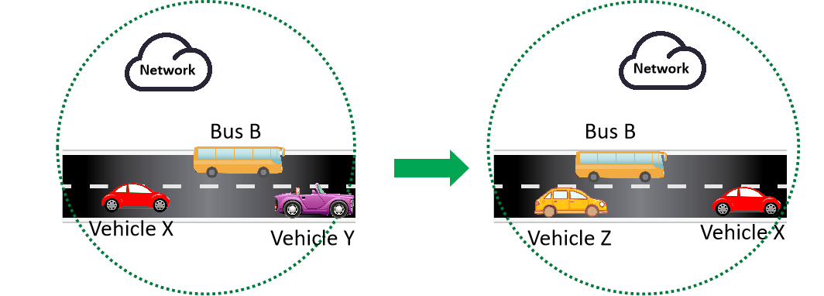

Figure x.x.3 temporary group for AI applications

1. After a day of traveling the city, Jerry takes bus B back to his hotel. He has captured lots of videos and photos during his travels and hopes to use AI to automatically edit, voice-over and render them into several video clips for social media. However, due to the limitation of his smartphone's performance, it cannot handle this complex task. Therefore, Jerry submits a request to Operator O for temporary group service.
2. Operator O analyzes the requirement of Jerry, and Bus B’s location, route, and possible nearby devices, then arranges a temporary group with vehicle X and vehicle Y, which is traveling on the same route.
3. Operator O develops an intelligent task allocation plan that considers estimated travel routes and potential changes among group members, such as predicting to vehicle Z along the route of future travel can be added to the group later, allowing for timely adjustments to task assignments.
4. While the bus is in operation, according to the task plan, some data is transferred from Jerry’s smartphone to vehicle X for processing, while some data is sent to vehicle Y for processing.
5. As vehicle Y suddenly becomes unable to continue providing computing power, it no longer accepts new data processing tasks and exits the group after completing its assigned tasks and sending back the results.
6. As vehicle Z enters from another intersection, it joins the group under the management of operator O. . Jerry’s smartphone sends the remaining data to base station Y for processing.
7. After all the data has been processed, the results are sent back to Jerry’s device in a secure way. Once Jerry verifies the video clips, Operator O cancels the temporary group.

### x.x.4 Post-conditions

Jerry uploads the processed video clips to social media platforms to share with his friends.

### x.x.5 Existing features partly or fully covering the use case functionality

None

### x.x.6 Potential New Requirements needed to support the use case

[P.R.x.x.6-001]The 6G system shall provide a mechanism to collect the information from trusted third parties of their computing resource for AI(e.g. computing capacity, available time, location).

[P.R.x.x.6-002]The 6G system shall support to create temporary group for AI applications.

[PR.x.x.6-003] The 6G system shall provide a mechanism for flexible group member selection based on their available computing resource for AI(e.g. computing capacity, available time, location).

[PR.x.x.6-004] The 6G system shall provide a mechanism for flexible group member management. .

[PR.x.x.6-005]The 6G system shall provide a mechanism to collect computing resource usage information associated with the AI application per each provider for charging.