3GPP TSG-SA WG1 Meeting #108 S1-244502
Orlando, Florida, USA, 18-22 November 2024 (revision of S1-244030 of S1-24416)

Title: Seamless Immersive Reality in Education
Agenda Item: 8.1.4. Immersive Reality
Source: TNO, KPN, Telefonica
Contact: Toon.norp@tno.nl

Abstract: use case focusing on the Seamless Immersive service applied in the education sector.

---------- First Change ----------

x.1 Use case on Seamless Immersive Reality in Education

x.1.1 Description
Immersive reality combines immersive telepresence and immersive collaboration. Immersive telepresence allows remote participants to appear as physically present in the very same environment as co-located participants. The remote participants perceive the environment and other participants as if they were there in person, thanks to stimulation of their visual, aural, and haptic senses. Immersive collaboration provides a new way of interaction with other people and objects.
Immersive reality technology opens up new opportunities in the education sector, where students are able to collaborate, discuss, and learn in an immersive setting with remote and co-located participants. Participants interact with each other in a more natural way in an immersive reality environment, and participants are also able to interact more naturally with virtual or digital representations of real objects.
The immersive classroom may be: local (where all students are physically co-located and learn with virtual objects), hybrid (with both physically co-located as well as remote participants), or fully immersive (where both students and instructors are virtually present).
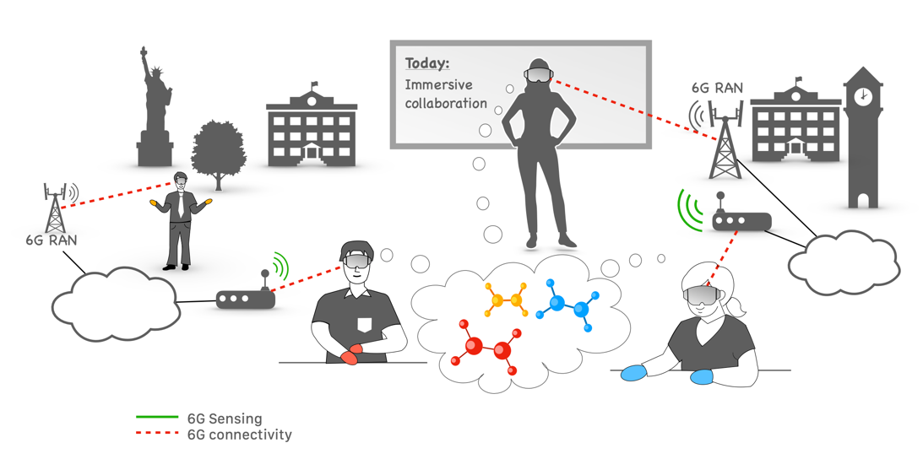
Figure X-1: Hybrid Immersive Classroom Scenario
For example, consider a hybrid immersive chemistry classroom, exploring and assembling 3D models of complex molecules, shown in Figure X-1. The “orange-handed” student and the teacher represent participants remote to the physical classroom while the “red-handed” and the “blue-handed” students represent participants physically present in the classroom. The equipment local to the physical classroom, e.g. cameras, and wearables worn by the students, senses the real environment, communicates the actions and the outcome of the collaborative molecule assembling, and communicates to establish immersive co-presence of the remote and physically present participants.
Further justification and background for the KPIs for this use case is found in the following table [x]:

Table X-1: Justification and clarification of KPIs

KPI | Target Range | Justification
User-experienced data rate  [Mb/s] | < 250 | For DL, but also for UL
Area traffic capacity [Mb/s/m²] | < 250  < 20 | Indoor: per floor in a multi-story building  Wide area: for immersive experience “on the go”
Mobility | seamless HO | Pedestrian for participants in the classroom
End-to-end latency  [ms] | < 10  < 50  < 150 | Split rendering  Voice  Collaboration
Reliability [%] | 99.9– 99.999 | Depending on data stream
Positioning accuracy  [cm] | ≤ 10 horizontal  ≤ 10 vertical | Positioning of AR glasses and sensors. Network-assisted positioning can be used for e.g. sensors, but high positioning accuracy for AR typically requires device-based sensors and sensor fusion.

Key Value impact analysis
Material resources: Increased electronic waste from the disposal of devices and network equipment Increased material consumption from producing the hardware components and expanding network infrastructure including raw material extraction, manufacturing processes, and transportation
Emissions: Reduction of emissions by a reduction in physical travel for work or education.
Inclusion & Equality: Enhances educational opportunities of the population regardless of their location, and improves the efficacy of the education process, both for the students and for the teachers. However, there is a potential digital inequality depending on connectivity access, information technologies (IT) literacy and economic status.
Trustworthiness: Preserved/uncompromised privacy is key for the enablement of this service. However, there are still potential risks for privacy intrusion associated to localisation and positioning data.

x.1.2 Pre-conditions
The students in the physical classroom are each using an AR device, and have joined the classroom application.
Both AR devices are very simple and light so that the students can use them for long periods of time, which means that the AR devices have limited battery and limited computing capabilities.
The physical classroom has a local server with available computing resources.

x.1.3 Service Flows
The teacher, who is located remotely, starts the classroom lesson and pulls up a 3D model of a complex molecule.
The AR devices of the students in the physical classroom uses the local server to perform the necessary computation tasks to enable their AR devices to display the same 3D model of the complex molecule (e.g. shadows and lighting aspects of the molecule).
The teacher asks the students in the classroom and the remote student to work together to disassemble the molecule and use the components to construct a new one.
A combination of the information from the wearables of the students and the cameras present in the physical classroom sense the environment, e.g. the students' hand gestures and movements.
The AR devices of the students in the physical classroom uses the local server to perform the necessary computation tasks (e.g. via an AIML model) to anticipate their hand gesture and movements and translate them into specific actions on the 3D molecule model.

x.1.4 Post-conditions
N/A

x.1.5 Existing features partly or fully covering the use case functionality
- Sensing: immersive experience requires the human sensory system to receive realistic stimuli from a mixed or virtual reality. Some scenarios may use integrated sensing and communication (ISAC) or may apply sensor fusion of network and sensor data of connected sensors. Sensing has been covered in Stage-1 in TS 22.137.
- Positioning: this use case requires accurate positioning for a seamless immersive experience. Positioning requirements are defined in TS 22.261. However, the KPIs from this use case need to be enhanced with greater accuracy compared with the 5G KPIs.
- Media synchronisation: low E2E latency, in combination with the synchronisation of different media for each participant, as well as synchronisation of inter-participant media are needed to ensure a coherent and realistic user experience. This has been covered by TS 22.156 (e.g. [R-5.1.1-002] and [R-5.1.1-003]).
- Digital immersive mapping as a service: to assist seamless immersive reality, digital immersive mapping is provided as a service by the network. This has been covered by TS 22.156 (i.e, clause 5.2.1. Localized mobile metaverse service).
- Service continuity: service at a minimum level to provide a sufficient and for the end user comprehensible and satisfactory QoE across diverse locations ranging from local wireless networks to the wide area network. This has been covered by TS 22.156.
- Distributed Federated Learning: distributed federated learning involving multiple UEs is discussed in TS 22.261. What is not discussed in federated inference, where a AM/ML model includes information from multiple cameras/wearables/sensors for inference.

x.1.6 Potential New Requirements needed to support the use case
Requirements
The 6G system shall enable entities in the 6G system to offload computing tasks to another entity, to render 6DoF video and spatial audio. This other entity may be provided by the operator, may be provided by a 3rd party, or may be a 3rd party application hosted by the operator.
The 6G system shall support hosting, e.g.. in the edge, of an AI/ML model, based on considerations such as latency, transport load, or data privacy. That AI/ML model may be performed by the operator, or performed by a 3rd party or performed by a 3rd party application hosted by the operator.
The 6G system shall support means to expose information from cameras/wearables/sensors, for a specific place, to an AI/ML model to improve the user’s perception of and interaction with an immersive scene, e.g. to more accurately predict scene changes or object movements within that specific place.

KPIs
Scenario | User-experienced data rate  [Mb/s] | Area traffic capacity [Mb/s/m2] |  | End-to-end latency  [ms] |  |  | Positioning accuracy  [cm] |  | Mobility
 |  | Indoor | Outdoor (Wide Area) | Split rendering | Voice | Collaboration | Horizontal | Vertical
Seamless Immersive Reality in Education | [< 250] | [< 250] | [< 20] | [< 10] | [< 50] | [< 150] | [≤ 10] | [≤ 10] | Pedestrian

---------- Second Change ----------

2 References
The following documents contain provisions which, through reference in this text, constitute provisions of the present document.
- References are either specific (identified by date of publication, edition number, version number, etc.) or non-specific.
- For a specific reference, subsequent revisions do not apply.
- For a non-specific reference, the latest version applies. In the case of a reference to a 3GPP document (including a GSM document), a non-specific reference implicitly refers to the latest version of that document in the same Release as the present document.
[1] 3GPP TR 21.905: "Vocabulary for 3GPP Specifications".
[x] Hexa-X-II, "Deliverable D1.2: 6G Use Cases and Requirements", December 2023.

