3GPP TSG-SA WG1 Meeting #108 S1-244xxx

Orlando, Florida, USA, 18-22 November 2024 (revision of S1-24187)

Title: Use case on mobility management based on environmental awareness
Agenda Item: 8.1.2
Source: vivo
Contact: Yanchao Kang, kangyanchao@vivo.com
Yannan Yuan, yannan.yuan@vivo.com
Tong Zhou, zhoutong@vivo.com

Abstract: this contribution describes a use case for sensing assisted communication, specifically, the 6G network performs mobility management based on environmental information collected via sensing to improve the communication performance

---------- Use Case template ----------

6 Integrated Sensing and Communication
Editor's Note: "Integrated Sensing and Communication" facilitates new applications and services that require sensing capabilities. It offers wide area multi-dimensional sensing that provides spatial information about unconnected objects as well as connected devices and their movements and surroundings.

6.x Use case on mobility management based on environmental awareness

6.x.1 Description
Accurate channel information is the basis for improving radio access network (RAN) performance. For a user equipment (UE) or base station (BS), typical methods for acquiring channel status information are channel estimation based on the received reference signals. When the wireless network has sensing capabilities, there are several benefits for sensing environment around the UE. The environmental information obtained through sensing can help improve the signal quality of the UE or BS, leading to improvements in communication performance and energy efficiency. For example, when the UE moves to a location where the signal is obscured by objects (e.g., buildings, passing cars, etc.), in the environmental awareness wireless networks the BS can predict the probability of deep fading of the signal based on the environmental information to assist in mobility management. Without environmental information, one of the traditional solutions is to monitor the received power, and as it starts to drop, look for alternative channel paths before the established connection is completely lost. Though this approach is feasible, it is reactive in nature. Once the link quality has sufﬁciently dropped to detect a possible blockage, it may not take long before the link is unsustainable. When the wireless network has sensing capabilities, potential blockages can be detected long before the received power drops substantially.
In the environmental awareness wireless networks, the network needs to obtain environmental information through sensing. The environmental information can be used by the RAN to assist in mobility management.

6.x.2 Pre-conditions
Annie is an employee of an international company. Annie travels frequently, and she needs to maintain smooth communication with her partners, colleagues and family. Sometimes Annie uses her time in transport (e.g. train, taxi, etc.) to participate in conference calls or communicate with friends through the immersive communication provided by the wireless network.
Annie’s operator is a 6G operator-X, operator-X deploys related functions to collect environment information via sensing, in order to improve the mobility management and communication service performance for the users including Annie.

6.x.3 Service Flows
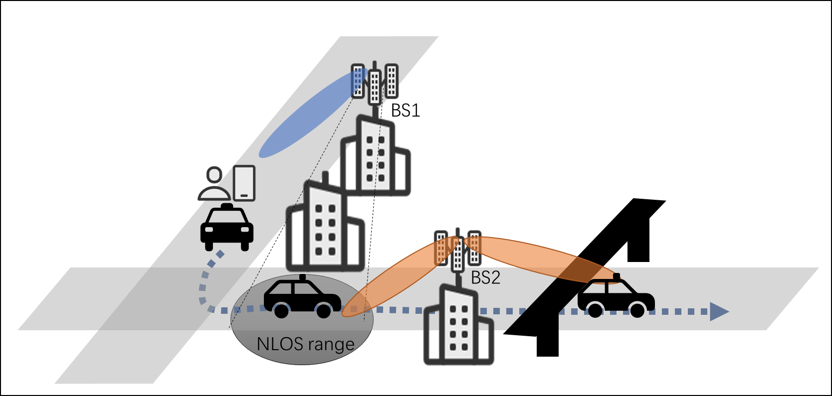
Figure 6.x.3-1 mobility management based on environmental awareness
Step 0: To improve communication performance, the 6G network-X performs mobility management based on environmental information collected via sensing, the RAN node, the UE or the CN node could trigger the sensing procedure for the mobility management purpose. Therefore, the 6G network-X selects several BSs and UEs in certain area to collect sensing data for environmental information.
The selected BSs or UEs acquire 6G based 3GPP sensing data. Due to the large data volume of the sensing data, the sensing data needs to be transmitted between UEs, RANs and CNs efficiently (e.g. new radio protocol for sensing data transmission, transport protocol for sensing data, data compression, and etc.). Due to data privacy reasons, the sensing data needs to be transmitted between UEs, RANs and CNs using data privacy protection mechanism. Moreover, the collected sensing data can be reused among multiple use cases of sensing assisted communication, such as sensing assisted mobility management, sensing based beam management, and etc.
The 6G system processes the sensing data from multiple BSs or UEs to obtain environmental information. This environmental information can be generated by incorporating the offline data, in particular quasi-static environmental information.
Step 1: Annie is taking a taxi to the airport. On the way, she is attending an important video conference via an application of immersive communication. The application supports mixed traffic of video, audio, and other environment data in a time-synchronized manner.
Step 2: Based on the environmental information collected in step 0, the RAN node detects that Annie's UE is about to enter the non-line-of-sight (NLOS) region of BS1 because Annie’s taxi is approaching the turn at the intersection, therefore, the RAN node switches Annie's UE to BS2 in a timely manner to avoid link failure of Annie’s connection. Annie's experience remains good, she does not suffer from the video stuttering caused by a sharp drop in signal quality after the turn at the intersection, thanks to the mobility management based on the sensing environmental information.
Step 3: Based on the environmental information collected in step 0, the RAN node detects that there is a flyover blocking Annie's UE signal. Instead of handover, the RAN decides to pre-schedules and transmits the downlink and uplink data to ensure a smooth video experience. the blocking time of the flyover is very short, handover will cause ping-pong handover and it not a good choice in such circumstances.
Step 4: As time goes by, the 6G system will select new BSs or UEs which is more suitable to perform sensing. The sensing data from the newly selected BSs or UEs is used to update the environment information to improve communication including mobility management. therefore, the communication performance for user including Annie UE is improved in current area.

6.x.4 Post-conditions
Thanks to the environmental information sensing capability, the mobility management performance is improved. Due to the better mobility management, Annie finished the video conference happily with a good user experience. Moreover, the spectrum efficiency for 6G communication has also been improved and the power consumption of the network and UEs has been reduced.

6.x.5 Existing features partly or fully covering the use case functionality
TR 22.837 includes potential requirements for enhancement of the 5G system to provide sensing services for applications. However, the existing features do not support sensing-assisted communication.

6.x.6 Potential New Requirements needed to support the use case
[PRx.1.6.-1] The 6G system shall support mechanisms to enable sensing service for the purpose of communication performance improvement within the system.

[PRx.1.6.-2] The 6G system shall support efficient mechanisms to collect, store, transfer and process sensing data for the purpose of communication performance improvement within the system.

