**3GPP TSG-SA WG1 Meeting** #**108 S1-244191**

**Orlando, Florida, USA, 18-22 Nov 2024** *(revision of S1-24xxxx)*

**Source: vivo**

**pCR Title: New Use case on** **end-to-end energy efficiency improvement for the network and UE**

**Draft Spec: 3GPP TR 22.870**

**Agenda item: 8.1.1(****FS_6G-REQ)**

**Document for: Approval**

**Contact: Zhuoyun Zhang,** [**zhangzhuoyun@vivo.com**](mailto:zhangzhuoyun@vivo.com)**;**

**Yanchao Kang,** [**kangyanchao@vivo.com**](mailto:kangyanchao@vivo.com)

**Hank Yu,** [**yuhang.txyjy@vivo.com**](mailto:yuhang.txyjy@vivo.com)

*Abstract: This pCR proposes to add the following use case to clause 5 on System and Operational Aspects.*

**1. Introduction**

This contribution proposes to introduce the new use case and requirements on end-to-end energy efficiency improvement for the network and UE for 6G system.

**2. Reason for Change**

Supporting end-to-end energy efficiency is an important design target for the sustainability of 6G system. The UE energy efficiency is an important part of the end-to-end 6G system. It is expected that the network could assist the UE to improve energy efficiency, and the UE could also assist the network to improve the system energy efficiency to further reduce operation cost for mobile operators. So the UE and network could mutually benefit from the coordination for energy efficiency improvement. The operator could further consider to offer energy efficiency improvement services to the subscribers. This new business model is also the driven for the 6G system deployement.

This contribution thinks that the end-to-end energy efficiency improvement for the network and UE is important for the 6G system. It is proposes to add the following new use case and requirements on end-to-end energy efficiency improvement for the network and UE in clause 5 of the TR.

**3. Conclusions**

None.

**4. Proposal**

It is proposed to agree the following 6G use case and requirements on end-to-end energy efficiency improvement for the network and UE to clause 5 of 3GPP TR 22.870 for FS_6G-REQ.

* * * First Change * * * *

# 2 References

The following documents contain provisions which, through reference in this text, constitute provisions of the present document.

- References are either specific (identified by date of publication, edition number, version number, etc.) or non‑specific.

- For a specific reference, subsequent revisions do not apply.

- For a non-specific reference, the latest version applies. In the case of a reference to a 3GPP document (including a GSM document), a non-specific reference implicitly refers to the latest version of that document *in the same Release as the present document*.

[1] 3GPP TR 21.905: "Vocabulary for 3GPP Specifications".

[x] GSMA, "Going green: benchmarking the energy efficiency of mobile", June 2021.

[y] 3GPP TR 32.972: " Study on system and functional aspects of energy efficiency in 5G networks".

* * * Second Change * * * *

# 5 System and Operational Aspects

Editor's Note: "System and Operational Aspects" facilitates system and network operation features that underpin overall operation, covering aspects that apply across use cases and services, and those that relate to network operations. These aspects include, for example: migration scenarios, interworking with earlier 3GPP systems, interworking with non-3GPP system, roaming and interconnection, network simplification, network sharing, security, privacy, resilience, sustainability and energy efficiency, device diversity, support of legacy services

## 5.x Use case on end-to-end energy efficiency improvement for the network and UE

### 5.x.1 Description

In the ITU-R Recommendation “Framework and overall objectives of the future development ​of IMT for 2030 and beyond”, sustainability is considered as the design principles commonly applicable to all usage scenarios. Supporting end-to-end energy efficiency is an important design target for the sustainability of 6G system.

Regards to end-to-end energy efficiency of 6G system, UE energy efficiency is an important part. Power consumption of modem (including both baseband and RF) has contributed more and more to total UE power consumption due to large number of power consuming features supported, e.g., AI and computing as well as the strong demand of high data volume transmission. Energy efficiency design for UE could further extend UE battery life while guarantee certain service quality. In the 6G system, it is expected that the network could assist the UE to improve energy efficiency as one of the services, e.g., UE could subscribe energy efficiency service to realize power saving based on network assistance. The UE could also assist the network to improve the system energy efficiency to further reduce operation cost for mobile operators. So the UE and network could mutually benefit from the coordination for energy efficiency improvement.

Considering the above, the energy efficiency and energy saving should consider the end-to-end performance including both the network and UE. **Considering the sustainability target of the 6G system, it should greatly improve the end-to-end energy efficiency compared to the 5G system.**

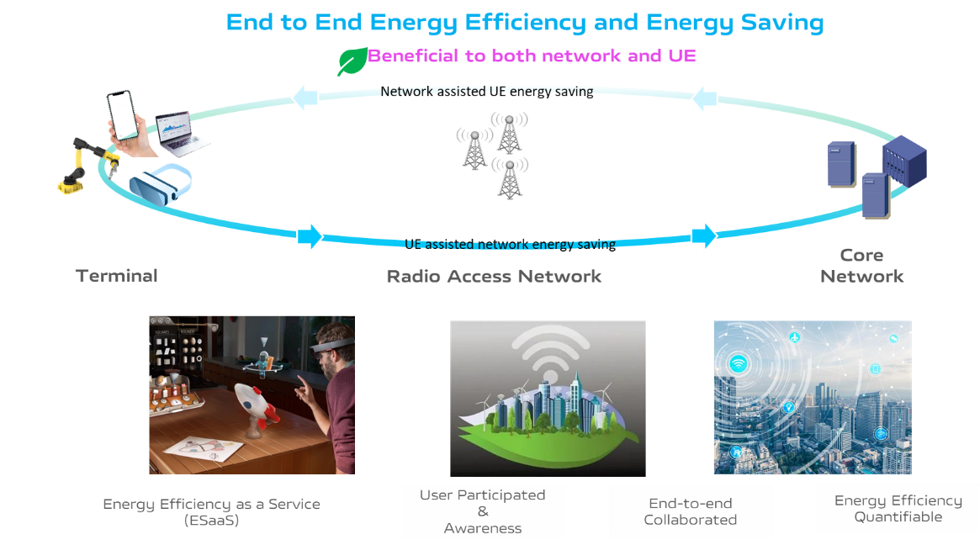

**Figure 5.x-1: Supporting end-to-end energy efficiency and energy saving**

**Energy efficiency shall be a quantifiable metric of sustainability and is important for the success of IMT-2030 technology.** The energy efficiency KPI should be defined to ensure that IMT-2030 is designed in an energy efficient way. From the operator’s point of view, the KPI helps the operator to decide how much the network energy efficiency is improved by applying a specific energy-saving technology. Then, based on the quantified KPI, the network could provide energy efficiency improvement services for the subscribers. From the subscriber’s point of view, the KPI clearly shows that the energy efficiency improvement services are important for them to reduce the power consumption for the data transmission, so they are more willing to subscribe the services from the network. This would also be a new business model for the operators. **In general, the energy efficiency KPI is important and helpful to both the operators and subscribers.**

**Energy efficiency should be defined taking into account both communication performance metric and energy consumption.** According to GSMA study [x] and 3GPP TR 32.972 [y], several measurements means for energy efficiency are proposed by considering the energy consumption and the data transmission. Communication related performance (e.g. data volume, latency, data rate, etc.) of data transmission should be considered for the energy efficiency measurements. For example, energy saving by reducing the data rate can’t always satisfy the subscribers’ requirements. It is also important for the network to realize energy saving with guaranteed QoS.

**Regards to end-to-end energy efficiency, the energy related information collection from radio access network, e.g., at per UE, or per application granularity, should also be considered.** Radio conditions would affect the energy consumption of the UE for the same amount of data volume transmission. For example, the UE location in the Cell affects the energy consumption, e.g., the UE located in cell edge consumes more energy compared to the one located in cell centre for the same amount of data volume transmission.

Considering the energy efficiency at the UE, it is closely related with the user experience. **Based on different technologies in the 6G network to improve the energy efficiency, the operator may offer different energy efficiency improvement services to the subscribers.** Based on UE’s indication, the network may apply certain power saving technology to improve energy efficiency at the UE to satisfy the user’s requirement on energy efficiency. This energy efficiency improvement service for the subscribers is also a new business model for the operators in 6G system. The new business model is also the driven for the 6G system deployment. The energy efficiency improvement service would further benefit the operators and subscribers to achieve the energy efficiency target in the 6G system.

### 5.x.2 Pre-conditions

The operator has offered a series of energy efficiency improvement services in the 6G network for the UE to save energy and extend the battery life. Different energy efficiency improvement services may be provided to the subscribers at different prices or incentives. The subscribers may order certain energy efficiency improvement services.

For example, the operator A may offer the following two kinds of energy efficiency improvement services:

* Energy efficiency improvement service A: Improving the energy efficiency by reducing UE energy consumption with maintaining the service experience (e.g., low latency, high throughput).
* Energy efficiency improvement service B: Improving the energy efficiency by reducing UE energy consumption with essential service access, e.g., voice call only. The essential service list is based on the agreement between the subscriber and operator.

Bob buys a pair of AR glasses and wants to wear it to access AR content during the trip. Normally, the battery of his AR glasses can last for two hours. Since it’s not possible to find the power source during the trip for the AR glasses, he orders the Energy efficiency improvement service A for the glasses from the operator.

Bob also has a cell phone. Sometimes his cell phone is about to run out of battery, but he does not want to miss some important calls, or still wants to access certain applications (e.g. navigation map application). He prefers the network to provide essential network access for services (e.g. voice call) for his cell phone in order to improve the energy efficiency and extend the battery life. So he orders the Energy efficiency improvement service B with providing his preference on the essential service list for his cell phone.

### 5.x.3 Service Flows

When visiting the pyramids, Bob wears his AR glasses to access specific AR tour guide information. Usually, the battery of his AR glasses can last for two hours. Considering that the tour might last for four hours, in order to save power for this AR glasses, Bob indicates to the network to apply Energy efficiency improvement service A to minimize the power consumption of the AR glasses while ensuring the specific QoS. Based on the indication, the network applies Energy efficiency improvement service A for Bob’s AR glasses.

After the long trip, Bob needs to take the bus to go back home. It takes nearly one hour. He finds that the battery of his cell phone is below 10% and he can’t charge his cell phone on the bus. So he indicates to the network to apply Energy efficiency improvement service B for his cell phone. Based on the indication, the network applies Energy efficiency improvement service B for Bob’s cell phone. The network only provides limited network access to the essential services (e.g. voice call) as predefined by Bob in order to reduce the UE energy consumption.

### 5.x.4 Post-conditions

During the visit to the pyramids, Bob is able to watch AR tour guide information with his AR glasses with good service experience. The AR glasses is used for four hours with good service experience due to the Energy efficiency improvement service A.

During the trip back home, due to Energy efficiency improvement service B, although the battery of his cell phone is below 10%, Bob’s cell phone could still access the basic services (e.g. voice call) for nearly one hour.

### 5.x.5 Existing features partly or fully covering the use case functionality

The energy efficiency requirements for 5G system have been defined in clause 6.15 and 6.15a of TS 22.261[x], including the general requirements, requirements for energy related information as a service criteria, requirements for energy states, requirements for monitoring and measurement, requirements for information exposure, requirements for network actions leveraging energy efficiency as a service criteria.

The study on Energy Efficiency as service criteria Ph 2 is under study in SA1 R20. The related use cases and requirements to the 5G system are introduced in TR 22.283 [y].

Some of the procedures and network functions proposed in 3GPP TR 23.700-66 [z] can be used to realize part of the 5G requirements and service flows described in TS 22.261 above.

The 6G system requirements on the energy efficiency and energy saving are based on the existing requirements in the 5G system.

### 5.x.6 Potential New Requirements needed to support the use case

[PR. 5.x.6-001] The 6G system shall support mechanism to improve systematic energy efficiency including the UE and the network.

[PR. 5.x.6-002] The 6G system shall support energy saving technologies in the radio access network to make efficient use of radio resources.

[PR. 5.x.6-003] The 6G system shall support UE power saving with network assistance.

[PR. 5.x.6-004] The 6G network shall be able to collect energy related information from radio access network at per UE granularity, e.g., the information which could reflect the UE energy consumption at the radio access network.

[PR. 5.x.6-005] Based on the user consent and operator’s policy, the 6G system shall be able to provide mechanisms for the subscribers to indicate the requirement of UE energy efficiency.

* * * End of Change * * * *