3GPP TSG-SA WG1 Meeting #108 S1-244550
Orlando, Florida, USA, 18-22 November 2024 (revision of S1-244189,4172)

Title: Migration and interworking
Agenda Item: 8.1.1
Source: vivo, China mobile
Contact: Yanchao Kang, kangyanchao@vivo.com
James Jin, James.Jin@vivo.com
Xiaonan Shi, shixiaonan@chinamobile.com
Huazhang Lv, lvhuazhang@chinamobile.com

Abstract: this contribution provides some considerations and potential requirements for migration and interworking aspect.
---------- Use Case template ----------

5 System and Operational Aspects
Editor's Note: "System and Operational Aspects" facilitates system and network operation features that underpin overall operation, covering aspects that apply across use cases and services, and those that relate to network operations. These aspects include, for example: migration scenarios, interworking with earlier 3GPP systems, interworking with non-3GPP system, roaming and interconnection, network simplification, network sharing, security, privacy, resilience, sustainability and energy efficiency, device diversity, support of legacy services

5.x Interworking for 6G system

5.x.1 Description
A 6G system is expected to support many new types of UEs and services. In order to efficiently support these new UEs and services, it is expected that the 6G system will include one or more RATs optimized for different purposes (e.g., support for high reliability/low latency vs support for low mobility/higher latency).
The device communication capabilities vary based on the diverse requirements of different scenarios and the complexity in terms of cost for terminals. Different UE capabilities shall be considered for 5G-6G interworking from beginning.

Due to the operators in the world has already invested to deploy 5G network, so during the 6G timeline, it is also possible that 6G system co-exist with other system, e.g. 5GS. In Fig 5.X.1-1, it shows the two cases of 6G network deployment. In Case 1, the 5GS and 6GS are co-exist and may overlapping deployment. In Case 2, two 6GS co-exists.
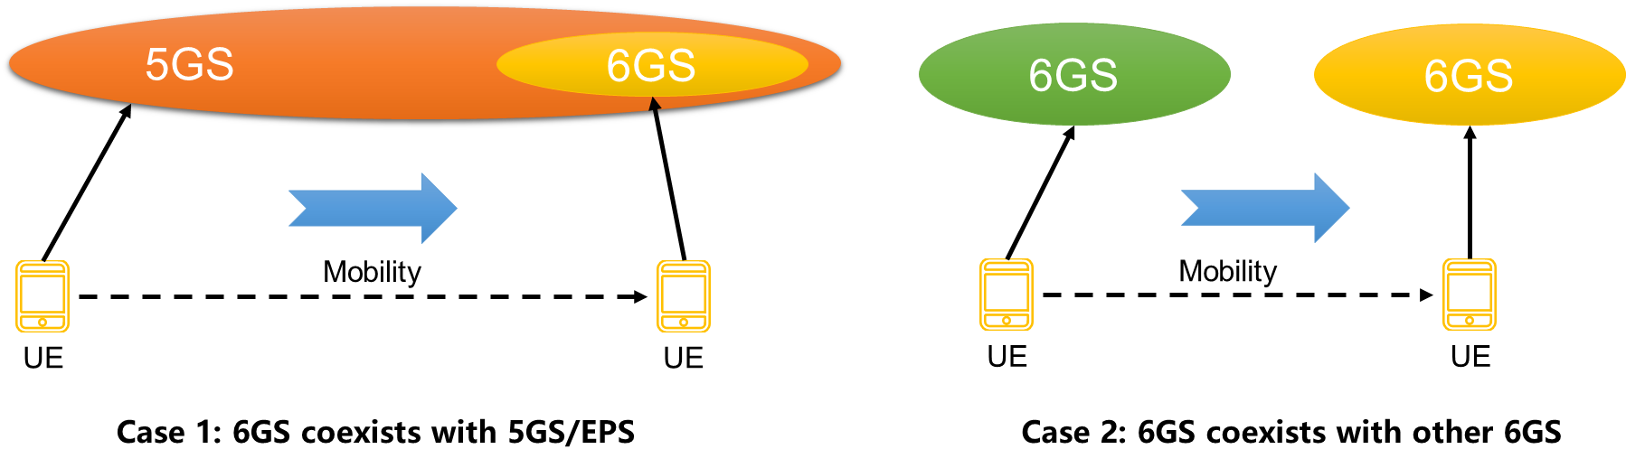
Figure 5.X.1-1: illustration of 6G network deployment
For the service of interworking, the interworking between 6G and 5G is recommended to be mandatory supported. The seamless handover between 6G and 5G should be supported.

5.x.2 Potential New Requirements

5.x.2.1 Interworking between 6G systems
[PR 5.X.2.1-001] The 3GPP system shall provide support for a device or UE with a 6G subscription roaming into a 6G Visited Mobile Network which has a roaming agreement with the device or UE's Home Mobile Network.
[PR 5.X.2.1-001a] The 3GPP system shall enable a visited mobile network to provide support for establishing home network provided data connectivity as well as visited network provided data connectivity.
[PR 5.X.2.1-001b] The 3GPP system shall enable a visited mobile network to provide support for services provided in the home network as well as provide services in the visited network. Whether a service is provided in the visited network or in the home network is determined on a service-by-service basis.
[PR 5.X.2.1-002] The 3GPP system shall provide a mechanism for a network operator to limit access to its services for a roaming subscriber with a 6G device or UE and subscription, e.g., based on a specific service logic agreement in a roaming agreement.
[PR 5.X.2.1-003] The 3GPP system shall provide a mechanism for a network operator to direct a UE onto a partnership network for routing all or some of the UE user plane traffic over the partnership network, subject to a bilateral agreement between the operators being in place.

5.x.2.2 Interworking with 6G system and 5GS
[PR 5.X.2.2-001] The 3GPP system shall be able to support seamless handover and inter-system mobility between 6G RAT(s) and NG-RAN.

