3GPP TSG-SA WG1 Meeting #108 S1-244530
Orlando, Florida, USA, 18-22 November 2024 (Revision of S1-244253)

Title: Use case on intelligent holographic shopping
Agenda Item: 8.1.4
Source: Indian Institute of Technology
Contact: Preksha Shah, 30005100@iitb.ac.in

Abstract: This paper proposes a use case on intelligent holographic shopping to be considered for FS_6G TR 22.870.

x.1 Use case on Intelligent Holographic Shopping

x.1.1 Description
Holographic shopping brings a multi-sensory experience to online or in-store shopping by simulating the multiple senses to create lifelike interactions with products. Holographic shopping creates a fully immersive environment allowing users to view garments up close, even giving the sensation of different textures and fabrics, and try clothing, accessories, or makeup in a virtual mirror. It can be similar to holographic flower shopping experiences that allow customers to smell flowers before buying flowers from a flower shop. Shopping apps analyze, predict, and store user preferences and provide product recommendations however, this requires massive computation, communication, and storage resources.
Holographic shopping can be customized by integrating the user’s choice learned using AI/ML. Through analyzing the user's eye gaze, actions, and context (e.g., shopping for a gift, routine purchase, or during specific seasons), AI learns user preferences, and likelihood of purchase. AI can learn that if a set of users have the same set of preferences, so for these users, the virtual environment highlights and shows the same set of clothes and product recommendations. As a result, this convergence of AI and holographic shopping can aid in reducing the network’s computational resources.
AI can predict what device or interface the user is interacting with (e.g., AR glasses, VR headset, or a mobile device) and adapt the network requirements accordingly, (such as bandwidth, latency, and graphical rendering). Through analyzing the complexity of the holographic scene (e.g., multiple users are interacting with complex 3D models) and forecasting traffic load patterns (e.g., when a particular product becomes popular) AI can scale the network resources accordingly to avoid bottlenecks.
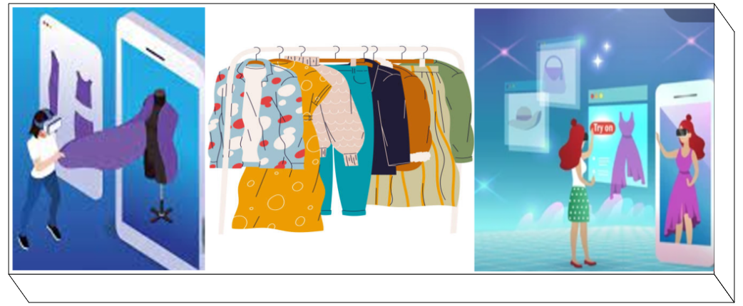
AI-based holographic shopping experience.

x.1.2 Pre-conditions
NA

***************** First Change ***********************

x.1.3 Service Flows

Multiple users are in the same session browsing jackets in a holographic shopping platform.

These users are focusing on a trending product.

AI service forecasts traffic peaks in the checkout zone and reroutes network resources to prevent bottlenecks.

AI services monitor the computational load and prioritize the resource allocation for the trending product's section and suggest adaptive rendering (e.g., reducing model complexity for less critical areas) to holographic services.

Holographic service update rendering quality based on AI insights and cache frequently accessed product models to reduce latency.

x.1.4 Post-conditions
NA

x.1.5 Existing features partly or fully covering the use case functionality

Due to the separate handling of the audio and video component, the 5G system will have to cater for the VR audio-video synchronisation in order to avoid having a negative impact on the user experience (i.e. viewers detecting lack of synchronization). To support VR environments the 5G system shall support audio-video synchronisation thresholds:
- in the range of [125 ms to 5 ms] for audio delayed and
- in the range of [45 ms to 5 ms] for audio advanced.

***************** Next Change ***********************

x.1.6 Potential New Requirements needed to support the use case
[PR 9.X.6-1] Due to the separate handling of the audio, video, and sensory components in holographic communications, the 6G system shall support audio-video-sensory synchronisation thresholds.
Editor’s note: KPIs for synchronisation thresholds are FFS.
[PR 9.X.6-2] Subject to operator policy and user consent, the 6G system shall support the coordination of holographic and AI services.
Editor’s note: KPIs required for the coordinationof holographic and AI services are FFS.

***************** End of Change ***********************

