**3GPP TSG-RAN WG4 Meeting # 113 *R4-2417820***

**Orlando, US, Nov.18 - Nov.22, 2024**

|  |  |  |  |  |  |  |  |  |
| --- | --- | --- | --- | --- | --- | --- | --- | --- |
| *CR-Form-v12.3* | | | | | | | | |
| **CHANGE REQUEST** | | | | | | | | |
|  | | | | | | | | |
|  | **38.114** | **CR** | **0018** | **rev** | **1** | **Current version:** | **18.3.0** |  |
|  | | | | | | | | |
| *For* ***HE******LP*** *on using this form: comprehensive instructions can be found at  http://www.3gpp.org/Change-Requests.* | | | | | | | | |
|  | | | | | | | | |

|  |  |  |  |  |  |  |  |  |
| --- | --- | --- | --- | --- | --- | --- | --- | --- |
| ***Proposed change affects:*** | UICC apps |  | ME |  | Radio Access Network | **X** | Core Network |  |

|  |  |  |  |  |  |  |  |  |  |  |
| --- | --- | --- | --- | --- | --- | --- | --- | --- | --- | --- |
|  | | | | | | | | | | |
| ***Title:*** | CR for TS 38.114, Correction on Correction on terminology of NCR and RF repeater | | | | | | | | | |
|  |  | | | | | | | | | |
| ***Source to WG:*** | CATT | | | | | | | | | |
| ***Source to TSG:*** | R4 | | | | | | | | | |
|  |  | | | | | | | | | |
| ***Work item code:*** | NR_netcon_repeater-Perf | | | | |  | ***Date:*** | | | 2024-11-08 |
|  |  | | | |  | |  | | |  |
| ***Category:*** | **F** |  | | | | | ***Release:*** | | | Rel-18 |
|  | *Use one of the following categories:* ***F*** *(correction)* ***A*** *(mirror corresponding to a change in an earlier release)* ***B*** *(addition of feature),* ***C*** *(functional modification of feature)* ***D*** *(editorial modification)*  Detailed explanations of the above categories can be found in 3GPP TR 21.900. | | | | | | | | *Use one of the following releases: Rel-8 (Release 8) Rel-9 (Release 9) Rel-10 (Release 10) Rel-11 (Release 11) … Rel-17 (Release 17) Rel-18 (Release 18) Rel-19 (Release 19)  Rel-20 (Release 20)* | |
|  |  | | | | | | | | | |
| ***Reason for change:*** | | To introduce the alignment for Rel-18 repeater terminology which is decided in [R4-2413502]. | | | | | | | | |
|  | |  | | | | | | | | |
| ***Summary of change:*** | | Alignment of terminology for Rel-18 repeater | | | | | | | | |
|  | |  | | | | | | | | |
| ***Consequences if not approved:*** | | The terminology of Rel-18 repeater would be ambiguous. | | | | | | | | |
|  | |  | | | | | | | | |
| ***Clauses affected:*** | | 1, 3, 4, 5, 6, 7, 8, 9 | | | | | | | | |
|  | |  | | | | | | | | |
|  | | **Y** | **N** |  | | | |  | | |
| ***Other specs*** | |  | **X** | Other core specifications | | | | TS/TR ... CR ... | | |
| ***affected:*** | |  | **X** | Test specifications | | | | TS/TR ... CR ... | | |
| ***(show related CRs)*** | |  | **X** | O&M Specifications | | | | TS/TR ... CR ... | | |
|  | |  | | | | | | | | |
| ***Other comments:*** | |  | | | | | | | | |
|  | |  | | | | | | | | |
| ***This CR's revision history:*** | | Revised from R4-2417820 | | | | | | | | |

<Start of Change>

# 1 Scope

The present document covers the assessment of RF repeater, network-controlled repeater and ancillary equipment in respect of Electromagnetic Compatibility (EMC). For network-controlled repeater (NCR), requirements for NCR-Fwd and NCR-MT apply.

The present document specifies the applicable requirements, procedures, test conditions, performance assessment and performance criteria for RF repeater, NCR and associated ancillary equipment in the following categories:

- RF repeater equipped with antenna connectors which are possible to be terminated during EMC testing, meeting the *RF repeater type 1-C* RF requirements of TS 38.106 [2], with conformance demonstrated by compliance to TS 38.115-1 [3].

- RF repeater not equipped with antenna connectors, i.e. with antenna elements radiating during the EMC testing, meeting the *RF repeater type 2-O* RF requirements of TS 38.106 [2], with conformance demonstrated by compliance to TS 38.115-2 [4].

- NCR equipped with antenna connectors or TAB connectors which are possible to terminated during EMC testing, meeting the NCR-Fwd/MT type 1-C and type 1-H RF requirements of TS 38.106 [2], with conformance demonstrated by compliance to TS38.115-1[3].

- NCR not equipped with antenna connectors, i.e. with antenna elements radiating during the EMC testing, meeting the NCR-Fwd/MT type 2-O RF requirements of TS 38.106 [2], with conformance demonstrated by compliance to TS38.115-2[4].

The environment classification used in the present document refers to the residential, commercial and light industrial environment classification used in IEC 61000‑6-1 [6], IEC 61000-6-3 [7] and IEC 61000-6-8 [24].

The EMC requirements have been selected to ensure an adequate level of compatibility for apparatus at residential, commercial and light industrial environments. The levels, however, do not cover extreme cases which may occur in any location but with low probability of occurrence.

# 3 Definitions, symbols and abbreviations

## 3.1 Definitions

For the purposes of the present document, the terms and definitions given in TR 21.905 [1] and the following apply. A term defined in the present document takes precedence over the definition of the same term, if any, in TR 21.905 [1].

**ancillary equipment:** electrical or electronic equipment, that is intended to be used with a receiver or transmitter

NOTE: It is considered as an ancillary equipment if:

the equipment is intended for use with a receiver or transmitter to provide additional operational and/or control features to the radio equipment, (e.g. to extend control to another position or location); and

the equipment cannot be used on a stand alone basis to provide user functions independently of a receiver or transmitter; and

the receiver or transmitter, to which it is connected, is capable of providing some intended operation such as transmitting and/or receiving without the ancillary equipment (i.e. it is not a sub-unit of the main equipment essential to the main equipment basic functions).

**antenna port:** for EMC purposes, port for connection of an antenna used for intentional transmission and/or reception of radiated RF energy, equivalent to an RF antenna connector.

**channel bandwidth:** the RF bandwidth supporting a single NR RF carrier with the transmission bandwidth configured in the uplink or downlink of a cell. The *channel bandwidth* is measured in MHz and is used as a reference for transmitter and receiver RF requirements.

**continuous phenomena:** electromagnetic disturbance, the effects of which on a particular device or equipment cannot be resolved into a succession of distinct effects (IEC 60050-161 [20]).

**exclusion band:** frequency range(s) not subject to test or assessment.

**multi-band repeater:** *RF repeater Type 1-C* whose *antenna connector* is associated with a transmitter and/or receiver that is characterized by the ability to process two or more *passband(s)* in common active RF components simultaneously, where at least one *passband* is configured at a different operating band than the other *passband(s)* and where this different operating band is not a sub-band or superseding-band of another supported operating band

**NCR-MT:** the NCR-MT is defined as a function entity to communicate with a gNB via a Control link (C-link) to enable exchange of control information (e.g. side control information at least for the control of NCR-Fwd). The C-link is based on NR Uu interface.

**NCR-Fwd:** the NCR-Fwd is defined as a function entity to perform the amplify-and-forwarding of UL/DL RF signal between gNB and UE via backhaul link and access link. The behavior of the NCR-Fwd will be controlled according to the received side control information from gNB.

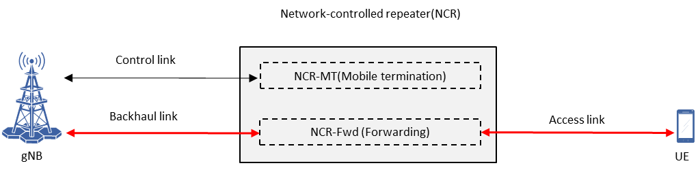

Figure 3.1-1: Conceptual model of network-controlled repeater

**NCR type 1-C:** network-controlled repeater including both NCR-MT and NCR-Fwd operating at FR1 with requirements set consisting only of conducted requirements defined at individual antenna connectors.

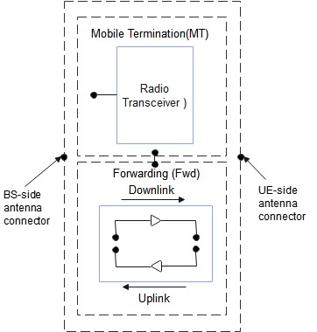

Figure 3.1-2: NCR type 1-C downlink and uplink interface

NOTE 1: the NCR-MT and NCR-Fwd may have the same or separate antenna connectors

**NCR type 1-H:** network-controlled repeater including both NCR-MT and NCR-Fwd operating at FR1 with a requirement set consisting of conducted requirements defined at individual TAB connectors and OTA requirements defined at RIB.

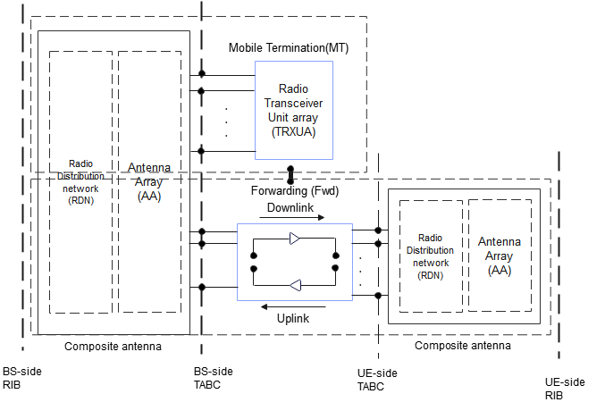

Figure 3.1-3: NCR type 1-H downlink and uplink interface

NOTE 1: the NCR-MT and NCR-Fwd may have the same or separate TAB connectors.

**NCR type 2-O:** network-controlled repeater including both NCR-MT and NCR-Fwd operating at FR2 with a requirement set consisting only of OTA requirements defined at the RIB.

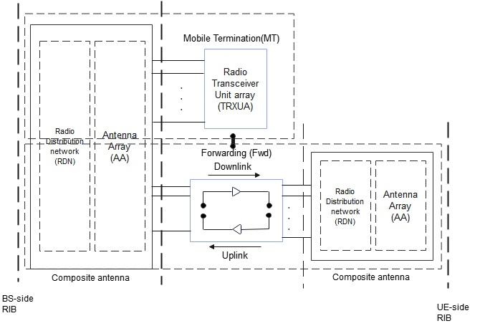

Figure 3.1-4: NCR type 2-O downlink and uplink interface

NOTE 1: the NCR-MT and NCR-Fwd may have the same or separate RIB.

**operating band:** frequency range in which NR operates (paired or unpaired), that is defined with a specific set of technical requirements.

**passband edge***:* Frequency at the edge of the passband.

**port:** A particular interface, of the specified equipment (apparatus), with the electromagnetic environment. For example, any connection point on an equipment intended for connection of cables to or from that equipment is considered as a port (see Figure 3.1-1).



Figure 3.1-5: Examples of ports

**RF repeater type 1-C**: RF repeater operating at FR1 with a requirement set consisting only of conducted requirements defined at individual *antenna connectors*.

**RF repeater type 2-O:** RF repeater operating at FR2 with a requirement set consisting only of OTA requirements defined at the RIB.

**radiated interface boundary**: *operating band* specific radiated requirements reference where the radiated requirements apply.

**signal/control port:** portintended for the interconnection of components of an EUT, or between an EUT and associated equipment and used in accordance with relevant functional specifications (for example for the maximum length of cable connected to it).

**single-band connector:** *RF repeater type 1-C* *antenna connector* supporting operation either in a single *operating band* only, or in multiple *operating bands* but does not meet the conditions for a *multi-band connector*

**spatial exclusion zone:** range of angles where no tests of radiated immunity are made for *RF repeater type 2-O* (i.e. half sphere around the EUT's radiating direction).

**telecommunication port:** ports which are intended to be connected to telecommunication networks (e.g. public switched telecommunication networks, integrated services digital networks), local area networks (e.g. Ethernet, Token Ring) and similar networks.

NOTE: *Telecommunication port* is called "wired network port" in CISPR 32 [5] and ETSI EN 301 489-1 [21].

**transient phenomena:** pertaining to or designating a phenomena or a quantity which varies between two consecutive steady states during a time interval short compared with the time-scale of interest (IEC 60050-161 [20]).

<Next Change>

# 4 Test conditions

## 4.1 General

Requirements throughout the EMC specifications are in some cases defined separately for different frequency ranges (FR). The frequency ranges FR1 and FR2 are defined in clause 5.1 of TS 38.106 [2]. RF repeater and NCR are designed to operate in FR1 and FR2-1.

The equipment shall be tested in normal test environment defined in the corresponding RF repeater conformance testing specification TS 38.115-1 [3] for *RF repeater type 1-C, NCR type 1-C* and *NCR type 1-H* or TS 38.115-2 [4] for *RF repeater type 2-O* and *NCR type 2-O.* The test conditions shall be recorded in the test report.

For Repeater capable of multi-band operation, the requirements in the present document apply for each supported *operating band* unless otherwise stated. *Operating bands* shall be activated according to the test configuration in clause 4.5. Tests shall be performed relating to each type of port and all *operating bands* shall be assessed during the tests.

The manufacturer shall declare the supported *operating band(s)* according to the list of RF repeater and NCR *operating bands* defined in TS 38.106 [2].

NOTE 1: NR *operating bands* for *RF repeater type 1-C*, *NCR type 1-C* and *NCR type 1-H*, are declared by the manufacturer according to the declaration D.2 specified in TS 38.115-1 [3], table 4.6-1.

NOTE 2: NR *operating bands* for *RF repeater type 2-O* and *NCR type 2-O,* are declared by the manufacturer according to the declaration D.4 specified in TS 38.115-2 [4], table 4.6-1.

## 4.2 Arrangements for establishing a communication link

The wanted RF input signal nominal frequency shall be selected by setting the NR Absolute Radio Frequency Channel Number (NR-ARFCN) to an appropriate number, as defined in TS 38.106 [2], clause 5.3.1.1.

A communication link shall be set up with a suitable test system capable of evaluating the required performance criteria (hereafter called "the test system") at the radio interface and *telecommunication port(s)* (the BS interface). The test system shall be located outside of the test environment.

When the EUT is required to be in the uplink/downlink operation, the following conditions shall be met:

- For the *RF repeater type 1-C*, *NCR type 1-C* and *NCR type 1-H,* the EUT shall be commanded to operate at maximum rated output power;

- For the *RF* r*epeater type 2-O* and *NCR type 2-O* testing, the EUT output power shall be configured as stated in clause 8.1 for emission test and clause 9.1 for immunity test accordingly;

- Adequate measures shall be taken to avoid the effect of the unwanted signal on the measuring equipment;

For immunity tests clause 4.3 shall apply and the conditions shall be as follows.

<Next Change>

## 4.4 Exclusion bands

The *exclusion band* for RF repeater and NCR is the frequency range over which no tests of radiated immunity are made in UL or DL.

The *exclusion band* for DL is defined as:

FDL,low – ΔfOBUE < f < FDL,high + ΔfOBUE

Where values of FDL,low and FDL,high are defined for each *operating band* in TS 38.106 [2], clause 5.2.

The *exclusion band* for UL is defined as:

FUL,low – ΔfOBUE < f < FUL,high + ΔfOBUE

Where values of FUL,low and FUL,high are defined for each *operating band* in TS 38.106 [2], clause 5.2.

For RF repeater and NCR capable of multi-band operation, the total *exclusion band* is a combination of the *exclusion bands* for each *operating band* supported by RF repeater or NCR.

The ΔfOBUE values are defined in table 4.4-1 for both DL and UL.

Table 4.4-1: ΔfOBUE offset values

|  |  |  |
| --- | --- | --- |
|  | *Operating band* characteristics | ΔfOBUE (MHz) |
| NCR type 1-H | FDL,high – FDL,low < 100 MHz, or  FUL,high – FUL,low < 100 MHz | 10 |
|  | 100 MHz ≤ FDL,high – FDL,low ≤ 900 MHz, or  100 MHz ≤ FUL,high – FUL,low ≤ 900 | 40 |
| RF repeater type 1-C, | FDL,high – FDL,low < 200 MHz, or  FUL,high – FUL,low < 200 MHz | 10 |
| NCR type 1-C | 200 MHz ≤ FDL,high – FDL,low ≤ 900 MHz, or  200 MHz ≤ FUL,high – FUL,low ≤ 900 MHz | 40 |

NOTE: As the radiated immunity testing is defined in the frequency range 80 MHz to 6 GHz, there is no exclusion band defined for FR2.

## 4.5 Repeaters test configurations

The present clause defines the repeaters test configurations that shall be used for demonstrating conformance. A single repeater carrier shall be used for testing of single-carrier capable repeaters.

The signal's channel bandwidth and subcarrier spacing used to build RF repeater and NCR Test Configurations shall be selected according to table 4.7.2-1 in TS 38.115-1 [3] clause 4.7 for *RF repeaters type 1-C*, *NCR type 1-C* and *NCR type 1-H* and table 4.7.2.1-1 in TS 38.115-2 [4] clause 4.7 for *RF repeaters type 2-O* and *NCR type 2-O*. The passband frequency range declared per *operating band* in TS 38.115-1 [3] clause 4.6, and TS 38.115-2 [4] clause 4.6 shall be used.

For other RF repeaters and NCR, the test configurations in tables 4.5-1, 4.5-2, 4.5-3 and 4.5-4 shall be used. The RF repeaters and NCR test configurations (RTCx) are defined in TS 38.115-1 [3], clause 4.7 for *RF repeaters type 1-C, NCR type 1-C* and *NCR type 1-H* and in TS 38.115-2 [4], clause 4.7 for *RF repeaters type 2-O, NCR type 2-O*.

Table 4.5-1: Test configurations for *RF repeaters type 1-C*

| Repeater test case | Repeater capable of single or multiple passbands in a single band | | | Repeater capable of multi-band operation | |
| --- | --- | --- | --- | --- | --- |
|  | Single passband repeater | Multiple passband capable repeater with identical parameters per passband | Multiple passband capable repeater with different parameters per passband | Common connector | Separate connectors |
| Emission tests | RTC1 | RTC1, RTC2 | RTC1, RTC2 | RTC1/2 (Note 1), RTC4 | RTC1/2 (Note 1, 2), RTC4 (Note 2) |
| Immunity tests | RTC1 | RTC1, RTC2 | RTC1, RTC2 | RTC1/2 (Note 1), RTC4 | RTC1/2 (Note 1, 2), RTC4 (Note 2) |
| NOTE 1: RTC1 and/or RTC2 shall be applied in each supported operating band.  NOTE 2: For single-band operation test, other antenna connector(s) is (are) terminated. | | | | | |

Table 4.5-2: Test configurations for *RF repeaters type 2-O*

| Repeater test case | Repeater capable of single or multiple passbands in a single band | | |
| --- | --- | --- | --- |
|  | Single passband repeater | Multiple passband capable repeater with identical parameters per passband | Multiple passband capable repeater with different parameters per passband |
| Emission tests | RTC1 | RTC1, RTC2 | RTC1, RTC2 |
| Immunity tests | RTC1 | RTC1, RTC2 | RTC1, RTC2 |

Table 4.5-3: Test configurations for *NCR type 1-C, NCR type 1-H*

| Repeater test case | Repeater capable of single or multiple passbands in a single band | | | Repeater capable of multi-band operation | |
| --- | --- | --- | --- | --- | --- |
|  | Single passband repeater | Multiple passband capable repeater with identical parameters per passband | Multiple passband capable repeater with different parameters per passband | Common connector | Separate connectors |
| Emission tests | NCRTC1 | NCRTC1, NCRTC2 | NCRTC1, NCRTC2 | NCRTC1/2 (Note 1), NCRTC4 | NCRTC1/2 (Note 1, 3), NCRTC4 (Note 3) |
| Immunity tests | NCRTC1 | NCRTC1, NCRTC2 | NCRTC1, NCRTC2 | NCRTC1/2 (Note 1), NCRTC4 | NCRTC1/2 (Note 1, 3), NCRTC4 (Note 3) |
| Note 1: NCRTC1 and/or NCRTC2 shall be applied in each supported operating band.  Note 2: NCRTC4 may be applied for Inter passband gap only.  Note 3: For single-band operation test, other antenna connector(s) is (are) terminated. | | | | | |

Table 4.5-4: Test configurations for *NCR type 2-O*

| Repeater test case | Repeater capable of single or multiple passbands in a single band | | |
| --- | --- | --- | --- |
|  | Single passband repeater | Multiple passband capable repeater with identical parameters per passband | Multiple passband capable repeater with different parameters per passband |
| Emission tests | NCRTC1 | NCRTC1, NCRTC2 | NCRTC1, NCRTC2 |
| Immunity tests | NCRTC1 | NCRTC1, NCRTC2 | NCRTC1, NCRTC2 |

<Next Change>

# 5 Performance assessment

## 5.1 General

The following information shall be recorded in or annexed to the test report:

- The primary functions of the radio equipment to be tested during and after the EMC testing;

- The intended functions of the radio equipment which shall be in accordance with the documentation accompanying the equipment;

- The method to be used to verify that a communications link is established and maintained;

- The user-control functions and stored data that are required for normal operation and the method to be used to assess whether these have been lost after EMC stress;

- The *ancillary equipment* to be combined with the radio equipment for testing (where applicable);

- The information about *ancillary equipment* intended to be used with the radio equipment;

- Information about the common and/or band-specific active RF components and other hardware blocks for a communication link in EUT capable of multi-band operation;

- An exhaustive list of ports (or RIBs), classified as either power or signal/control. Power ports shall further be classified as AC or DC power.

Performance assessment of a RF repeater or NCR with multiple enclosures may be done separately, according to the manufacturer's choice.

A communication link used by more than one *operating band*, shall be assessed on all *operating band*s. Communication link(s) and/or radio performance parameters for the *operating band*s can during the test be assessed simultaneously or separately for each band, depending on the test environment capability.

## 5.2 RF repeaters and NCR

The parameter used for assessment of performance of a RF repeater and NCR-Fwd is the power accuracy within the operating band.

For downlink assessment of the NCR-MT, a communication link shall be established between the transmitter (via port for the *NCR type 1-C* and *NCR type 1-H*, or via RIB for the *NCR type 2-O*) and the test equipment. Test equipment shall meet the requirements for the throughput assessment defined in TS 38.106 [2] for the bearer used in the immunity tests. The level of the signal supplied to the equipment should be within the range for which the assessment of throughput is not impaired. Power control shall be OFF during the immunity testing.

For uplink assessment of the NCR-MT, the value of the throughput at the output of the receiver shall be monitored at NG interface by using suitable test equipment.

<Next Change>

# 6 Performance criteria

## 6.1 Performance criteria for continuous phenomena

### 6.1.1A Performance criteria for continuous phenomena for RF repeaters and NCR-Fwd

The power accuracy of the EUT shall be measured throughout the period of exposure of the phenomenon.

For *RF* *repeater type 1-C*, *NCR type 1-C*, and *NCR type 1-H,* the measured output power Pmax,p,AC during the test shall not change from the rated passband output power Prated,p,AC measured before the test by more than ± 1 dB.

For *RF* repeater type 2-O and *NCR type 2-O,* the maximum passband TRP output power Pmax,p,TRP during the test shall not change from the rated passband TRP output power Prated,p,TRP measured before the test by more than ± 1 dB.

At the conclusion of the test the EUT shall operate as intended with no loss of user control functions or stored data.

### 6.1.1 Performance criteria for continuous phenomena for NCR-MT

The test should, where possible, be performed using a bearer with the characteristics of data rate and throughput defined in table 6.1.1-1 and table 6.1.1-2. If the test is not performed using one of these bearers (for example, none of them are supported by the NCR-MT), the characteristics of the bearer used shall be recorded in the test report.

The throughput in table 6.1.1-1 and table 6.1.1-2 is stated relative to the maximum throughput of the FRC.

The NCR-MT uplink and downlink paths shall each meet the performance criteria defined in table 6.1.1-1 and table 6.1.1-2 during the test. If the uplink and downlink paths are evaluated as a one loop then the criteria is two times the throughput reduction shown in table 6.1.1-1 for FR1 WA NCR-MT and table 6.1.1-2 for FR2 NCR-MT (i.e. throughput > 90 % instead of throughput > 95 %). After each test case NCR-MT shall operate as intended with no loss of user control function, stored data and the communication link to both UE and donor test equipment shall be maintained.

For LA NCR-MT the performance criteria shall be that the throughput shall be ≥ 95% of the maximum throughput of the reference measurement channel as specified in annex A in TS 38.101-1 [3] or TS 38.101-2 [4] for FR1 and FR2 respectively, with parameters specified in clause 7.3.2 in TS 38.101-1 [3] or TS 38.101-2 [4] during the test sequence.

Table 6.1.1-1: FR1 performance criteria for continuous phenomena for WA NCR-MT

|  |  |  |  |
| --- | --- | --- | --- |
| NR channel bandwidth (MHz) as defined in TS 38.106 section 5.4.2 [2] for NCR-MT | Sub-carrier spacing (kHz) | Bearer information data rate for NCR-MT | Performance criteria  (Note 1, Note 2) |
| 10, 15 | 30 | G-FR1-A1-22 in annex A.1 in TS 38.106 [2] | Throughput > 95 %,  no loss of service |
| 10, 15 | 60 | G-FR1-A1-23 in annex A.1 in TS 38.106 [2] |
| 20 to 100 | 30 | G-FR1-A1-25 in annex A.1 in TS 38.106 [2] |
| 20 to 100 | 60 | G-FR1-A1-26 in annex A.1 in TS 38.106 [2] |
| NOTE 1: The performance criteria, throughput > 95 %, no loss of service, applies also if a bearer with another characteristics is used in the test.  NOTE 2: The performance criteria, throughput > 90 %, no loss of service, applies instead if the uplink and downlink paths are evaluated as a one loop. | | | |

Table 6.1.1-2: FR2-1 performance criteria for continuous phenomena for NCR-MT

|  |  |  |  |
| --- | --- | --- | --- |
| NR channel bandwidth (MHz) | Sub-carrier spacing (kHz) | Bearer information data rate for NCR-MT | Performance criteria  (Note 1, Note 2) |
| 50, 100, 200 | 60 | G-FR2-A1-21 in annex A.1 in TS 38.106 [2] | Throughput > 95 %,  no loss of service |
| 50 | 120 | G-FR2-A1-22 in annex A.1 in TS 38.106 [2] |
| 100, 200, 400 | 120 | G-FR2-A1-23 in annex A.1 in TS 38.106 [2] |
| NOTE 1: The performance criteria, throughput > 95 %, no loss of service, applies also if a bearer with another characteristics is used in the test.  NOTE 2: The performance criteria, throughput > 90 %, no loss of service, applies instead if the uplink and downlink paths are evaluated as a one loop. | | | |

## 6.2 Performance criteria for transient phenomena

### 6.2.1A Performance criteria for transient phenomena for RF repeaters and NCR-Fwd

The power accuracy of the EUT shall be measured before the test and after each exposure.

For RF repeater type 1-C, *NCR-Fwd type 1-C* and *NCR-Fwd type 1-H,* the measured output power Pmax,p,AC after each exposure and after the total test shall not change from the rated passband output power Prated,p,AC measured before the test by more than ± 1 dB.

For RF repeater type 2-O and *NCR-Fwd type 2-O*, the maximum passband TRP output power Pmax,p,TRP after each exposure and after the total test shall not change from the rated passband TRP output power Prated,p,TRP measured before the test by more than ± 1 dB.

At the conclusion of the total test comprising the series of individual exposures, the EUT shall operate as intended with no loss of user control functions or stored data.

### 6.2.1 Performance criteria for transient phenomena for NCR-MT

The test should, where possible, be performed using a bearer with the characteristics of data rate and throughput defined in table 6.2.1-1 and table 6.2.1-2. If the test is not performed using one of these bearers (for example, none of them are supported by the NCR-MT), the characteristics of the bearer used shall be recorded in the test report.

The NCR-MT uplink and downlink paths shall each meet the performance criteria defined in table 6.1.1-1 and table 6.1.1-2 during the test. If the uplink and downlink paths are evaluated as a one loop, then the criteria is two times the throughput reduction shown in table 6.1.1-1 for FR1 WA NCR-MT and table 6.1.1-2 for FR2 NCR-MT (i.e. throughput > 90 % instead of throughput > 95 %). After each test case NCR-MT shall operate as intended with no loss of user control function, stored data and the communication link to both UE and donor test equipments shall be maintained.

For LA NCR-MT the performance criteria shall be that the throughput shall be ≥ 95% of the maximum throughput of the reference measurement channel as specified in annex A in TS 38.101-1 [3] or TS 38.101-2 [4] for FR1 and FR2 respectively, with parameters specified in clause 7.3.2 in TS 38.101-1 [3] or TS 38.101-2 [4] during the test sequence.

<Next Change>

# 7 Applicability overview

## 7.0 General

Throughout this specification, whenever the NCR requirement is referred, its applicability shall be considered as applicable to the NCR node as a whole (i.e. NCR-Fwd and NCR-MT), irrespective of its implementation.

## 7.1 Emission

Table 7.1-1: Emission requirements applicability

|  |  |  |  |  |  |  |
| --- | --- | --- | --- | --- | --- | --- |
| Phenomenon | Application | Equipment test requirement | | | Reference  clause in the | Reference  standard |
|  |  | RF repeater equipment | NCR equipment | Ancillary equipment | present document |  |
| Radiated emission | Enclosure | applicable for *RF* *repeater type 1-C*  (Note 1) | applicable for *NCR type 1-C* and NCR type 1-H  (Note 1) | not applicable | 8.2.1 | ITU-R SM.329 [19] |
| Radiated emission | Enclosure of *ancillary equipment* | not applicable | not applicable | applicable | 8.2.2 | CISPR 32 [5] |
| Conducted emission | DC power input/output port | applicable | applicable | applicable | 8.3 | CISPR 32 [5] |
| Conducted emission | AC mains input/output port | applicable | applicable | applicable | 8.4 | CISPR 32 [5] |
| Conducted emission | *Telecommunication port* | applicable | applicable | applicable | 8.5 | CISPR 32 [5] |
| Harmonic current emissions | AC mains input port | applicable | applicable | applicable | 8.6 | IEC 61000-3-2 [8] or IEC 61000-3-12 [11]  (NOTE 2) |
| Voltage fluctuations and flicker | AC mains input port | applicable | applicable | applicable | 8.7 | IEC 61000-3-3 [9] or IEC 61000-3-11 [10]  (NOTE 2) |
| NOTE 1: Radiated emission requirements for *RF* *repeater type 2-O and NCR type 2-O* are described in clause 8.2.1.  NOTE 2: Selection of the reference IEC specification is based on the rated input current of the EUT’s power supply. | | | | | | |

## 7.2 Immunity

Table 7.2-1: Immunity requirements applicability

|  |  |  |  |  |  |  |
| --- | --- | --- | --- | --- | --- | --- |
| Phenomenon | Application | Equipment test requirement | | | Reference | Reference |
|  |  | RF repeater equipment | NCR equipment | Ancillary equipment | clause in the present document | standard |
| RF electro­magnetic field (80 – 6000 MHz) | Enclosure | applicable | applicable | applicable | 9.2 | IEC 61000‑4‑3 [13] |
| Electrostatic discharge | Enclosure | applicable | applicable | applicable | 9.3 | IEC 61000‑4‑2 [12] |
| Fast transients common mode | Signal, telecommunications and control ports, DC and AC power input ports | applicable | applicable | applicable | 9.4 | IEC 61000‑4‑4 [14] |
| RF common mode  0.15 - 80 MHz | Signal, telecommunications and control ports, DC and AC power input ports | applicable | applicable | applicable | 9.5 | IEC 61000‑4‑6 [16] |
| Voltage dips and interruptions | AC mains power input *port*s | applicable | applicable | applicable | 9.6 | IEC 61000‑4‑11 [17] |
| Surges, common and differential mode | AC power input *port*s and *telecommunications port* | applicable | applicable | applicable | 9.7 | IEC 61000‑4‑5 [15] |

<Next Change>

# 8 Emission

## 8.1 Test configurations

This clause defines the configurations for emission tests as follows:

- The equipment shall be tested under normal test conditions as specified in the functional standards;

- The test configuration shall be as close to normal intended use as possible;

- If the equipment is part of a system, or can be connected to ancillary equipment, then it shall be acceptable to test the equipment while connected to the minimum configuration of *ancillary equipment* necessary to exercise the ports;

- If the equipment has a large number of ports, then a sufficient number shall be selected to simulate actual operation conditions and to ensure that all the different types of termination are tested;

- The test conditions, test configuration and mode of operation shall be recorded in the test report;

- Ports which in normal operation are connected shall be connected to an *ancillary equipment* or to a representative piece of cable correctly terminated to simulate the input/output characteristics of the *ancillary equipment*; in case of *RF* *repeater type 1-C, NCR type 1-C* and *NCR type 1-H*, *antenna port*s shall be correctly terminated;

- For *RF repeater type 2-O* and *NCR type 2-O* without *antenna ports* but intentionally radiating through the *antenna array*, the equipment shall be placed in a test setup suitable for the radiated power;

- Ports which are not connected to cables during normal operation, e.g. service connectors, programming connectors, temporary connectors etc. shall not be connected to any cables for the purpose of EMC testing. Where cables have to be connected to these ports, or interconnecting cables have to be extended in length in order to exercise the EUT, precautions shall be taken to ensure that the evaluation of the EUT is not affected by the addition or extension of these cables;

- The test arrangements for uplink and downlink of the RF repeater and NCR are described separately for the sake of clarity. However, where possible the test of the uplink clause and downlink clause of the EUT may be carried out simultaneously to reduce test time.

## 8.2 Radiated emission

### 8.2.1 Radiated emission, RF Repeater and NCR

This test is applicable to *RF repeater type 1-C, NCR type 1-C* and *NCR type 1-H*. This test shall be performed on a representative configuration of RF repeater or NCR.

For *RF repeater type 2-O* and *NCR type 2-O*, the radiated emission is covered by radiated spurious emission requirement in TS 38.106 [2], conforming to the test requirement in TS 38.115-2 [4].

#### 8.2.1.1 Definition

This test assesses the ability of RF repeater or NCR to limit unwanted emission from the *enclosure port*.

#### 8.2.1.2 Test method

a) A test site fulfilling the requirements of ITU-R SM.329 [19] shall be used. The RF repeater or NCR shall be placed on a non-conducting support and shall be operated from a power source via a RF filter to avoid radiation from the power leads. One of the following two alternative measurement methods shall be used:

1) Field strength method measurement

The test method shall be in accordance with CISPR 32 [5]. The field strength measurements shall be performed on a test site that is validated according to the methods and requirements of CISPR 16-1-4 [25].

Unless otherwise stated, measurements are conducted at 3 m or 10 m on an open area test site (OATS) or semi anechoic chamber (SAC) for frequencies up to 1 GHz, or at 3 m on a free space open area test site (FSOATS) or fully-anechoic room (FAR) for frequencies above 1 GHz. Unless otherwise stated, all measurements are done with RMS detector and with the -3 dB bandwidth of the measuring filter equal to the reference bandwidth in table 8.2.1.3-1.

NOTE 1: Test site validation methods for radiated emissions tests are defined in CISPR 16-1-4 [25], clause 6 and 7. Examples of test site validation methods are listed below:

- 30 - 1000 MHz frequency range: Normalized Site Attenuation (NSA), Reference Site Method (RSM).

- 1 - 18 GHz frequency range: SVSWR standard test procedure, SVSWR reciprocal test procedure.

2) Substitution method measurement (also called a substitution method)

Mean power of any spurious components shall be detected by the test antenna and measuring receiver (e.g. a spectrum analyser). At each frequency at which a component is detected, the RF repeater or NCR shall be rotated and the height of the test antenna adjusted to obtain maximum response, and the effective radiated power (e.r.p.) of that component determined by a substitution measurement. The measurement shall be repeated with the test antenna in the orthogonal polarization plane. Unless otherwise stated, all measurements are done as mean power (RMS).

NOTE 2: Effective radiated power (e.r.p.) refers to the radiation of a half wave tuned dipole instead of an isotropic antenna. There is a constant difference of 2.15 dB between e.i.r.p. and e.r.p, as defined in ITU-R SM.329 annex 1 [19].

e.r.p. (dBm)  EIRP (dBm)  2.15

b) The RF repeater or NCR shall transmit with maximum power declared by the manufacturer with all transmitters active. Set the RF repeater or NCR to transmit a signal as stated in clause 4.5.

c) The received power shall be measured over the frequency range from 30 MHz to FDL,low - ΔfOBUE and from FDL,high + ΔfOBUE up to 12750 MHz. For some *operating bands*, the upper limit is higher than 12.75 GHz in order to comply with the 5th harmonic limit of the downlink *operating band*, as specified in ITU-R SM.329 [19]. The video bandwidth shall be approximately three times the resolution bandwidth. If this video bandwidth is not available on the measuring receiver, it shall be the maximum available and at least 1 MHz. Unless otherwise stated, all measurements are done as mean power (RMS).

#### 8.2.1.3 Limits

The frequency boundary and reference bandwidths for the detailed transitions of the limits between the requirements for out of band emissions and spurious emissions are based on ITU-R Recommendations SM.329 [19] and SM.1539-1 [26].

The *RF repeater type 1-C, NCR-Fwd type 1-C* and *NCR-Fwd type 1-H* shall meet the limits below:

Table 8.2.1.3-1: Limits for radiated emissions from RF repeater type 1-C, NCR-Fwd type 1-C, NCR-Fwd type 1-H

|  |  |  |  |  |  |
| --- | --- | --- | --- | --- | --- |
| Frequency range | e.r.p.  (dBm) | Field strength at 3 m (dBµV/m)  (NOTE 4) | Field strength at 10 m  (dBµV/m)  (NOTE 4) | Reference bandwidth | Notes |
| 30 MHz ≤ f < 1000 MHz | -36 | 65.4 (NOTE 5) | 54.9 (NOTE 5) | 100 kHz | NOTE 7 |
| 1 GHz ≤ f < 12.75 GHz | -30 | 67.4 | Not applicable | 1 MHz | NOTE 7 |
| 12.75 GHz ≤ f < 5th harmonic of the upper frequency edge of the DL operating band in GHz | -30 | 67.4 | Not applicable | 1 MHz | NOTE 1,7 |
| 12.75 GHz - 26 GHz | -30 | 67.4 | Not applicable | 1 MHz | NOTE 6,7 |
| FDL,low - ΔfOBUE < f < FDL,high +ΔfOBUE | Not defined | Not defined | Not defined | Not defined | NOTE 2,3,7 |
| NOTE 1: This frequency range applies only for operating bands for which the 5th harmonic of the upper frequency edge of the DL operating band is reaching beyond 12.75 GHz.  NOTE 2: For RF repeater or NCR capable of multi-band operation, the frequency ranges relating to the RF bandwidths of all supported *operating bands* apply.  NOTE 3: ΔfOBUE is defined in clause 6.5.3 of TS 38.106 [2].  NOTE 4: The field strength measurements shall be conducted on OATS or SAC for frequencies up to 1 GHz, or on FSOATS or FAR for frequencies above 1 GHz.  NOTE 5: Limits for radiated emissions are translated from the e.r.p. limit of -36 dBm into the field strength limit of 61.4 dBµV/m (at 3m) or 50.9 dBµV/m (at 10m), and increased by the site gain value of 4 dB. The value of the site gain is based on ITU-R Recommendations SM.329 [19].  NOTE 6: For NCR when NCR-Fwd and NCR-MT are transmitting simultaneously, the RSE requirements should apply for sum of NCR-MT and NCR-Fwd transmission. | | | | | |

For *NCR-MT type 1-C* and *NCR-MT type 1-H*, the radiated emission is covered by radiated spurious emission requirement in clauses 6.5.4.4.2 of TS 38.106 [2].

#### 8.2.1.4 Interpretation of the measurement results

The interpretation of the results recorded in a test report for the radiated emission measurements described in the present document shall be as follows:

- the measured value related to the corresponding limit will be used to decide whether an equipment meets the requirements of the present document;

- the value of the measurement uncertainty for the measurement of each parameter shall be included in the test report;

- the recorded value of the measurement uncertainty shall be, for each measurement, equal to or lower than the figures in table 8.2.1-4-1 for RF repeater or NCR.

Table 8.2.1.4-1 specifies the maximum measurement uncertainty of the test system. The test system shall enable the equipment under test to be measured with an uncertainty not exceeding the specified values. All tolerances and uncertainties are absolute values, and are valid for a confidence level of 95 %, unless otherwise stated.

A confidence level of 95 % is the measurement uncertainty tolerance interval for a specific measurement that contains 95% of the performance of a population of test equipment.

Table 8.2.1.4-1: Maximum measurement uncertainty (RF repeater or NCR)

|  |  |  |
| --- | --- | --- |
| Parameter | Uncertainty for EUT dimension ≤ 1 m  (NOTE 2) | Uncertainty for EUT dimension >1 m  (NOTE 2) |
| Effective radiated RF power between 30 MHz and 180 MHz | ±6 dB | ±6 dB |
| Effective radiated RF power between 180 MHz and 4 GHz | ±4 dB | ±6 dB |
| Effective radiated RF power between 4 GHz and 12,75 GHz | ±6 dB | ±9 dB (NOTE 1) |
| Effective radiated RF power between 12,75 GHz and 26 GHz | ±6 dB | ±9 dB (NOTE 1) |
| Field strength between 30 MHz and 12,75 GHz | ±6 dB | ±6 dB |
| NOTE 1: This value may be reduced to ±6 dB when further information on the potential radiation characteristic of the EUT is available.  NOTE 2: These MU values estimates and are not based on the MU budget calculations. For more background on MU derivation analyses refer to CISPR 16-4-2 [27] and ETSI TR 100 028-1 [28]. | | |

NOTE: If the Test System for a test is known to have a measurement uncertainty greater than that specified in table 8.2.1.4-1, this equipment can still be used, provided that an adjustment is made follows:

Any additional uncertainty in the Test System over and above that specified in table 8.2.1.4-1 is used to tighten the test requirements, i.e. making the test harder to pass.

This procedure will ensure that a test system not compliant with table 8.2.1.4-1 does not increase the probability of passing an EUT that would otherwise have failed a test if a test system compliant with table 8.2.1.4-1 had been used.

<Next Change>

# 9 Immunity

## 9.1 Test configurations

This clause defines the configurations for immunity tests as follows:

- the equipment shall be tested under normal test conditions as specified in the functional standards;

- during the test, the RF output power may be reduced to a power level sufficient for establishing and maintaining the required communication link;

- the test configuration shall be as close to normal intended use as possible;

- if the equipment is part of a system, or can be connected to *ancillary equipment*, then it shall be acceptable to test the equipment while connected to the minimum configuration of *ancillary equipment* necessary to exercise the ports;

- if the equipment has a large number of ports, then a sufficient number shall be selected to simulate actual operation conditions and to ensure that all the different types of termination are tested;

- the test conditions, test configuration and mode of operation shall be recorded in the test report;

- ports which in normal operation are connected shall be connected to an *ancillary equipment* or to a representative piece of cable correctly terminated to simulate the input/output characteristics of the *ancillary equipment*. In case of *RF* *repeater type 1-C, NCR type 1-C* and *NCR type 1-H*, *antenna ports* shall be correctly terminated;

- ports which are not connected to cables during normal operation, shall not be connected to any cables for the purpose of EMC testing. Where cables have to be connected to these ports, or interconnecting cables have to be extended in length in order to exercise the EUT, precautions shall be taken to ensure that the evaluation of the EUT is not affected by the addition or extension of these cables;

- immunity tests on the entire RF repeater shall be performed by establishing communication links at the radio interface (e.g. with the mobile simulator) and the BS interface (e.g. with a BS simulator) and evaluating the power accuracy; (see figures 9.1-1 and 9.1-2);

- immunity tests on the entire NCR shall be performed by establishing communication links at the radio interface (e.g. with the mobile simulator) and the BS interface (e.g. with a BS simulator) and evaluating the power accuracy for NCR-Fwd and throughput for NCR-MT; (see figures 9.1-3 and 9.1-4);

- immunity tests shall be performed on both the uplink and downlink paths. The tests shall also include both the radio interface and the BS interface. Power accuracy or throughput evaluation may be carried out at either interface, where appropriate, and the measurements for the uplink and downlink paths may be carried out as a single path looped at either the radio interface or BS interface. In case of looping is used care have to be taken that the power accuracy or throughput information doesn't change due to looping;

- for RF repeater or NCR capable of multi-band operation, communication links shall be established in such a way that all *operating band*(s) are activated during the test according to the applicable test configurations in clause 4.5. Performance assessment may be done separately for each *operating band*.

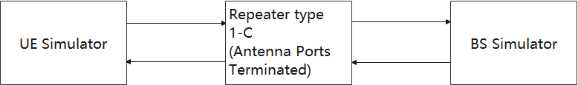

Figure 9.1-1: Communication link set up for *RF repeater type 1-C* immunity measurement

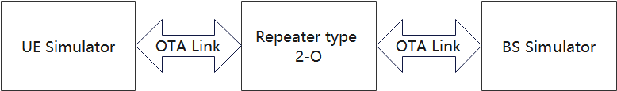

Figure 9.1-2: Communication link set up for *RF* *repeater type 2-O* immunity measurement

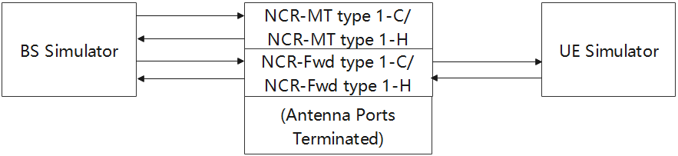

Figure 9.1-3: Communication link set up for *NCR type 1-C/NCR type 1-H* immunity measurement

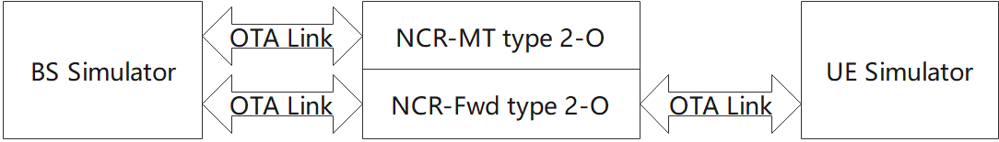

Figure 9.1-4: Communication link set up for *NCR type 2-O* immunity measurement

<Next Change>

### 9.2.2 Test method and level

The test method shall be in accordance with IEC 61000‑4‑3 [13], which specified test methodology based on anechoic chamber. The use of reverberation chamber test method according to IEC 61000-4-21 [18], clause 6.1 and Annex D as alternative method is allowed.

The following requirements shall apply:

- The test level shall be 3 V/m amplitude modulated to a depth of 80 % by a sinusoidal audio signal of 1 kHz;

- The stepped frequency increments shall be 1 % of the momentary frequency;

- The test shall be performed over the frequency range 80 MHz - 6000 MHz; with the exception of the exclusion band for receivers (see clause 4.4.2);

- Responses in stand-alone receivers or receivers which are part of transceivers occurring at discrete frequencies which are narrow band responses, shall be disregarded, see clause 4.3;

- The frequencies selected during the test shall be recorded in the test report.

- For the test method in accordance with IEC 61000-4-3 [13], for RF repeater or NCR operating in FR2-1 the *spatial exclusion zone* can be chosen to protect the RF repeater’s and NCR’s receiver. For the frequency arrange above 690 MHz (according to the test method in ETSI EN 301 489-50 [22) the EMC RF electromagnetic field immunity requirement applies on the non-radiating faces of the RF *repeater type 2-O* or *NCR type 2-O,* as depicted on figure 9.2.2-1.

NOTE: Depending on the BS implementation, application of the spatial exclusion to all radiating faces of the RF repeater or NCR may not allow proper execution of the RI testing. In such cases, to protect the RF *repeater type 2-O* or *NCR type 2-O* receiver(s), exclusion bands shall be considered, as in table 4.4.2-2.

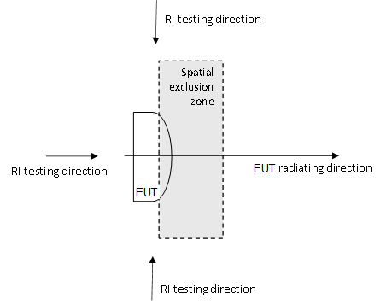

Figure 9.2.2-1: EMC RF electromagnetic field immunity requirement testing directions for RF *repeater type 2-O* or *NCR type 2-O* (horizontal plane depicted) with the *spatial exclusion zone* applied

### 9.2.3 Performance criteria

**RF repeater or NCR:**

The performance criteria of clause 6.1 shall apply for RF repeater.

The performance criteria of clause 6.1 shall apply for NCR-Fwd and clause 6.1.1 shall apply for NCR-MT.

**Ancillary equipment:**

The performance criteria of clause 6.3 shall apply.

<Next Change>

### 9.3.3 Performance criteria

**RF repeater or NCR:**

The performance criteria of clause 6.2 shall apply for RF repeater.

The performance criteria of clauses 6.2 shall apply for NCR-Fwd and clause 6.2.1 shall apply for NCR-MT.

**Ancillary equipment:**

The performance criteria of clause 6.4 shall apply.

<Next Change>

### 9.4.3 Performance criteria

**RF repeater or NCR:**

The performance criteria of clause 6.2 shall apply for RF repeater.

The performance criteria of clauses 6.2 shall apply for NCR-Fwd and clause 6.2.1 shall apply for NCR-MT.

**Ancillary equipment:**

The performance criteria of clause 6.4 shall apply.

<Next Change>

### 9.5.3 Performance criteria

**RF repeater or NCR:**

The performance criteria of clause 6.1 shall apply for RF repeater.

The performance criteria of clauses 6.1 shall apply for NCR-Fwd and clause 6.1.1 shall apply for NCR-MT.

**Ancillary equipment:**

The performance criteria of clause 6.3 shall apply.

<Next Change>

### 9.6.3 Performance criteria

For a 0 % residual voltage dip test, the performance criteria for transient phenomena shall be applied:

- Criteria 6.2 for RF repeater

- Criteria 6.2 for NCR-Fwd

- Criteria 6.2.1 for NCR-MT

- Criteria 6.4 for *ancillary equipment*

For a 70% residual voltage dip test and for voltage interruption test, the following applies:

1. In the case where the equipment is fitted with or connected to a battery back-up, the following performance criteria shall be applied:

- Criteria 6.2 for RF repeater

- Criteria 6.2 for NCR-Fwd

- Criteria 6.2.1 for NCR-MT

- Criteria 6.4 for *ancillary equipment*

2. In the case where the equipment is powered solely from the AC mains supply (without the use of a parallel battery back-up) volatile user data may have been lost and if applicable the communication link need not to be maintained and lost functions should be recoverable by user or operator:

- No unintentional responses shall occur at the end of the test

- In the event of loss of communications link or in the event of loss of user data, this fact shall be recorded in the test report.

<Next Change>

### 9.7.3 Performance criteria

**RF repeater or NCR:**

The performance criteria of clause 6.2 shall apply for RF repeater.

The performance criteria of clauses 6.2 shall apply for NCR-Fwd and clause 6.2.1 shall apply for NCR-MT.

**Ancillary equipment:**

The performance criteria of clause 6.4 shall apply.

<End of Change>