**3GPP TSG-RAN WG4 Meeting # 113 *R4-2417817***

**Orlando, US, Nov.18 - Nov.22, 2024**

|  |  |  |  |  |  |  |  |  |
| --- | --- | --- | --- | --- | --- | --- | --- | --- |
| *CR-Form-v12.3* | | | | | | | | |
| **CHANGE REQUEST** | | | | | | | | |
|  | | | | | | | | |
|  | **38.108** | **CR** | **0093** | **rev** | **1** | **Current version:** | **17.9.0** |  |
|  | | | | | | | | |
| *For* ***HE******LP*** *on using this form: comprehensive instructions can be found at  http://www.3gpp.org/Change-Requests.* | | | | | | | | |
|  | | | | | | | | |

|  |  |  |  |  |  |  |  |  |
| --- | --- | --- | --- | --- | --- | --- | --- | --- |
| ***Proposed change affects:*** | UICC apps |  | ME |  | Radio Access Network | **X** | Core Network |  |

|  |  |  |  |  |  |  |  |  |  |  |
| --- | --- | --- | --- | --- | --- | --- | --- | --- | --- | --- |
|  | | | | | | | | | | |
| ***Title:*** | CR for TS 38.108, Correction on NTN SAN requirement reference points | | | | | | | | | |
|  |  | | | | | | | | | |
| ***Source to WG:*** | CATT | | | | | | | | | |
| ***Source to TSG:*** | R4 | | | | | | | | | |
|  |  | | | | | | | | | |
| ***Work item code:*** | NR_NTN_solution-Core | | | | |  | ***Date:*** | | | 2024-11-08 |
|  |  | | | |  | |  | | |  |
| ***Category:*** | **F** |  | | | | | ***Release:*** | | | Rel-17 |
|  | *Use one of the following categories:* ***F*** *(correction)* ***A*** *(mirror corresponding to a change in an earlier release)* ***B*** *(addition of feature),* ***C*** *(functional modification of feature)* ***D*** *(editorial modification)*  Detailed explanations of the above categories can be found in 3GPP TR 21.900. | | | | | | | | *Use one of the following releases: Rel-8 (Release 8) Rel-9 (Release 9) Rel-10 (Release 10) Rel-11 (Release 11) … Rel-17 (Release 17) Rel-18 (Release 18) Rel-19 (Release 19)  Rel-20 (Release 20)* | |
|  |  | | | | | | | | | |
| ***Reason for change:*** | | To correct the diagram of NTN SAN requirement reference points. | | | | | | | | |
|  | |  | | | | | | | | |
| ***Summary of change:*** | | To modify the connecting line between satellite gateway and satellite payload in NTN SAN requirement reference points. | | | | | | | | |
|  | |  | | | | | | | | |
| ***Consequences if not approved:*** | | The diagram of NTN SAN requirement reference points would be ambiguous. | | | | | | | | |
|  | |  | | | | | | | | |
| ***Clauses affected:*** | | 4.3 | | | | | | | | |
|  | |  | | | | | | | | |
|  | | **Y** | **N** |  | | | |  | | |
| ***Other specs*** | |  | **X** | Other core specifications | | | | TS/TR ... CR ... | | |
| ***affected:*** | | **X** |  | Test specifications | | | | TS 38.181 | | |
| ***(show related CRs)*** | |  | **X** | O&M Specifications | | | | TS/TR ... CR ... | | |
|  | |  | | | | | | | | |
| ***Other comments:*** | |  | | | | | | | | |
|  | |  | | | | | | | | |
| ***This CR's revision history:*** | | Revised from R4-2417817 | | | | | | | | |

<Start of Change>

## 4.3 Requirement reference points

### 4.3.1 SAN type 1-H

For *SAN type 1-H*, the requirements are defined for two points of reference, signified by radiated requirements and conducted requirements.

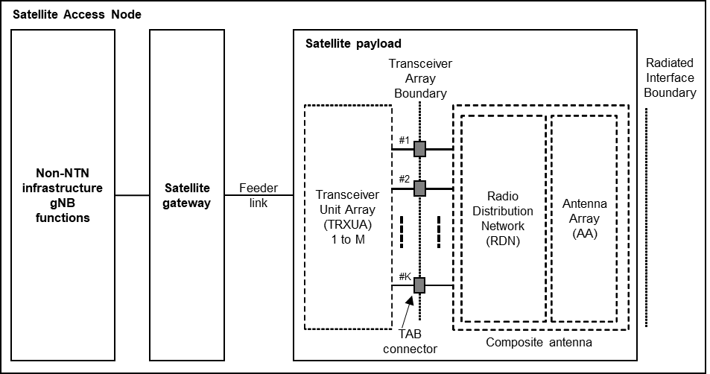

Figure 4.3.1-1: Radiated and conducted reference points for *SAN type 1-H*

Radiated characteristics are defined over the air (OTA), where the radiated interface is referred to as the *Radiated Interface Boundary* (RIB). Radiated requirements are also referred to as OTA requirements. The (spatial) characteristics in which the OTA requirements apply are detailed for each requirement.

Conducted characteristics are defined at individual or groups of *TAB connectors* at the *transceiver array boundary*, which is the conducted interface between the transceiver unit array and the composite antenna.

The transceiver unit array is part of the composite transceiver functionality receiving and transmitting modulated signal to ensure radio links with users.

The satellite payload is composed by a transceiver unit array and a composite antenna array. The transceiver unit array contains an implementation specific number of transmitter units and an implementation specific number of receiver units.

The composite antenna contains a radio distribution network (RDN) and an antenna array. The RDN is a linear passive network which distributes the RF power generated by the transceiver unit array to the antenna array, and/or distributes the radio signals collected by the antenna array to the transceiver unit array, in an implementation specific way.

How a conducted requirement is applied to the *transceiver array boundary* is detailed in the respective requirement clause.

### 4.3.2 SAN type 1-O

For *SAN type 1-O*, the radiated characteristics are defined over the air (OTA), where the *operating band* specific radiated interface is referred to as the *Radiated Interface Boundary* (RIB). Radiated requirements are also referred to as OTA requirements. The (spatial) characteristics in which the OTA requirements apply are detailed for each requirement.

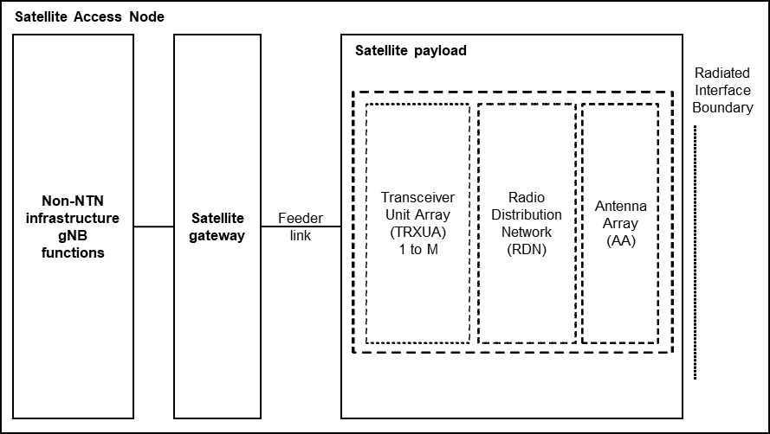

Figure 4.3.2-1: Radiated reference points for *SAN type 1-O*

<End of Change>