**3GPP TSG-RAN WG4 Meeting # 113 R4-240xxxx**

**Orlando, US, 18 – 22 November, 2024**

**Agenda item:** 4.1.2

**Source:** Moderator (Huawei, HiSilicon)

**Title:** Topic summary for [113][202] Maintenance_R17

**Document for:** Information

# Introduction

This document provides summary for RRM related Tdocs submitted to the following AI

*4.5.2 Rel-17 maintenance [WI code]*

Please kindly take following notes for Tdoc handling in this topic thread.

1. Open issues are based on Discussion papers.
2. Based on Chair’s guidance, all CRs in this email thread will be first handled in NWM flagging procedure which will be triggered separately.
3. Tdocs that are withdrawn or revised in the Tdocs list will not be handled in the summary document or the NWM flagging procedure.
4. Cat-A CRs will not be handled in the summary document or the NWM flagging procedure.

Recommended issues for online discussion:

Sub-topic 1-2: Applicability of tci-ActivatedConfig

Sub-topic 1-3: SCG activation delay

Sub-topic 1-4: UE monitoring behavior at PSCell activation

Sub-topic 2-1: Low SNR in 1Rx RedCap test-cases

Sub-topic 1-1: Interruption requirements for RLF/BFD for deactivated SCG

# Topic #1: LTE_NR_DC_enh2

## Companies’ contributions summary

|  |  |  |
| --- | --- | --- |
| **T-doc number** | **Company** | **Proposals / Observations** |
| [**R4-2419436**](https://www.3gpp.org/ftp/TSG_RAN/WG4_Radio/TSGR4_113/Docs/R4-2419436.zip) | Ericsson | Proposal 1: RAN4 update the TS36.133 interruption requirement based on the 0.5% for interruption caused by RLM/BFD measurement. |
| [**R4-2418378**](https://www.3gpp.org/ftp/TSG_RAN/WG4_Radio/TSGR4_113/Docs/R4-2418378.zip) | Nokia | 1. Update the RAN4 UE requirements capturing the UE requirements when tci-ActivatedConfig is configured for a deactivated SCell and a direct activated SCell.   However, if proposal 1 is not agreeable we suggest clarifying the issue with RAN2   1. Send LS to RAN2 clarifying the RAN2 understanding of the tci-ActivatedConfig IE, if proposal 1 is not agreeable. |
| [**R4-2418381**](https://www.3gpp.org/ftp/TSG_RAN/WG4_Radio/TSGR4_113/Docs/R4-2418381.zip) | Nokia | 1. When ‘*bdf-and-RLM*’ with value ‘*true*’ is configured for the deactivated PSCell the UE shall perform BFD and RLM on the deactivated PSCell. 2. Evaluation of RLM and BFD on a deactivated PSCell requires the UE to measure the deactivated PSCell regularly to evaluate the downlink radio link quality. 3. If no link problems have been detected, the link is currently regarded good enough for continuing the operation in a cell. 4. When UE is configured with *bfd-and-RLM* on the deactivated PSCell, and the UE no link problems (beam failure or RLF) have been detected on the deactivated PSCell, link is regarded good enough for continuing operation. 5. When UE is configured with *bfd-and-RLM = true* and UE has not detected link problems, there is no need for prolonged measurements at PSCell activation.   Proposal 1: In general, a UE which has not detected neither BFD nor RLF on the deactivated PSCell while deactivated, the search time needed at PSCell activation is greatly reduced (Tsearch << 24 Trsms).  Proposal 2: A UE which has detected either BFD or RLF on the deactivated PSCell would need some search time at PSCell activation.  Proposal 3: For RACH based PSCell activation for unknown PSCell, RAN4 to agree on conditions for reduced Tsearch at PSCell activation, when the UE is configured with bfd-and-RLM=true.  Proposal 4: The condition for when Tsearch for PSCell activation of an unknown PSCell, can be reduced from 24*Trs, is when no RLM has occurred.  Proposal 5: For RACH based PSCell activation, if the FR1 or FR2 PSCell is known, Tsearch = 0 ms. If the PSCell is an unknown FR1 or FR2 PSCell, configured with bfd-and-RLM with value true, provided no RLM has occurred, if Es/Iot ≥ -2 dB then for FR2 Tsearch = [8]* Trs ms. Otherwise, if the FR2 PSCell is unknown and Es/Iot ≥ -2 dB, then Tsearch = 24* Trs ms.   1. UE PDCCH monitoring requirement in the newly activated PSCell is ambiguous.   Proposal 6: UE shall start monitoring PDCCH on the activated PSCell immediately after the SCG activation delay.  Proposal 7: Send LS to RAN2 clarifying PDCCH monitoring assumption with RAN2. |

## Open issues summary

### Sub-topic 1-1: Interruption requirements for RLF/BFD for deactivated SCG

* Proposals
  + Option 1 (E///):
    - RAN4 update the TS36.133 interruption requirement based on the 0.5% for interruption caused by RLM/BFD measurement.

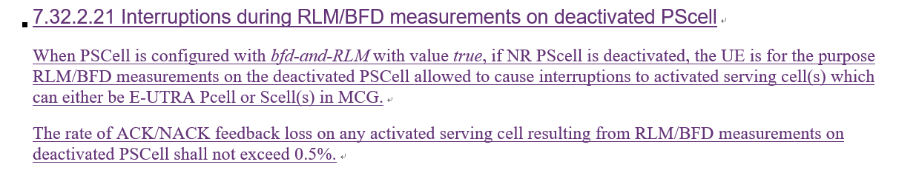

* Recommended WF
  + Discuss the option

### Sub-topic 1-2: Applicability of tci-ActivatedConfig

* Proposals
  + Option 1 (Nokia):
    - Update the RAN4 UE requirements capturing the UE requirements when tci-ActivatedConfig is configured for a deactivated SCell and a direct activated SCell.
    - If proposal 1 is not agreeable, send LS to RAN2 clarifying the RAN2 understanding of the tci-ActivatedConfig IE, if proposal 1 is not agreeable.

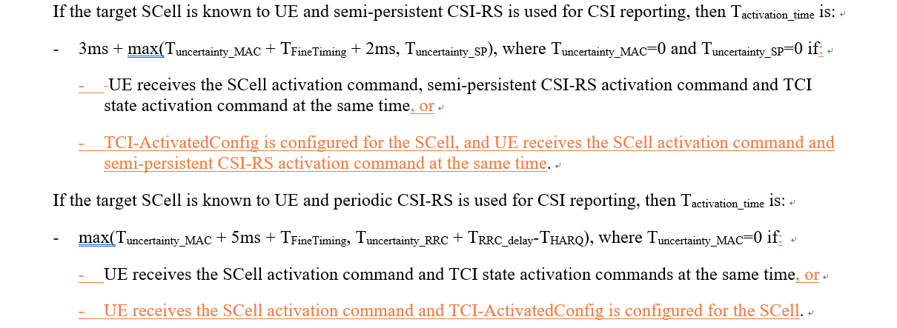

* Recommended WF
  + Discuss the option
  + It is noted that in RAN4#112 the following is agreed in R4-2413867

|  |
| --- |
| Agreement:  Update the RAN4 UE requirements capturing that tci-ActivatedConfig can be considered as a condition to have Tuncertainty_MAC = 0 for SCell activation, including normal MAC CE based and direct SCell activation. |

### Sub-topic 1-3: SCG activation delay

* Proposals
  + Option 1 (Nokia):
    - For RACH based PSCell activation for unknown PSCell, RAN4 to agree on conditions for reduced Tsearch at PSCell activation, when the UE is configured with bfd-and-RLM=true.
    - The condition for when Tsearch for PSCell activation of an unknown PSCell, can be reduced from 24*Trs, is when no RLM has occurred.
    - For RACH based PSCell activation, if the FR1 or FR2 PSCell is known, Tsearch = 0 ms. If the PSCell is an unknown FR1 or FR2 PSCell, configured with bfd-and-RLM with value true, provided no RLM has occurred, if Es/Iot ≥ -2 dB then for FR2 Tsearch = [8]* Trs ms. Otherwise, if the FR2 PSCell is unknown and Es/Iot ≥ -2 dB, then Tsearch = 24* Trs ms.

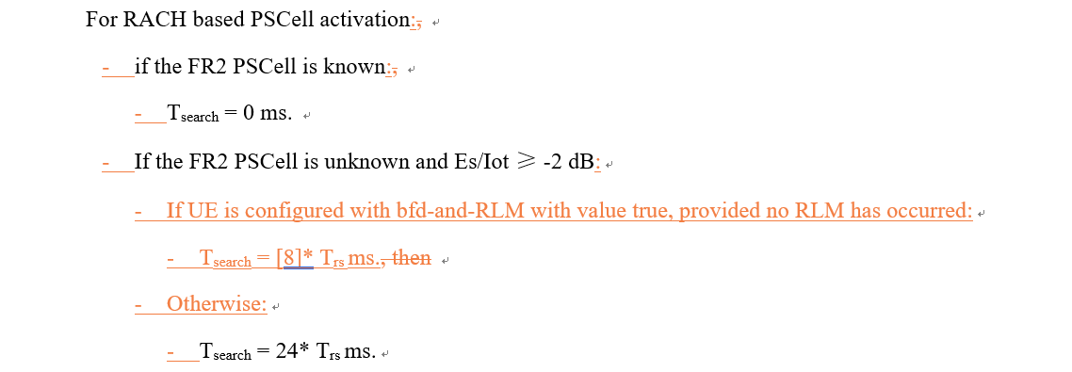

* Recommended WF
  + Discuss the option

### Sub-topic 1-4: UE monitoring behavior at PSCell activation

* Proposals
  + Option 1 (Nokia):
    - UE shall start monitoring PDCCH on the activated PSCell immediately after the SCG activation delay.
    - Send LS to RAN2 clarifying PDCCH monitoring assumption with RAN2.

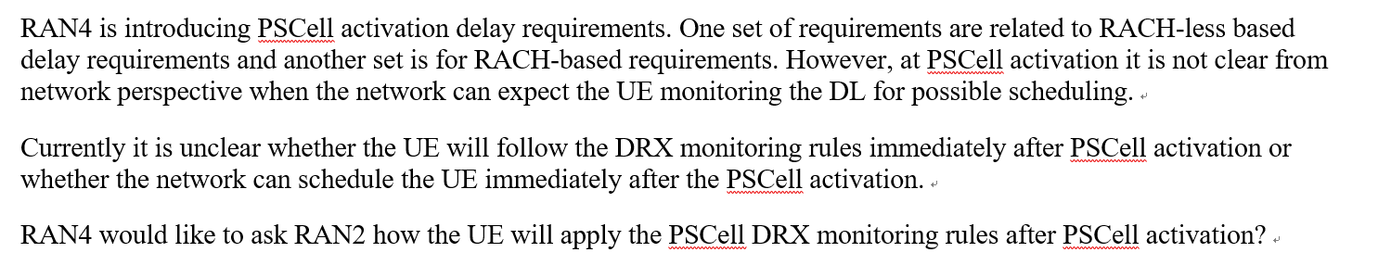

* Recommended WF
  + Discuss the option

# Topic #2: NR_redcap-Perf

## Companies’ contributions summary

|  |  |  |
| --- | --- | --- |
| **T-doc number** | **Company** | **Proposals / Observations** |
| [**R4-2418087**](https://www.3gpp.org/ftp/TSG_RAN/WG4_Radio/TSGR4_113/Docs/R4-2418087.zip) | Qualcomm Incorporated | **Observation 1: RAN4 specifies the same SNR and same MCS for both 1Rx and 2Rx UEs in RRM test-cases.**  **Observation 2: UE cannot decode MCS4 at very low SNR in SS-SINR and SS-RSRQ measurement accuracy test-cases for 1Rx RedCap UEs and may declare RLF.**  **Observation 3: The purpose of these test is not to test UEs demod performance.**  **Proposal 1: RAN4 to discuss the solutions to address UE encountering RLF during the SS-SINR and SS-RSRQ measurement accuracy test-cases for 1Rx RedCap UEs. Two potential solutions are:**   * **Use a lower MCS (e.g., MCS0) in the test-cases** * **Use a higher SNR (e.g., 3db higher) in the test-cases** |

## Open issues summary

### Sub-topic 2-1: Low SNR in 1Rx RedCap test-cases

* Proposals
  + Option 1 (QC):
    - RAN4 to discuss the solutions to address UE encountering RLF during the SS-SINR and SS-RSRQ measurement accuracy test-cases for 1Rx RedCap UEs. Two potential solutions are:
      * Use a lower MCS (e.g., MCS0) in the test-cases
      * Use a higher SNR (e.g., 3db higher) in the test-cases
* Recommended WF
  + Discuss the option