**3GPP TSG-RAN WG4 Meeting #113 R4-2420384**

**Orlando, US, 18-22 Nov, 2024**

**Title:** WF on requirements for less than 5MHz

**Agenda Item:** 5.8.1

**Source:** Huawei

**Document for:** Approval

# 1. Clarification of transmission bandwidth configuration on TS 38.101-1 Table 5.4.3.1-3

In the case of SSREF= 920.73MHz or 921.45 MHz, the following is the expected behavior:

|  |  |  |  |
| --- | --- | --- | --- |
| SS Block frequency position SSREF  (MHz) | PBCH PRB size | transmission bandwidth  PRB size | Maximum transmission bandwidth NRB (RRC IE *carrierBandwidth*) |
| 920.73 | 12 | 12 | 15 |
| 921.45 | 20 | 20 | 25 |

**Agreement:**

During the online session, it was discussed to enhance the wording of the Note on TS 38.101-1 Table 5.4.3.1-3.

TS 38.101-1 Table 5.4.3.1-3: Additional GSCN parameters for band n100

|  |  |  |
| --- | --- | --- |
| SS Block frequency position SSREF  (MHz) | GSCN | Note |
| 920.73 | 41637 | Only applicable for 12 PRB transmission bandwidth configuration when NRB= 15 PRB with punctured PBCH defined in TS 38.211 [6] clause 7.4.3.1. |
| 921.45 | 41638 | Only applicable for 20 PRB transmission bandwidth configuration when NRB= 25 PRB with unpunctured PBCH defined in TS 38.211 [6] clause 7.4.3.1. |

# Clarification of the definition of IE *carrierBandwidth*

In TS 38.101-1 section 5.3.4 the carrierBandwidth is mentioned as following.

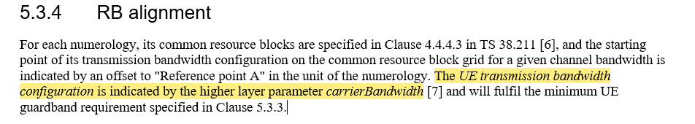

**Agreement:**

As the IE *carrierBandwidth corresponds to the maximum transmission bandwidth the text needs to be updated as*

|  |
| --- |
| 5.3.4 RB alignment For each numerology, its common resource blocks are specified in Clause 4.4.4.3 in TS 38.211 [6], and the starting point of its transmission bandwidth configuration on the common resource block grid for a given channel bandwidth is indicated by an offset to "Reference point A" in the unit of the numerology. The *UE maximum transmission bandwidth configuration* is indicated by the higher layer parameter *carrierBandwidth* [7] and will fulfil the minimum UE guardband requirement specified in Clause 5.3.3. |