3GPP RAN WG4 Meeting #113 R4-2420389

Orlando, USA, 18th – 22nd November 2024 (revision of R4-2417743)

Agenda item: 7.2.4.2

Source: Apple, MediaTek, Samsung

Title: TP on UE RF design options for the 14800-15350MHz frequency range

WI/SI: FS_NR_IMT_4400_7125_14800MHz

Release: Rel-19

Document for: Discussion

# 1 Introduction

The WRC-23 conference identified three frequency ranges as potential IMT candidates and tasked ITU-R WP5D to conduct the corresponding sharing and compatibility studies. In turn, the ITU-R WP5D sent the LS to a number of bodies, including 3GPP, asking to provide technical parameters for the candidate frequencies [1]. In response to that LS from WP5D and based on the technical input from RAN WG4 [2], the 3GPP RAN#103 meeting approved a new SI [3], purpose of which will be to study and provide the corresponding IMT technical parameters.

During the RAN4#111 meeting an initial discussion took place and RAN WG4 concluded that for this frequency range both FR1- and FR2-like approaches for the UE RF architecture will be studied further. Next, RAN4#112bis decided that FR1 omnidirectional UE RF design would be taken as a baseline for the co-existence studies, which however does not preclude more advanced RF options. Thus, this document presents a text proposal to capture a potential UE RF design options for the 15GHz frequency range (based on the technical content from contributions R4-2417743, R4-2419399 and R4-2419417).

# 2 Text proposal

-------------------------------------------- TP BEGIN --------------------------------------------

# 6 14800 - 15350 MHz frequency range

## 6.5 Antenna characteristics

### 6.5.1 BS antenna characteristics

#### 6.5.1.1 Antenna model

#### 6.5.1.2 Antenna parameters

### 6.5.2 UE antenna characteristics

#### 6.5.2.x FR1-like design with patch antennas

The FR1-like approach with patch antennas gives more flexibility to the OEM vendors because even if a device implements more than one Tx, there is an additional flexibility on where Tx antennas can be placed. Furthermore, more than one Tx antenna can attain coherent EIRP gain through the corresponding placement of co-directional and co-located antennas when coherent Tx is implemented. Each antenna in an FR1-like system is linked to its own digital chain, allowing for easy support of coherent Tx. It can also reduce the PA power requirement for each antenna element, thus enhancing the overall power consumption of the UE at 15GHz, and it can help increase the coverage distance between the base station and the UE, which is especially important for co-located FR1 and 15GHz base stations. For instance, 6.5.2.x-1 presents a general mobile device form factor with two patch antennas placed within the device as presented at the distance corresponding to approximately three wavelengths.

Figure 6.5.2.x-1: Exemplary placement of two patch antennas within a mobile device.

Each patch antenna gain is around 2dB with the Tx power 23dBm. So, Figure 6.5.2.x-2 below presents separately distribution of antenna and EIRP gains for the considered antennas, where the baseline curve is only one antenna. Gain values are obtained by probing all points in 3D space around considered antennas, which allows us to find the best beam at each point of space independent of the base station location. In other words, these figures illustrate all possible gain values, including the best one, regardless of the phone orientation with respect to the base station. As can be seen, from the antenna gain perspective, the average gain comparing to one Tx is around 2.5dB. From the EIRP perspective, the average gain comparing to one Tx is around 5.5dB, which comprises 2.5dB antenna gain and 3dB coming from the fact that there are two Tx antennas each transmitting at 23dBm.

Figure 6.5.2.x-2: Antenna and EIRP gain for the considered two Tx antennas.Another aspect for the FR1-like antenna design is the resulting radiation pattern. It is worth noting that unlike at the antenna and EIRP gain, which are not very sensitive for the actual placement of Tx antennas, the radiation pattern may vary a lot. For instance, Figure 6.5.2.x-3 below presents the resulting beam pattern from two Tx antennas physical location of which is the same as in Figure 6.5.2.x-1. For the sake of better clarity, we present the resulting radiation pattern in 2D and 3D spaces. Since two Tx antennas are placed at the back side of the phone, the resulting radiation pattern has a big negative gain in the opposite direction.

Figure 6.5.2.x-3: Radiation pattern for two Tx antennas presented in Figure 6.5.2.x-2.

On the Rx side, more than one FR1-like antenna with digital beamforming can maximize the received signal power to improve the cell edge performance. And when UE is at the cell center, instead of maximizing the received signal power all antennas can be used jointly to achieve spatial multiplexing gain.

6.5.2.x FR1-like design with metal frame antennas

As the FR1-like antenna widely used as the current design for handheld devices, a simulation with two general metal frame Tx antennas was conducted to estimate the antenna gain and performance for cases of single-Tx and multi-Tx without beam steering assumptions. The antenna placement for the evaluation is captured in 6.5.2.x-1.

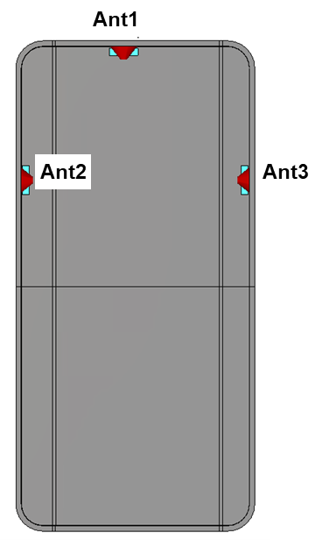

Figure 6.5.2.x-1: Exemplary placement of metal frame antennas within a mobile device.

With the assumption above, simulation results of the antenna performance are summarized in Figure 6.5.2.x-2 and Table 6.5.2.x-1, which also capture radiation efficiency and directivity in terms of peak antenna gains of each scenario.

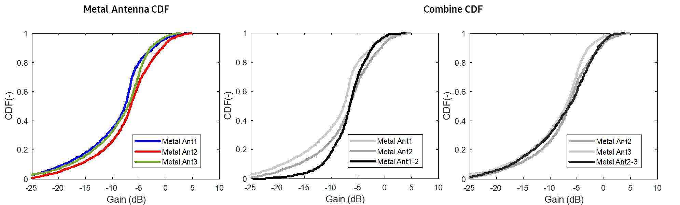

Figure 6.5.2.x-2: CDF of peak antenna gains for metal antennas

Table 6.5.2.x-1: Peak antenna gains for one-Tx and two-Tx

|  |  |  |  |
| --- | --- | --- | --- |
|  | Ant1 | Ant2 | Ant3 |
| Gain (dB) | 3.9 | 4.8 | 2.7 |
| Rad. Efficiency (dB) | -6.3 | -4.8 | -6.3 |
| Directivity (dB) | 10.2 | 9.6 | 9.0 |
|  | Ant1 + Ant2 | Ant1 + Ant 3 | Ant2 + Ant3 |
| Combined gain (dB) | 3.8 | 2.6 | 3.9 |
| Gain drop (dB) | -1.0 | -1.3 | -0.9 |

As seen from Figure 6.5.2.x-2 and Table 6.5.2.x-1, in terms of the peak antenna gain with metal frame antennas, it is shown that the single-Tx antenna gain can reach up to 4.8 dB with its directivity and efficiency characteristics at the frequency range around 15 GHz. However, for the case of two-Tx, it is shown that the peak gain of combined two Tx antennas does not show better performance, but rather drops compared to the single-Tx case for the antenna placement in Figure 6.5.2.x-1. This would be coming from two different radiation patterns as depicted in Figure 6.5.2.x-3.

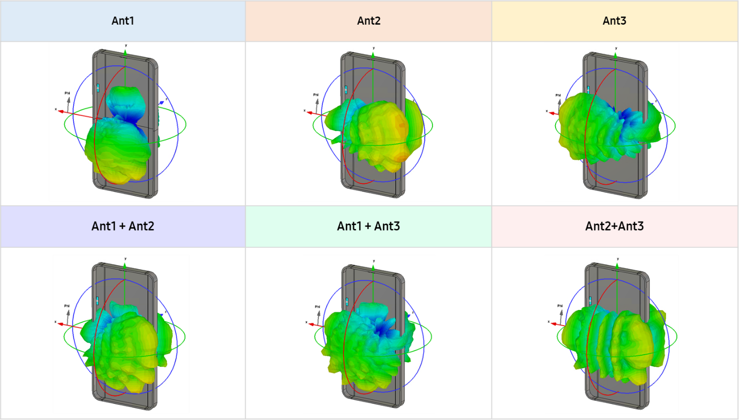

Figure 6.5.2.x-3: Simulated radiation patterns for one-Tx and two-Tx cases

The radiation pattern of antennas in a practical device has different peak direction compared with the boresight direction since the UE ground has much longer electric strength at this frequency range as shown in Figure 6.5.2.x-3. For example, Ant2 would form its peak direction toward Ant3, and similarly, Ant1 has the peak gain at the opposite direction toward the bottom side of UE at this case. On the other hand, if two Tx antennas are adjacent with the same orientation, it may have increased peak antenna gain thanks to the same radiation pattern between two Tx antennas although it would face a different issue such as antenna isolation to keep the fundamental performance.

In this regard, for FR1-like design with metal frame antennas, similar to the conclusion of FR1-like patch antenna case, it should be noted that multi-Tx antennas may not help improving peak gain performance unless their placements are not designed carefully in terms of both radiation patterns and isolation.

-------------------------------------------- TP END --------------------------------------------

# 3 References

1. RP-240024, "LS on Parameters of terrestrial component of IMT for sharing and compatibility studies in the frequency bands 4400-4800 MHz, 7125-8400 MHz and 14.8-15.35 GHz", ITU-R WP5D
2. R4-2102840, "LS on Parameters of terrestrial component of IMT for sharing and compatibility studies in preparation for WRC-23 (6.425 to 10.5 GHz)", RAN WG4.
3. RP-240765, "Study on IMT parameters for 4400 to 4800 MHz, 7125 to 8400 MHz and 14800 to 15350 MHz"
4. 3GPP TR 38.921, "Study on International Mobile Telecommunications (IMT) parameters for 6.425-7.025GHz, 7.025-7.125GHz and 10.0-10.5 GHz", v17.1.0