3GPP TSG-WG4 Meeting #113 R4-2420377

Orlando, USA, November 18 – 22, 2024
Title: WF on Power domain enhancement
Agenda Item: 7.1.3
Source: Huawei, HiSilicon
Document for: Approval

Topic #1: Power domain enhancements for single carrier

Sub-topic 1-1: Approaches to enable MPR reduction for both scenario 1 and scenario2
Scenarios discussed previous RAN4 meetings:
- Scenario 1-1: Scenario with no adjacent in-band/out-of-band co-existence issue (single operator)
- Scenario 1-2: Scenario with no adjacent in-band/out-of-band co-existence issue (adjacent operators)
- Scenario 2: Narrower UE channel BW within wider BS bandwidth

Issue 1-1-1: Approaches of converting outer RB allocation to inner RB allocation
Agreement in main session:
- Extended CBW based approach
  - where the extended CBW or aggregated CBWs for the DL-only contiguous intra-band CA case is signalled from network to UE
  - Both scenario 1 and 2 should be covered
  - The network should ensure the co-existence be met when signaling the extended CBW.

Issue 1-1-2: Approaches of calculating the new inner RB region
- Options
  - Option 1: The NW signals the extended number of RBs and RB shift towards the UE configured CBW or RRC signalling to indicate the extended RB number at each side of the UE CBW for the UE to calculate the new inner, outer, and edge regions
    - The extended number of RBs may not necessarily be the same as those in the BS CBWs
    - The intersection of the Inner region relative to the extended UE CBW and the Outer region relative to the configured UE CBW is where the inner MPR can be expected from UE
  - Option 2: Based on the fixed extension ratio, it is up to the NW to judge the gap width on both sides of the UE and grant the permission to UE using the reduced MPR for the new inner region
    - The extension ratio on both sides, 0.5* UE CBW should be stipulated in the spec
    - The intersection of the Inner region relative to the extended UE CBW and the Outer region relative to the configured UE CBW is where the inner MPR can be expected from UE
  - Option 3: For a UE supporting [capability] and configured with a UE channel bandwidth within a carrier with a bandwidth greater than the transmission bandwidth configuration of this UE channel bandwidth, N_{RB} = N´_{RB} is the said carrier bandwidth as indicated by carrierBandwidth in [SIB1] and the condition for an inner RB allocation is modified accordingly
    - The intersection of the Inner region relative to the NW CBWs and the Outer region relative to the configured UE CBW is where the inner MPR can be expected from UE

Examples of new inner region just for illustration purpose:
Example 1: single CC scenario | Example 2: multi-CC scenario
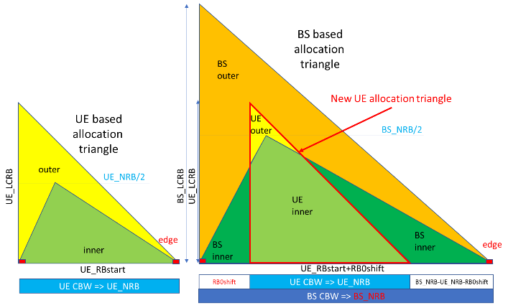 | 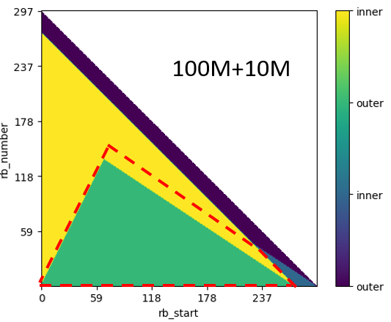  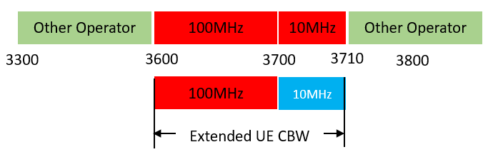
- Recommended WF
  - The intersection of the Inner region relative to the extended UE CBW and the Outer region relative to the configured UE CBW is where the inner MPR can be expected from UE
    - NW CBWs could be considered as special case of extended UE CBW
  - Discuss the way how UE get the extended RB number as well as the RB shift
    - FFS how to reflect the new inner region in the spec

Issue 1-1-3: Width/RB numbers of extended CBW at each side of UE CBW
- Options
  - Option 1: The extended RBs on each side should be equal to N_{RB}/2, where N_{RB} is the maximum transmission bandwidth configuration of the original UE CBW
  - Option 2: The extended RB number for each side can be different and the value could vary from zero to the one specified in Table 5.3.2-1 in TS 38.101-1, but it is no need to exceed the one corresponding to 50MHz, which is the half of the maximum UE CBW 100MHz.
  - Option 3: Width of Extended UE channel bandwidth can be up to BS channel bandwidth but no more or it can be narrower than BS CBW
  - Other options are not precluded

- Recommended WF
  - Discuss the following aspects and make decision
    - whether extended RB number on each side of UE CBW is fixed or could be different
      - Fixed: N_{RB}/2 on each side of UE CBW, N_{RB} is max transmission configuration for UE CBW
      - Different: up to N_{RB}/2 on each side of UE CBW, depends on the adjacent spectrum by operator in all possible scenarios
      - whether extended RB number should be limited to max 50MHz at each side, which means the extended CBW is relevant to the configured UE CBW

Sub-topic 1-2: Applicable requirements

Issue 1-2-1: Where to use extended IBE in the larger BS CBW
- Proposals
  - Proposal 1: IBE should be used between edges of UE CBW and extended UE CBW. (vivo, ZTE, Huawei, Qualcomm, China Telecom, Skyworks)
    - Alt 1: extension of the IBE is NOT used in the guard band of UE CBW.
    - Alt 2: extension of the IBE is also used in the guard band of UE CBW.
    - Alt 3: extension of the IBE applies in the guard band of the UE CBW but not in the guard band of the extended UE CBW
- Recommended WF
  - Proposal 1 is agreeable, further discuss the alternatives

Issue 1-2-2: How to derive the extended IBE
- Proposals
  - Proposal 1: (vivo)
    - For IBE of both original CBW and extended CBW, NRB should be based on the original UE CBW, ΔRB should also be limited within the original UE CBW. (vivo, ZTE, Huawei)
    - The IBE requirement of the extension portion should be equal to that of the last non-allocated RB in the original UE CBW. (vivo, ZTE, Huawei)
    - For UE CBW with full RB allocation, the IBE of the extended part could be simplified to:
$$IBE_general = max⁡(\overline{P_{RB}} - 30 dB,$$
$$max⁡\{-25, 20*\log_{10}EVM -3 +\frac{5}{L_{CRB}},$$
$$-57dBm + 10log10(SCS/15kHz)- \overline{P_{RB}}\})$$
  - Proposal 2: (ZTE)
    - Use the IBE limit of -25 dB between edges of UE CBW and extended UE CBW for full RB allocation scenario
  - Proposal 3: (Huawei)
    - For the full RB allocation case, the RB index that used for IBE value derivation applies to all the extended RBs is set to +1(-1). The equation for IBE derivation is:
$$\max\left\{-25, 10\log_{10}EVM-3, -57dBm+10\log_{10}\left(\frac{SCS}{15kHz}\right)-\overline{P_{RB}}\right\}$$
  - Proposal 4: (China Telecom)
    - For full RB allocation, if the extended UE CBW exists, the IBE should be applied.
  - Proposal 5: (Qualcomm)
    - The IBE between the edge of the UE BW and the edge of the extended UE BW should be an extension of the IBE for the signal within the UE BW.
- Recommended WF
  - Check whether proposal 1 is agreeable, which covers the cases on how to derive the extended IBE for both partial RB allocation and full RB allocation in the UE CBW

Issue 1-2-3: Boundary to apply ACLR and SEM
- Proposals
  - Proposal 1: ACLR and SEM should be applicable from the edge of extended UE CBW. (Nokia, Qualcomm, vivo, ZTE, LGE, OPPO, Huawei, China Telecom)
    - Alt 1: The OOBE requirements are based on UE CBW
    - Alt 2: The OOBE requirements are based on extended UE CBW
Alt 1
Alt 2

- Recommended WF
  - Proposal 1 is agreeable, further check which alternative is adopted for the OOBE requirements

Issue 1-2-4: Boundary to apply SE
- Proposals
  - Proposal 1: The application range of SE should be altered with the shifting of the edge of the UE CBW. (vivo, LGE)
  - Proposal 2: Boundary between NR out of band and general spurious emission domain on power domain enhancements for single carrier context is defined as Extended UE CBW + 5 MHz. (Nokia)
  - Proposal 3: The SE limits apply for the frequency ranges that are more than UE CBW+5MHz from the edge of the extended UE CBW (Qualcomm, OPPO)

- Recommended WF
  - The proposals are not mutually exclusive, check whether the merged proposal is agreeable
    - The application range of SE should be altered with the shifting of the edge of the UE CBW, which is more than UE CBW+5MHz from the edge of the extended UE CBW

Issue 1-2-5: Whether small CBWs, e.g. 3MHz, 5MHz should be excluded from the extended UE CBW approach
- Proposals
  - Proposal 1: To prevent the ITU frequency emissions limits being lower than the 3GPP SE frequency limits BW extension is not possible for 3MHz and 5MHz UE BWs (Qualcomm)

- Recommended WF
  - Check whether proposal 1 is agreeable

Sub-topic 1-3: Signaling and others

Issue 1-3-2: Others
- Proposals
  - Proposal 1: (Skyworks)
    - Proposal on additional emission requirements: In cases where additional emission should be met, the UE performs the max(MPR, A-MPR) function with:
      - A-MPR based on the L_{CRB} and RB_{start} and frequency based on the UE CBW (N_{RB} and RB_{start} parameters)
      - MPR based on the extended UE BW and position (BS_NRB and RB0shift parameters).
- Recommended WF
  - Check whether the revised proposal is agreeable
    - In cases where additional emission should be met, the UE performs the max(MPR, A-MPR) function with:
      - A-MPR based on the L_{CRB} and RB_{start} and frequency based on the UE CBW (N_{RB} and RB_{start} parameters)
      - MPR based on the approach converting outer allocation to inner allocation

Topic #2: MPR applicability for FR1 intra-band UL CA

Sub-topic 2-1: Intra-band contiguous UL CA
Sub-topic description
Open issues and candidate options before meeting:

Issue 2-1-1: Applicable emission requirements for PC2/PC3 intra-band contiguous CA with single activated cell
Agreement in main session:
- ULCA emission requirements (SEM/ACLR/SE) based on the aggregated BW should apply, independent of the dualPA IE indication.

Issue 2-1-2: Applicable emission requirements for PC1.5 intra-band contiguous CA with single activated cell
- WF
  - Drop the discussion, as it was already discussed and agreed in last meeting that to further discuss handling of PC1.5 once the UL CA requirements are available

Issue 2-1-3: Others
- Proposals
  - Proposal 1: The granularity of Rel-19 UE capability on FR1 intra-band UL CA MPR improvement should be per BC. Whether separate capabilities for contiguous and non-contiguous case can be FFS. (Huawei)
  - Proposal 2: MPR applicability and enhancement in the cases of more than one active cell with time non-overlapping UL transmission should be considered also in Rel-19 if time allows. (Nokia)
- Recommended WF
  - TBA

Sub-topic 2-2: Intra-band non-contiguous CA

Issue 2-2-1: Applicable MPR and corresponding spectrum requirements for PC2/PC3 intra-band NC CA
Agreement in main session:
- No change of applicable MPR requirement in current spec but with clarification that applicable emission requirements are composite based regardless of dualPA IE indication.
  - FFS on whether update MPR for Single CC Fallback from Non-contiguous ULCA without dual PA support depending on UE capability.

Topic #3: MPR applicability for FR2

Sub-topic 3-1: CC activation based enhancement for FR2

Issue 3-1-1: Conditions of CC activation based enhancement
Agreement in main session:
- For the Rel-19 activation based enhancement, FR2 UE CA MPR is based on the activated subset of the CCs in the CA configuration where all the activated UL CCs forms a contiguous block.
  - FFS emission requirements are activated UL CCs BW based or Cumulative aggregated channel bandwidth (CABW) based

Issue 3-1-2: Optional UE capability
Agreement:
- For Rel-19 FR2 UE MPR, define distinct enhancement capabilities for configuration-based enhancements and activation-based enhancement.

Sub-topic 3-2: Others
- Proposals in R4-2418337 (Samsung)
  - Proposal 1: Highlight 800MHz upper limit for the enhanced MPR feature when applying MPR values in the tables.
  - Proposal 2: RAN4 to further discuss the MPR applicability when bandwidth basis = 400MHz or 800MHz.
- Recommended WF
  - Agree with proposal 1, FFS whether and how to clarify the limit of UL CA in the spec
  - FFS proposal 2 with the identified discrepancy of CA BW class and MPR table

