3GPP TSG-RAN WG4 Meeting #113 R4-2420352

Orlando, Florida, US, 18th – 22nd November, 2024

Title: WF on A-MPR values for NS_36 and NS_26 for n68

Agenda item: 6.16.1

Source: Ericsson

Document for: Approval

# 1 Background

This contribution is a WF on the A-MPR needed for band n68.

# 2 Discussion

## 2.1 Background

The followingcontributions [3], [4] and [5] shared A-MPR simulation and measurements results. Based on those contributions and additional offline, the following agreements were reached.

## 2.2 Agreement

### 2.2.1 NS_26

The NS_26 A-MPR RB regions are proposed as a starting point for further discussion in below’s table (15kHz SCS based).

|  |  |  |  |  |  |  |  |  |  |  |
| --- | --- | --- | --- | --- | --- | --- | --- | --- | --- | --- |
| Channel bandwidth (MHz) | Rb_start | L_crb | DFT-s-OFDM | | | | CP-OFDM | | | |
| QPSK | 16QAM | 64QAM | 256QAM | QPSK | 16QAM | 64QAM | 256QAM |
| 5 | 0-1 | ≥ 1 |  |  |  |  |  |  |  |  |
| 10 | 0-12 | ≥ 1 |  |  |  |  |  |  |  |  |
| 15 | 0-25 | ≥ 1 |  |  |  |  |  |  |  |  |

Companies are encouraged to provide their A-MPR values for each region for next meeting.

The A-MPR values will be specified by averaging companies’ results.

### 2.2.2 NS_36

The NS_36 A-MPR RB regions are proposed as a starting point for further discussion in below’s table (15kHz SCS based) and figure.

Companies are encouraged to provide their A-MPR values for each region for next meeting.

The A-MPR values will be specified by averaging companies’ results.

|  |  |  |  |  |  |  |  |  |  |  |  |
| --- | --- | --- | --- | --- | --- | --- | --- | --- | --- | --- | --- |
| CBW |  | Rb_start | L_crb | DFT-s-OFDM | | | | CP-OFDM | | | |
| QPSK | 16QAM | 64QAM | 256QAM | QPSK | 16QAM | 64QAM | 256QAM |
| 5 MHz | A1 | 0-6 | ≥ 1 |  |  |  |  |  |  |  |  |
| A2 | 6-15 | ≥ 10 |  |  |  |  |  |  |  |  |
| 10 MHz | A1 | 0-12 | ≥ 1 |  |  |  |  |  |  |  |  |
| 13-21 | ≥ 22 + (Rb_start-13) |  |  |  |  |  |  |  |  |
| A2 | 13-24 | ≥ 10 + ceil((Rb_start-13)/2) and  < 22 + (Rb_start-13) |  |  |  |  |  |  |  |  |
| >24 | ≥ 16 - (Rb_start-24) |  |  |  |  |  |  |  |  |
| 15 MHz | A1 | 0 – 23 | ≥ 1 |  |  |  |  |  |  |  |  |
| 23 - 34 | ≥ 35 + (Rb_start-23) |  |  |  |  |  |  |  |  |
| A2 | 23 – 40 | ≥ 15 + ceil((Rb_start-23)/2) and  < 35 + (Rb_start-24) |  |  |  |  |  |  |  |  |
| > 40 | ≥ 25 - (Rb_start-40) |  |  |  |  |  |  |  |  |

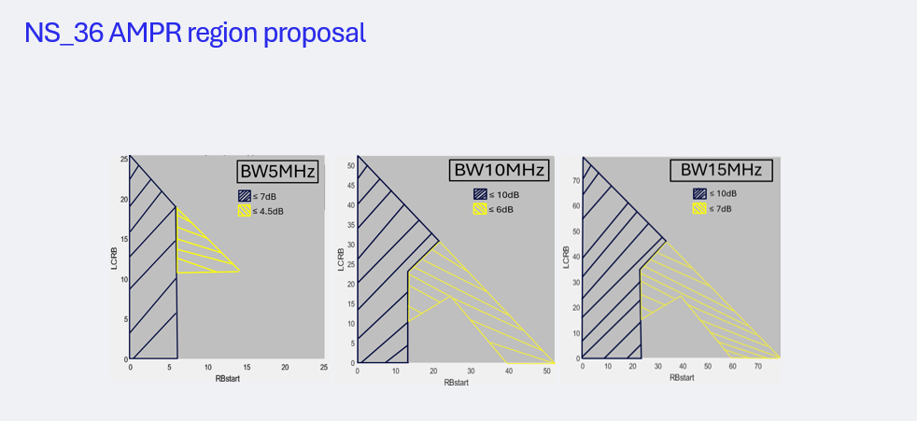

# 3 Conclusion

This contribution captures the A-MPR agreements for the introduction of band n68 made in RAN4#113.

# 4 References

[1] RP-241664,New WID on introduction of NR band n68, Ericsson

[2] R4-2414273, WF on introduction of NR band n68, Ericsson

[3] R4-2418048, n68: Introduction of the new band and NS_26 / NS_36, Apple

[4] R4-2418102, Preliminary A-MPR values for NS_36 and NS_26, Qualcomm

[5] R4-2419196, n68 NS_26 and NS_36 A-MPR simulations, Nokia