3GPP TSG-CT WG3 Meeting #138 C3-246216

Orlando, US, 18 – 22 November, 2024 (Revision of C3-246216)
CR-Form-v12.3
CHANGE REQUEST
 | 29.522 | CR | 1444 | rev | 1 | Current version: | 19.0.0
For HELP on using this form: comprehensive instructions can be found at
http://www.3gpp.org/Change-Requests.

Proposed change affects: | UICC apps |  | ME |  | Radio Access Network |  | Core Network | X

Title: | Clarification of NEF complement the RSD
Source to WG: | Ericsson, Nokia
Source to TSG: | CT3
Work item code: | UEP19 |  |  |  |  |  | Date: |  |  | 2024-11-19
Category: | B |  |  |  |  |  | Release: |  |  | Rel-19
 | Use one of the following categories:  F (correction)  A (mirror corresponding to a change in an earlier release)  B (addition of feature),  C (functional modification of feature)  D (editorial modification)  Detailed explanations of the above categories can  be found in 3GPP TR 21.900. |  |  |  |  |  |  |  | Use one of the following releases:  Rel-8 (Release 8)  Rel-9 (Release 9)  Rel-10 (Release 10)  Rel-11 (Release 11)  …  Rel-17 (Release 17)  Rel-18 (Release 18)  Rel-19 (Release 19)  Rel-20 (Release 20)
Reason for change: |  | The current 29.522 RSD is implemented as:  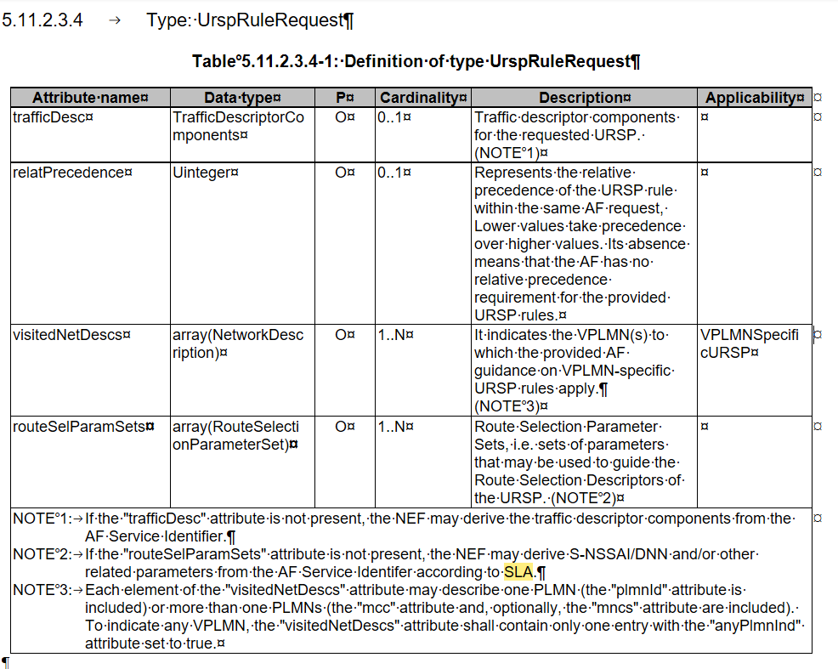  According to the procedure, when NEF complement the routeSelParamSets can only apply to when the request is with one route selection parameter set. Such clarification is not aligned with the Note in the table, which indicate  When the routeSelParamSets is not present , the NEF may need to derive the relative parameters based on the SLA.  In addition, the Note indicate the relative parameters, which not clear which relative parameters, it is misleading and need a clarification align with the procedure.
d
Summary of change: |  | Clarification about how NEF shall complement the RSD when the routeSelParamSets is not present.
Consequences if not approved: |  | How NEF complement the RSD parameters is not clear and leading to implementation errors.
Clauses affected: |  | 5.11.2.3.4
 |  | Y | N
Other specs |  |  | X | Other core specifications |  |  |  | TS/TR ... CR ...
affected: |  |  | X | Test specifications |  |  |  | TS/TR ... CR ...
(show related CRs) |  |  | X | O&M Specifications |  |  |  | TS/TR ... CR ...
Other comments: |  | This CR does not have any impact in the Open API specification.
This CR's revision history:

Additional discussion(if needed):

Proposed changes:

*** First Change ***

5.11.2.3.4 Type: UrspRuleRequest
Table 5.11.2.3.4-1: Definition of type UrspRuleRequest
Attribute name |  | Data type |  | P |  | Cardinality |  | Description |  | Applicability
trafficDesc |  | TrafficDescriptorComponents |  | O |  | 0..1 |  | Traffic descriptor components for the requested URSP. (NOTE 1)
relatPrecedence |  | Uinteger |  | O |  | 0..1 |  | Represents the relative precedence of the URSP rule within the same AF request, Lower values take precedence over higher values. Its absence means that the AF has no relative precedence requirement for the provided URSP rules.
 | visitedNetDescs |  | array(NetworkDescription) |  | O |  | 1..N |  | It indicates the VPLMN(s) to which the provided AF guidance on VPLMN-specific URSP rules apply.  (NOTE 3) |  | VPLMNSpecificURSP
routeSelParamSets |  | array(RouteSelectionParameterSet) |  | O |  | 1..N |  | Route Selection Parameter Sets, i.e. sets of parameters that may be used to guide the Route Selection Descriptors of the URSP. (NOTE 2)
NOTE 1: If the "trafficDesc" attribute is not present, the NEF may derive the traffic descriptor components from the AF Service Identifier.
NOTE 2: If the "routeSelParamSets" attribute is not present, the NEF may derive any combination of the optional attributes within "routeSelParamSets" to construct one route selection parameter setfrom the AF Service Identifer according to SLA. If the "routeSelParamSets" contains only one route selection parameter set and any of the optional attributes "dnn", "snssai", "precedence", and "spatialValidity" is missing, the NEF may derive any of these parameters based on local configuration for the provided AF service identifier.
NOTE 3: Each element of the "visitedNetDescs" attribute may describe one PLMN (the "plmnId" attribute is included) or more than one PLMNs (the "mcc" attribute and, optionally, the "mncs" attribute are included). To indicate any VPLMN, the "visitedNetDescs" attribute shall contain only one entry with the "anyPlmnInd" attribute set to true.

End of Change

