3GPP TSG-SA3 Meeting # Conference Call S3-220XXX

e-meeting, 12 April 2022

Source: ChinaTelecom

Title: Resolving the ENs on secondary authentication procedure in control plane

Document for: Approval
Agenda Item: 4.13

1 Decision/action requested
This contribution proposes to.

2 References
[1] 3GPP TS 33.503 "Security aspects of enhancement for proximity based services in the 5G System".

3 Rationale
This contribution proposes to resolve the following two Editors Notes:
Editor’s Notes: How the SUPI of the 5G ProSe remote UE is obtained by SMF is FFS.
Editor’s Notes: how SMF obtains the 5G ProSe remote UE’s subscription info is FFS.
And according to TS 33.503 v0.3.0, the following statement is made in step 8 of clause 6.3.3.3.4.2:
The SMF receives the message from AMF which includes the 5G ProSe Remote UE's SUPI, obtained by AMF during a controlled authorization of 5G ProSe Remote UE procedure as described in 6.3.3.3.2.

But in clause 6.3.3.3.2, after performing the 5G ProSe Remote UE specific authentication, the AUSF of the 5G ProSe Remote UE derives K_{AUSF} without calculating the K_{SEAF}, so the AUSF of the 5G ProSe Remote UE does not send the SUPI of the Remote UE to the AMF of the 5G ProSe UE-to-Network Relay UE, because the 5G ProSe Remote UE specific authentication is different from the primary authentication.
For EAP-AKA’, the AUSF of the 5G ProSe Remote UE and the 5G ProSe Remote UE may exchange EAP-Request/AKA’-Notification and EAP-Response /AKA’-Notification messages via the AMF of the 5G ProSe UE-to-Network Relay. After the exchanges, the AUSF of the 5G ProSe Remote UE derives K_{AUSF} without calculating the K_{SEAF}.

So this contribution proposes to :
For the first EN, in Clause 6.3.3.3.2, add the following actions:
- Step 2-5: If the DN requested by the Remote UE needs secondary authentication, the Remote UE includes the secondary authentication indication in the DCR message, and this indication will be forwarded to the AUSF of the Remote UE via the 5G ProSe UE-to-Network Relay UE and Relay UE’s AMF.
- Step 7f: If the message received by AUSF in step 5 contains the secondary authentication indication, AUSF sends the SUPI of the Remote UE to the AMF of the 5G ProSe UE-to-Network Relay UE , after completing the 5G ProSe Remote UE specific authentication.
Therefore, in step 8 of clause 6.3.3.3.4.2, SMF will obtain the SUPI of the Remote UE from AMF.
For the second EN, SMF obtains the 5G ProSe remote UE’s subscription info from UDM according to the SUPI obtained from AMF in step 8.

4 Detailed proposal
**** 1st CHANGE ****

6.3.3.3.2 Connection with 5G ProSe UE-to-Network Relay connection with setup of network Prose security context during PC5 link establishment
This subclause describes a procedure for a 5G ProSe Remote UE to establish a PC5 link between a 5G ProSe Remote UE and a 5G ProSe UE-to-Network Relay. The procedure includes how the 5G ProSe Remote UE is authenticated by AUSF via 5G ProSe UE-to-Network Relay and 5G ProSe UE-to-Network Relay's AMF during 5G ProSe PC5 establishment. The mechanism can be used by a 5G ProSe Remote UE while out of coverage.
Figure 6.3.3.3.2-1: 5G ProSe UE-to-Network Relay security procedure with setup of network Prose security context during PC5 link establishment
0. The 5G ProSe Remote UE and the 5G ProSe UE-to-Network Relay shall be registered with the network. The 5G ProSe UE-to-Network Relay shall be authenticated and authorized by the network to provide UE-to-Network relay service. The 5G ProSe Remote UE shall be authenticated and authorized by the network to receive UE-to-Network relay service. PC5 security policies are provisioned to the 5G ProSe Remote UE and the 5G ProSe UE-to-Network Relay respectively during this authorization and information provisioning procedure.
1. The 5G ProSe Remote UE shall initiate discovery procedure using any of Model A or Model B method as specified in clause 6.3.1.2 or 6.3.1.3 of TS 23.304 [2] respectively.
2-5. After the discovery of the 5G ProSe UE-to-Network Relay, the 5G ProSe Remote UE shall send a Direct Communication Request to the 5G ProSe UE-to-Network Relay for establishing secure PC5 unicast link. The 5G ProSe Remote UE shall include its security capabilities and PC5 security signalling policy in the DCR message as specified in TS 33.536 [6]. The message shall also include SUCI, Relay Service Code, Nonce_1. Upon receiving the DCR message, the 5G ProSe UE-to-Network Relay shall send the Relay Key Request to the AMF of the 5G ProSe UE-to-Network Relay, including partial parameters received in the DCR message. The 5G ProSe UE-to-Network Relay shall also include in the message a transaction identifier that identifies the 5G ProSe Remote UE for the subsequent messages over 5G ProSe UE-to-Network Relay's NAS messages and PC5 messages. The AMF of the 5G ProSe UE-to-Network Relay shall verify whether the 5G ProSe UE-to-Network Relay is authorized to provide the UE-to-Network relay service. The AMF of the 5G ProSe UE-to-Network Relay shall select an AUSF based on SUCI and forward the parameters received in Relay Key Request to the AUSF in Nausf_UEAuthentication_ProseAuthenticate Request message. The Nausf_UEAuthentication_ProseAuthenticate Request message shall contain the 5G ProSe Remote UE’s SUCI, Relay Service Code, Nonce_1. The AUSF shall initiate a 5G ProSe Remote UE specific authentication using the ProSe specific parameters received (i.e., RSC, etc.). The serving network name handling is same as defined in TS 33.501 [3]. The security policy negotiation and protection of messages hereafter shall follow the one-to-one security establishment described in clause 6.2.3 of the present document.
NOTE 1: If the DN requested by the 5G ProSe Remote UE needs secondary authentication, the 5G ProSe Remote UE includes the secondary authentication indication in the DCR message, and this indication will be forwarded to the AUSF of the 5G ProSe Remote UE via the 5G ProSe UE-to-Network Relay UE and the AMF of the 5G ProSe UE-to-Network Relay UE.
6. The AUSF of the 5G ProSe Remote UE shall retrieve the Authentication Vectors from the UDM via Nudm_UEAuthentication_GetProseAv Request message and trigger authentication of the 5G ProSe Remote UE . This authentication is performed between the AUSF of the 5G ProSe Remote UE and the 5G ProSe Remote UE via the AMF of the 5G ProSe UE-to-Network Relay and the 5G ProSe UE-to-Network Relay. Based on SUPI, the UDM shall choose the authentication method.
7a. If EAP-AKA' is selected by UDM, the AUSF of the 5G ProSe Remote UE shall trigger authentication of the 5G ProSe Remote UE based on EAP-AKA'. The AUSF of the 5G ProSe Remote UE generates the EAP-Request/AKA'-Challenge message defined in clause 6.1.3.1 of TS 33.501 and send EAP-Request/AKA'-Challenge message to the AMF of the 5G ProSe UE-to-Network Relay in a Nausf_UEAuthentication_ProSeAuthenticate Response message.
7b. The AMF of the 5G ProSe UE-to-Network Relay shall forward the Relay Authentication Request (including the EAP-Request/AKA'-Challenge) to the 5G ProSe UE-to-Network Relay over NAS message, including transaction identifier of the 5G ProSe Remote UE in the message. The NAS message is protected using the NAS security context created for the 5G ProSe UE-to-Network Relay.
7c. Based on the transaction identifier, the 5G ProSe UE-to-Network Relay shall forwards the EAP-Request/AKA'-Challenge to the 5G ProSe Remote UE over PC5 messages.
The USIM in the 5G ProSe Remote UE verifies the freshness of the received values by checking whether AUTN can be accepted as described in TS 33.102 [11].
For EAP-AKA', the USIM computes a response RES. The USIM shall return RES, CK, IK to the ME. The ME shall derive CK' and IK' according to Annex A.3 in TS 33.501.
7d. The 5G ProSe Remote UE shall return EAP-Response/AKA'-Challenge to the 5G ProSe UE-to-Network Relay over PC5 messages.
7e. The 5G ProSe UE-to-Network Relay forwards the EAP-Response/AKA'-Challenge together with the transaction identifier of the 5G ProSe Remote UE to the AMF of the 5G ProSe UE-to-Network Relay in a NAS message Relay Authentication Response.
7f. The AMF of the 5G ProSe UE-to-Network Relay forwards EAP-Response/AKA'-Challenge to the AUSF of the 5G ProSe Remote UE via Nausf_UEAuthentication_ProSeAuthenticate Request.
The AUSF of the 5G ProSe Remote UE performs the UE authentication by verifying the received information as described in TS33.501.
For EAP-AKA’, the AUSF of the 5G ProSe Remote UE and the 5G ProSe Remote UE may exchange EAP-Request/AKA’-Notification and EAP-Response /AKA’-Notification messages via the AMF of the 5G ProSe UE-to-Network Relay. After the exchanges, the AUSF of the 5G ProSe Remote UE derives K_{AUSF} without calculating the K_{SEAF}.
The AUSF of the 5G ProSe Remote UE and the 5G ProSe Remote UE shall derive a new K_{AUSF_P} (different from K_{AUSF}). NAS SMC procedure is not performed between 5G ProSe Remote UE and AMF of the 5G ProSe UE-to-Network Relay.
NOTE 2: If the message received by AUSF in step 5 contains the secondary authentication indication, AUSF sends the SUPI of the 5G ProSe Remote UE to the AMF of the 5G ProSe UE-to-Network Relay UE , after completing the 5G ProSe Remote UE specific authentication.
8. On successful authentication, the AUSF of the 5G ProSe Remote UE and the 5G ProSe Remote UE shall generate 5GPRUK as specified in Annex A.2 and 5GPRUK ID as specified in Annex A.3 using the newly derived K_{AUSF_P}.
9. The AUSF of the 5G ProSe Remote UE shall generate the K_{NR_ProSe} key as defined in Annex A.4.
10-11. The AUSF of the 5G ProSe Remote UE shall send the K_{NR_ProSe}, Nonce_2 in Nausf_UEAuthentication_ProseAuthenticate Response message to the 5G ProSe UE-to-Network Relay via the AMF of the 5G ProSe UE-to-Network Relay. When receiving a K_{NR_ProSe} from the AUSF of the 5G ProSe Remote UE, the AMF of the 5G ProSe UE-to-Network Relay shall not attempt to trigger NAS SMC procedure with the 5G ProSe Remote UE. The 5G ProSe UE-to-Network Relay derives PC5 session key K_{relay-sess} and confidentiality and integrity keys from K_{NR_ProSe}, as defined in clause 6.3.3.3.3 of this document. K_{NR_ProSe} ID and K_{relay-sess} ID are established in the same way as K_{NRP} ID and K_{NRP-sess} ID in TS 33.536 [6].
12. The 5G ProSe UE-to-Network Relay shall send the received Nonce_2 to the 5G ProSe Remote UE in Direct Security mode command message, which is protected using K_{relay-int} or/and K_{relay-enc} derived from K_{relay-sess} according to the negotiated PC5 signalling policies between the 5G ProSe Remote UE and the 5G ProSe UE-to-Network Relay.
13-15. The 5G ProSe Remote UE shall use the 5GPRUK ID to locate the K_{AUSF_P}/5GPRUK to be used for the PC5 link security. The 5G ProSe Remote UE shall generate the K_{NR_ProSe} key to be used for Remote access via the 5G ProSe UE-to-Network Relay in the same way as defined in step 9. The 5G ProSe Remote UE shall derive PC5 session key K_{relay-sess} and confidentiality and integrity keys from K_{NR_ProSe} the same way as defined in step 11. The 5G ProSe Remote UE shall send the Direct Security Mode Complete message containing its PC5 user plane security policies to the 5G ProSe UE-to-Network relay, which is protected by K_{relay-int} or/and K_{relay-enc} derived from K_{relay-sess} according to the negotiated PC5 signalling policies between the 5G ProSe Remote UE and the 5G ProSe UE-to-Network Relay. After the successful verification of the Direct Security Mode complete message, the 5G ProSe UE-to-Network Relay responds a Direct Communication Accept message to the 5G ProSe Remote UE to finish the PC5 connection establishment procedures.
Further communication between the 5G ProSe Remote UE and the Network takes place securely via the 5G ProSe UE-to-Network Relay.
Editor's note: Further details on the needs and usage of 5GPRUK ID are FFS.
.**** 2nd CHANGE ****

6.3.3.3.4.2 PDU Session secondary authentication of 5G ProSe Remote UE via 5G ProSe Layer-3 UE-to-Network Relay
The PDU session secondary authentication of 5G ProSe Remote UE via 5G ProSe Layer-3 UE-to-Network Relay follows the steps described below on the Figure 6.3.3.3.4.2-1.
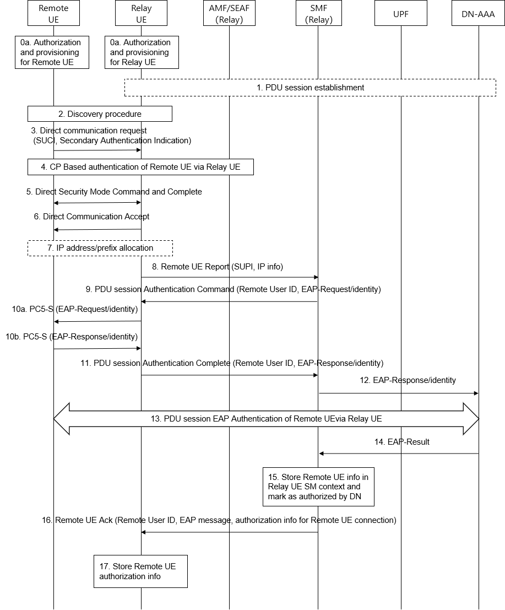
Figure 6.3.3.3.4.2-1: Procedure for PDU session secondary authentication of 5G ProSe Remote UE
via 5G ProSe Layer-3 UE-to-Network Relay
- During the Registration procedure, authorization and provisioning are performed for 5G ProSe Remote UE(0a) and 5G ProSe Layer-3 UE-to-Network Relay(0b). When the 5G ProSe Remote UE is not in the coverage, the 5G ProSe Remote UE may use its preconfigured policy and parameter for PC5 discovery and communication to establish a PC5 connection with a 5G ProSe Layer-3 UE-to-Network Relay.
1. The 5G ProSe Layer-3 UE-to-Network Relay may establish a PDU session for relaying with default PDU session parameters received in step 0 or pre-configured in the 5G ProSe Layer-3 UE-to-Network Relay, e.g. S-NSSAI, DNN, SSC mode, or PDU Session Type.
2. Based on the authorization and provisioning in step 0, the 5G ProSe Remote UE performs the discovery of a 5G ProSe Layer-3 UE-to-Network Relay. As part of the discovery procedure, the 5G ProSe Remote UE learns about the connectivity service the 5G ProSe Layer-3 UE-to-Network Relay provides (e.g., based on a broadcasted Relay Service Code).
3. The 5G ProSe Remote UE selects a 5G ProSe Layer-3 UE-to-Network Relay and may determine from the configuration in step 0 that the service code is associated with a DN that requires secondary authentication. Based on this determination, the 5G ProSe Remote UE sends a DCR (Direct Communication Request) message including its identity (e.g., SUCI), Relay Service Code, Secondary Authentication indication.
4. On the condition that the DCR message includes a SUCI, the AUSF of the 5G ProSe Remote UE triggers a 5G ProSe Remote UE specific authentication, as described in 6.3.3.3.2. If the required identity parameter (e.g., SUCI) is missing, the 5G ProSe Layer-3 UE-to-Network Relay may send an identity request message to the 5G ProSe Remote UE to obtain the 5G ProSe Remote UE identity (e.g., SUCI) .
If there is no PDU session satisfying the requirements of the PC5 connection with the 5G ProSe Remote UE, e.g. S-NSSAI, DNN, QoS, UP security activation status, the 5G ProSe Layer-3 UE-to-Network Relay initiates a new PDU session establishment or modification procedure for relaying.
5. Upon successful 5G ProSe Remote UE specific authentication procedure the 5G ProSe Layer-3 UE-to-Network Relay initiates a Direct Security Mode Command procedure with the 5G ProSe Remote UE to establish the security of the PC5 link. The security of the PC5 link may be established as described in 6.2.3.
6. Upon successful security establishment, the 5G ProSe Layer-3 UE-to-Network Relay sends a DCA (Direct Communication Accept) message that may include an indication that a PDU Session with secondary authentication is pending. Based on the indication in the DCA message, the 5G ProSe Remote UE may refrain from sending any data traffic over the PC5 link until successful completion of subsequent PDU Session secondary authentication.
7. For IP PDU Session Type and IP traffic over the PC5 reference point, the IPv6 prefix or IPv4 address is allocated for the 5G ProSe Remote UE. The 5G ProSe Layer-3 UE-to-Network Relay may configure a traffic filter (e.g., as a default filter for IP or non-IP traffic) for the PC5 link to prevent any data traffic until successful completion of subsequent PDU Session secondary authentication.
8. The 5G ProSe Layer-3 UE-to-Network Relay sends a Remote UE Report message to the SMF for the PDU session associated with the 5G ProSe Layer-3 UE-to-Network Relay. The message may include the Remote User ID and 5G ProSe Remote UE addressing info (e.g., IP or MAC address). The SMF receives the message from AMF which includes the 5G ProSe Remote UE's SUPI, obtained by AMF during a 5G ProSe Remote UE specific authentication procedure as described in 6.3.3.3.2.

NOTE 1: In the case of Home Routed roaming, the SMF in the call flow is the H-SMF (and the V-SMF is not shown for simplicity). SMF selection by AMF is performed as per TS 23.502 [13], clause 4.3.2.2.3 (e.g., using PLMN ID of the SUPI, S-NSSAI, etc.).
9. When the SMF received Remote UE Report the SMF obtains the 5G ProSe remote UE’s subscription info from UDM according to the SUPI, and the SMF determines based on the subscription data of the 5G ProSe Remote UE (i.e., Secondary authentication indication as per TS 23.502 [13], Table 5.2.3.3.1) and the local configuration of the SMF that the requested DN is subject to secondary authentication. The SMF may also check whether the 5G ProSe Remote UE has been authenticated by the same DN as indicated in the subscription data and, if negative, triggers a PDU Session secondary authentication of 5G ProSe Remote UE via 5G ProSe Layer-3 UE-to-Network Relay by sending PDU Session Authentication Command message to the 5G ProSe Layer-3 UE-to-Network Relay including Remote User ID and an EAP-Request/Identity.
Note 2: The information on a successful authentication between a 5G ProSe Remote UE and an SMF may be saved in SMF and/or UDM.

NOTE 3: The local configuration of the SMF is set by the operator. If it indicates that secondary authentication is not required, the SMF does not perform secondary authentication for the 5G ProSe Remote UE.
10. The 5G ProSe Layer-3 UE-to-Network Relay sends an EAP-Request/Identity to the 5G ProSe Remote UE via PC5 signalling(10a). The 5G ProSe Remote UE sends an EAP-Response/Identity to the 5G ProSe Layer-3 UE-to-Network Relay via PC5 signalling(10b).
11. The 5G ProSe Layer-3 UE-to-Network Relay sends PDU Session Authentication Complete message to the SMF including Remote User ID and an EAP-Response/Identity received from the 5G ProSe Remote UE.
12. The SMF sends an EAP-Response/Identity to the DN-AAA.
13. The DN AAA server and the 5G ProSe Remote UE should exchange EAP messages, as required by the EAP method.
14. The DN-AAA sends EAP-Success or EAP-Failure to the SMF.
15. Upon successful PDU Session secondary authentication via the Relay procedure, the SMF stores the 5G ProSe Remote UE information in the Relay Session Management context including 5G ProSe Remote UE identity (e.g., GPSI), individual authorization information (e.g., QoS parameters) received from DN-AAA.
16. The SMF sends Remote UE Report Ack message to the 5G ProSe Layer-3 UE-to-Network Relay indicating the result of the PDU Session secondary authentication, including an identity of the 5G ProSe Remote UE (e.g., GPSI, Remote User Id), an EAP success or failure message. In the case of successful secondary authentication, the message may include QoS authorization info for the 5G ProSe Layer-3 UE-to-Network Relay to enforce. In case the secondary authentication is failed, the NAS message may indicate that 5G ProSe Layer-3 UE-to-Network Relay should release the PC5 link with the 5G ProSe Remote UE.
17. In the case of successful secondary authentication for the 5G ProSe Remote UE, the 5G ProSe Layer-3 UE-to-Network Relay stores any received authorization info associated with the 5G ProSe Remote UE. In case the secondary authentication is failed, the 5G ProSe UE-to-Network Relay releases the PC5 link with the 5G ProSe Remote UE and may keep the PDU session as the default PDU session or release it if there is no more 5G ProSe Remote UE using the same PDU session.
Editor’s Notes: It is FFS how to support secondary authentication when roaming..
**** END OF CHANGES ****

