3GPP TSG-SA3 Meeting #115 S3-23xxxx

Athens, February 26 - March 01, 2024 (revision of S3-yyxxxx)

Source: China Telecom, ZTE, Nokia, Nokia Shanghai Bell

Title: Overview of TR 33.757

Document for: Approval
Agenda Item: 5.3

1 Decision/action requested
This contribution proposes to add overview to TR 33.757.

2 References
[1] 3GPP TS 22.261: "Service requirements for the 5G system; Phase 1"

3 Rationale
The contribution proposes to add overview to TR 33.757.

4 Detailed proposal
It is suggested to approve the following change.

*************** Start of the change ****************

4 Overview

NPN can be hosted by a PLMN. NPN customers can request dedicated NFs to be deployed in the customer premises for performance and privacy reasons. Figure 4-1 and Figure 4-2 demonstrate two specific PNI-NPNs with dedicated NFs deployed in the the customer premises.
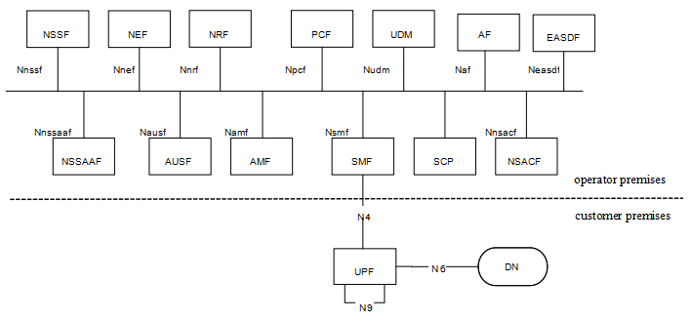
Figure 4-1 PNI-NPN with dedicated UPF deployed in the customer premises
For scenario 1, as depicted in Figure4-1, dedicated UPF is deployed in the customer premises, the other NFs are deployed in the operator premises. The interface between the dedicated UPF in the customer premises and NFs in the operator premises is N4.
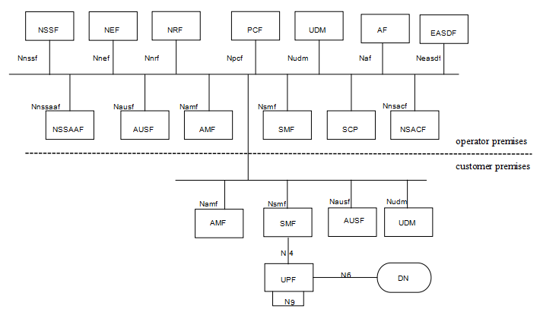
Figure 4-2 PNI-NPN with dedicated UPF and part of CP functions deployed in the customer premises
For scenario 2, as depicted in Figure 4-2, dedicated UPF and part of CP functions are deployed in the customer premises. The interface between the dedicated NFs in the customer premises and the NFs in the operator premise is SBA interface. Examples of dedicated CP functions that are likely to be hosted by NPN in the customer premises are as below:
- AMF.
- SMF.
- UDM and AUSF. UDM and AUSF may be deployed in the customer premises together so that when the connection between customer premises and operator premises is broken, UE can still connect to NPN through dedicated UDM and AUSF. AUSF is not likely to be deployed in customer premises alone.
SA1 has captured the scenarios and added requirements in clause 8.2 of TS 22.261[1], which is:
“The 5G system shall enable a PLMN to host an NPN without compromising the security of that PLMN.
NOTE: Dedicated network entities of NPN can be deployed in customer premises that are outside the control of the PLMN operator.”
*************** End of the change ****************

