3GPP TSG-SA3 Meeting #115 S3-240413

Athens, Greece, 26th February - 1st March 2024

Source: China Telecom, ZTE, Nokia, Nokia Shanghai Bell

Title: Overview of TR 33.757

Document for: Approval
Agenda Item: 5.3

1 Decision/action requested
This contribution proposes to add overview to TR 33.757.

2 References
[1] 3GPP TS 22.261: "Service requirements for the 5G system; Phase 1"
[2] 3GPP TS 23.501: “System Architecture for the 5G System (5GS), Stage 2"
[3] 3GPP TS 33.501: “Security architecture and procedures for 5G system”

3 Rationale
The contribution proposes to add overview to TR 33.757.

4 Detailed proposal
It is suggested to approve the following change.

*************** Start of the change ****************

4 Overview

NPN can be hosted by a PLMN. NPN customers can request dedicated NFs to be deployed in the customer premises for performance and privacy reasons.
Public Network Integrated NPNs are NPNs made available via PLMNs e.g. by means of dedicated DNNs, or by one (or more) Network Slice instances allocated for the NPN. [2] Therefore, NFs which may reside within PNI-NPN Network Slice instances may require interfaces which cross the operational domains between PNI-NPNs and PLMNs. In addtion, AFs which reside within a PNI-NPN DNNs operational domain may require interfaces which cross the operational domains between PNI-NPNs and PLMNs.
The creation, modification, and termination of a Network Slice Instance (NSI) are supported by Management Services provided by the 5G management systems. [3] Therefore, NFs which provide NSI Management Services may cross the operational domains between PNI-NPNs and PLMNs.
NFs which reside in the PNI-NPN operational domain may require interfaces which cross the trust boundary between PNI-NPN and PLMN. Therefore, these interfaces require security controls to mutually protect the NFs which reside in the PLMN operational domain and in the PNI-NPN operational domain.
Figure 4-1 and Figure 4-2 demonstrate two example PNI-NPNs with dedicated NFs deployed in the the customer premises.
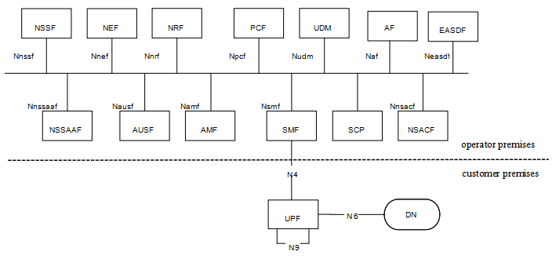
Figure 4-1 PNI-NPN with dedicated UPF deployed in the customer premises
For scenario 1, as depicted in Figure4-1, dedicated UPF is deployed in the customer premises, the other NFs are deployed in the operator premises. The interface between the dedicated UPF in the customer premises and NFs in the operator premises is N4.
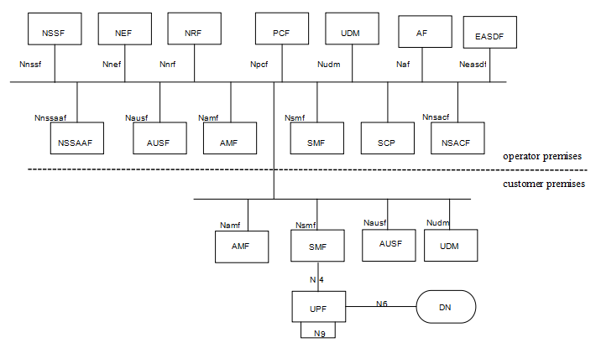
Figure 4-2 PNI-NPN with dedicated UPF and part of CP functions deployed in the customer premises
For scenario 2, as depicted in Figure 4-2, dedicated UPF and part of CP functions are deployed in the customer premises. The interface between the dedicated NFs in the customer premises and the NFs in the operator premise is SBA interface. Examples of dedicated CP functions that are likely to be hosted by NPN in the customer premises are as below:
- AMF.
- SMF.
- UDM and AUSF. UDM and AUSF may be deployed in the customer premises together so that when the connection between customer premises and operator premises is broken, UE can still connect to NPN through dedicated UDM and AUSF. AUSF is not likely to be deployed in customer premises alone.
Editors Note: It is FFS whether UDM and AUSF may be deployed in customer premises given that TS 23.501, clause 5.30.3.1 states “When a PNI-NPN is made available via a PLMN, then the UE shall have a subscription for the PLMN in order to access PNI-NPN.”
SA1 has captured the scenarios and added requirements in clause 8.2 of TS 22.261[1], which is:
“The 5G system shall enable a PLMN to host an NPN without compromising the security of that PLMN.
NOTE: Dedicated network entities of NPN can be deployed in customer premises that are outside the control of the PLMN operator.”
*************** End of the change ****************

