3GPP TSG-SA3 Meeting #115Adhoc-e S3-24xxxx

Online, 15th -19th April, 2024

Source: ISSDU, III

Title: Prevent acquiring the list of SUPI stored in the database of 5GC UDM

Document for: Discussion
Agenda Item: 5.3

1 Decision/action requested
Endorse the proposal and recommend CT1 to modify 3GPP TS 24.501 based on the observation in this contribution.

2 References
[1] 3GPP TR 33.846, Study on authentication enhancements in the 5G System (5GS); (Release 17)
[2] 3GPP TS 24.501, Non-Access-Stratum (NAS) protocol for 5G System (5GS); Stage 3 (Release 18)

3 Rationale
Although TR33.846 concludes that no normative work is needed for key issue #3.2: SUPI guessing attacks, it's important to note that this conclusion does not address security issues related to multi-UE guessing attacks within the database of UDM, particularly where they occur in Non-Public Networks (NPN) architecture.
The concerns highlighted in Annex A.1 of 3GPP TS 24.501, particularly regarding Cause #3 – Illegal UE, pertain to scenarios where a UE’s identity, like the SUPI, is not accepted by the network or fails authentication checks. However, these issues are not thoroughly addressed in the context of UDM database security, especially in Non-Public Networks, where the risk of multi-UE guessing attacks could be more pronounced. The technical discussions are currently lacking in terms of addressing cybersecurity threats targeting the UDM database, particularly in NPN contexts, where managing vulnerabilities associated with multiple unknown or unauthenticated SUPIs is critical.
According 4.4.4.2 of 3GPP TS 24.501, except the messages listed below, no NAS signalling messages shall be processed by the receiving 5GMM entity in the UE or forwarded to the 5GSM entity, unless the network has established secure exchange of 5GS NAS messages for the NAS signalling connection: … b) AUTHENTICATION REQUEST; …
Therefore, the UE will receive Authentication Request after sending Registration Request with SUPI, which the value is found in the database of UDM.
Figure 1: SUPI is not found in UDM
Figure 2: SUPI is found in UDM
The following test is performed over N1 interface via N2 Interface of gNB/UE emulator. The same result will be obtained over N1 interface via NR-Uu air interface of UE emulator.
- Demonstration of filed Test
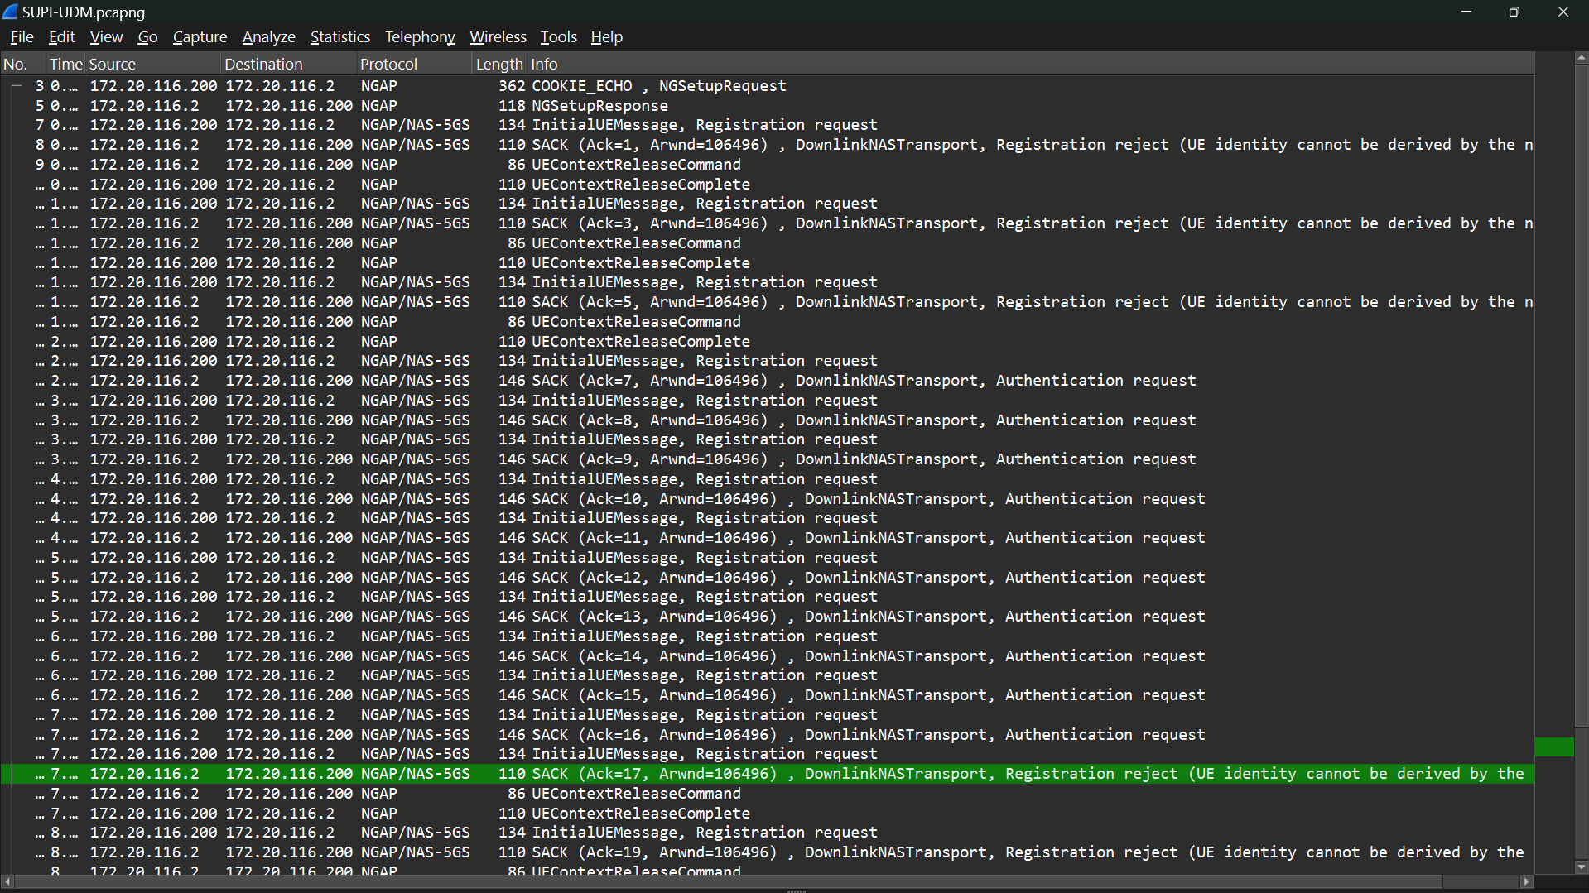
- Evidence of pcap log
Figure 3: Acquiring the list of SUPI stored in the database of 5GC UDM
Tests on the gNB/UE emulator using N1 and N2 interfaces show that attacking the SUPI list in the 5GC UDM database is a threat to the NPN network. Improved protections and adjustments to the Registration Request message help reduce cybersecurity risks. The 3GPP TS 24.501 need to define that stronger encryption and access control effectively reduce SUPI exfiltration as confirmed by UE emulator tests on the NR-Uu air interface.
Observation: Key Issue #3.2 in 3GPP TR 33.846 discusses "SUPI guessing attacks". This is where someone might send many Registration Requests to the 5G network to guess SUPIs. For customers of private network, the list of SUPIs is very important and we should keep the list in private. Different private networks might share this list. The 5G UDM of private networks stores a list of SUPIs. Keeping the SUPI list safe is important. It helps protect Customer Information, prevents unauthorized attacker from accessing the network, and maintains the uniqueness of each customer.
Proposal: After reviewing 3GPP TS 24.501, we recommended modifying the Registration Request message security details to protect against unauthorized access to the SUPI list in the UDM database.

4 Conclusion and Proposal
Observation：Key Issue #3.2 in 3GPP TR 33.846 discusses "SUPI guessing attacks". This is where someone might send many Registration Requests to the 5G network to guess SUPIs. For customers of private network, the list of SUPIs is very important and we should keep the list in private. Different private networks might share this list. The 5G UDM of private networks stores a list of SUPIs. Keeping the SUPI list safe is important. It helps protect Customer Information, prevents unauthorized attacker from accessing the network, and maintains the uniqueness of each customer.
Proposal: After reviewing 3GPP TS 24.501, we recommended modifying the Registration Request message security details to protect against unauthorized access to the SUPI list in the UDM database.

