3GPP TSG-SA3 Meeting #115 S3-24xxxx
Athens, Greece, 26 Feb - 01 March 2024

Source: Nokia, Nokia Shanghai Bell

Title: pCR on KI for UE connecting to the new TNAP

Document for: Approval
Agenda Item: 5.8

1 Decision/action requested
It is requested to approve the chapter 4 content.

2 References
[x] 3GPP TR 33.702: "Study on Security for mobility over non-3GPP access to avoid full primary authentication."

3 Rationale
This pCR introduces the new KI in the FS_Non3GPPMob_Sec TR. Please note that this KI was discussed, and many solutions were also presented in the TR 33.887. Rel18 however, there is no conclusion. In this KI, the UE disconnects from an TNAP and connects to a new TNAP within the same TNGF. The other use cases have not been studied before. Therefore, it is important to study all use cases together to provide a seamless user experience across non-3GPP access.

4 Detailed proposal
**** START OF FIRST CHANGE ****

2 References
The following documents contain provisions which, through reference in this text, constitute provisions of the present document.
- References are either specific (identified by date of publication, edition number, version number, etc.) or non-specific.
- For a specific reference, subsequent revisions do not apply.
- For a non-specific reference, the latest version applies. In the case of a reference to a 3GPP document (including a GSM document), a non-specific reference implicitly refers to the latest version of that document in the same Release as the present document.
[1] 3GPP TR 21.905: "Vocabulary for 3GPP Specifications".
[x] 3GPP TR 33.887: " Study on security aspects for support for 5G Wireless and Wireline Convergence (5WWC) phase 2”

**** END OF THE FIRST CHANGE ****

**** START OF NEXT CHANGE ****

5.x Key issue #x: Security aspect of UE connecting to a new TNAP within the same TNGF.

5.x.1 Key issue details
When UE moves from TNAP1 and TNAP2, where both TNAPs are nearby or overlapping, the UE connectivity will break while connecting to the new TNAP2. Additionally, UE also goes through another full primary authentication procedure, even though the second non-3GPP access connects to the same TNGF.

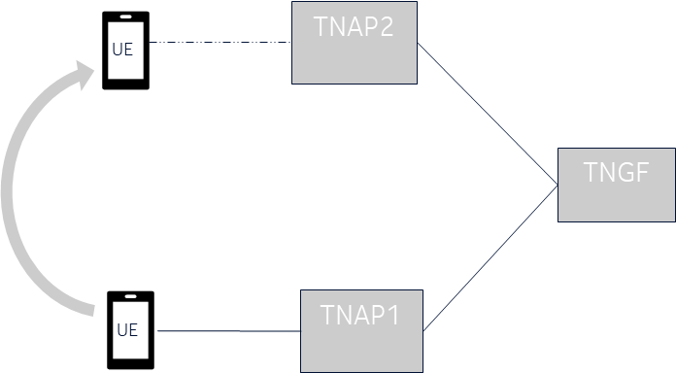
Figure 5.X.1-1: UE moves from TNAP1 to TNAP2

A new full primary authentication may lead to additional signalling and may cause latency in the UE connection. If we skip the full primary authentication, it provides connection time optimisation, but then the security aspect of UE to target TNAP/TNGF should be studied.

5.x.2 Threats
As it is only AUN3 device connection time optimisation, the threat is not applicable. .

5.x.3 Potential security requirements
5GS should support a mechanism for communication between the UE and TNAP/TNGF to establish security with a TNAP without performing full primary authentication when the UE switches from another TNAP within the same TNGF.
While switching from one TNAP to another TNAP within the same TNGF, the interface between UE and the new TNAP shall be confidentiality, integrity, and replay protected.

**** END OF CHANGE ****

