3GPP TSG-SA WG1 Meeting # S1-23xxxx
(revision of S1-231768)

Title: Use Case on traffic duplication for a set of devices
Agenda Item: 7.9
Source: NEC, Ericsson, Nokia, Nokia Shanghai Bell, Novamint, Qualcomm
Contact: jasmina.mcmenamy@neclab.eu; taketoshi@nec.com; g-fujimoto@nec.com; takamichi@nec.com

Abstract: This paper proposes an addition of a new use case in TR 22.841 v.1.0.0.

5.x Use case on traffic duplication for a set of devices

5.x.1 Description
In many cases, devices operating on the factory floor need to be grouped based on their function, location or other characteristics. For example, in a smart factory, the manufacturing process of a product or a component may involve heterogeneous devices or equipment, where each device (within a particular set of devices) may be performing a sub-task - working with other devices towards accomplishing a particular task.
Such a set of devices may each be monitored and controlled from the edge cloud, requiring reliable connectivity for the timely delivery of commands and feedback. The communication link(s) between the control system and each device must be reliable in both directions. The communication links must also provide the required QoS in uplink and downlink to ensure their safe and efficient operation.
This use case addresses one or more of such infrastructure-assisted devices on a large factory floor in an NPN scenario, whereby a system controller, located in the edge cloud, provides operating instructions to each of the devices that participate in a particular sub-task. The communication between each device and the control system is bidirectional.
The wireless environment on the factory floor is highly complex, as interference and blockages of links frequently happen due to a cluttered environment, moving objects and humans. Therefore, the NPN operators may use different NR access networks, including deploying NR repeaters together with traffic duplication mechanisms to improve reliability.
NOTE 1: The use case assumes traffic duplication mechanisms beyond RAN (e.g. dual connectivity or other RAN duplication mechanisms may not be suitable or preferred by the NPN operator, due to configuration complexity).
NOTE 2: This use case does not preclude the use of D2D communication in addition to communication with the radio access network.
NOTE 3: A group where there is a group leader receiving instructions from the control centre and communicating those instructions to others is not within the scope of this UC.

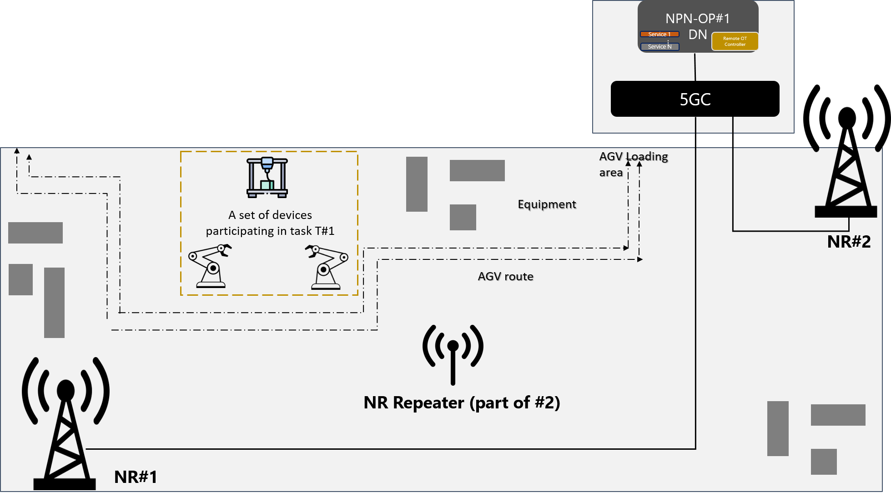
Figure 1 NPN-OP#1 provides 3GPP access networks for provision of highly reliable and high quality connectivity to its edge-cloud based services. The deployment also includes NR repeaters.

5.x.2 Pre-conditions
A set of integrated UE devices inside a large-scale plant each work towards accomplishing a particular task. An operator, e.g. an NPN operator NPN-OP#1, provides coverage within the plant using two 3GPP access networks for increased reliability. The devices are within the coverage of the two NR networks - via base station #1 and via an NR repeater, which is a part of base station #2.
Each device has connectivity to the NPN-OP#1’s data services in the edge cloud.
Each UE supports dual-3GPP access and dual-radio over the two RATs. The devices are equipped with sensors to collect and report real-time information.
There is a distribution of functions such that the redundant user plane paths are possible.

5.x.3 Service Flows
1) A set of devices work towards task T#1, performing each their sub-task, and each communicate to the system controller in the edge cloud via base station #1.
2) The controller in the edge cloud monitors and controls the devices and production process by collecting sensor data from each of the devices.
3) Several AGVs, with on-board cameras and UEs for communication with a video server in the edge cloud, start transporting goods through the plant. The AGVs’ data transmission and their movement through the plant start causing blockages of wireless links and a significant load on base station #1.
4) As radio network condition of one or more devices deteriorates (the condition can be reported by, e.g. the application function), there is a requirement to increase the reliability of the real-time monitoring process between the devices and the system controller. Hence, NPN-OP#1 activates the duplication of data traffic across two access networks, one using base station #1 and the other using NR repeater, which is a part of base station #2. Base station #2 is lightly loaded.
5) The traffic between each of the devices and system control in both directions is duplicated.
6) After AGVs return to the stationary point, blockages of wireless links caused by their movement significantly subside and base station#1 is lightly loaded again. The duplication of traffic across two access networks is not further required and PN-OP#1 deactivates the duplication.
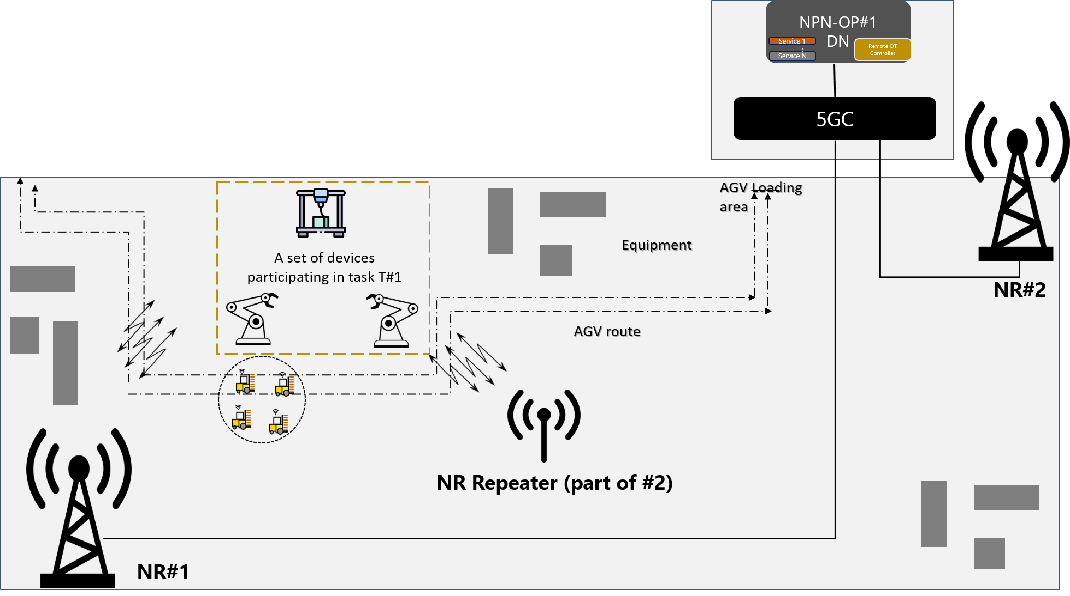
Figure 2 One or more devices participating in task T#1 experience deteriorating radio conditions due to the movement of AGVs through the factory floor. In order to increase the reliability of the real-time monitoring process between the devices and the system controller, NPN-OP#1 activates the duplication of data traffic across two access networks, with NR#1 and NR#2, including the repeater.

5.x.4 Post-conditions
The data is successfully duplicated for as long as there is movement of machinery and humans around the manufacturing area, causing blockages and interference for UEs.
Note: The steps above are illustrative. Traffic duplication may remain over dual 3GPP accesses depending on operator’s traffic policies and rules, and conditions in the network.

5.x.5 Existing features partly or fully covering the use case functionality
Same as in Section 5.8.5 of this TR.

5.x.6 Potential New Requirements needed to support the use case
[PR 5.x.6-001] Based on operator’s policy, the 5G system shall be able to support mechanisms to enable traffic duplication of UE’s user data pertaining to a single data session, across two 3GPP access networks provided by an NPN, for one or more UEs with NPN subscription accessing NPN services.

NOTE: The above requirement assumes a non-standalone NPN i.e. a NPN hosted by a PLMN or offered as a slice of a PLMN, and data anchoring in the NPN.

