Company | RIL Number | Comment
Xiaomi | X002 | 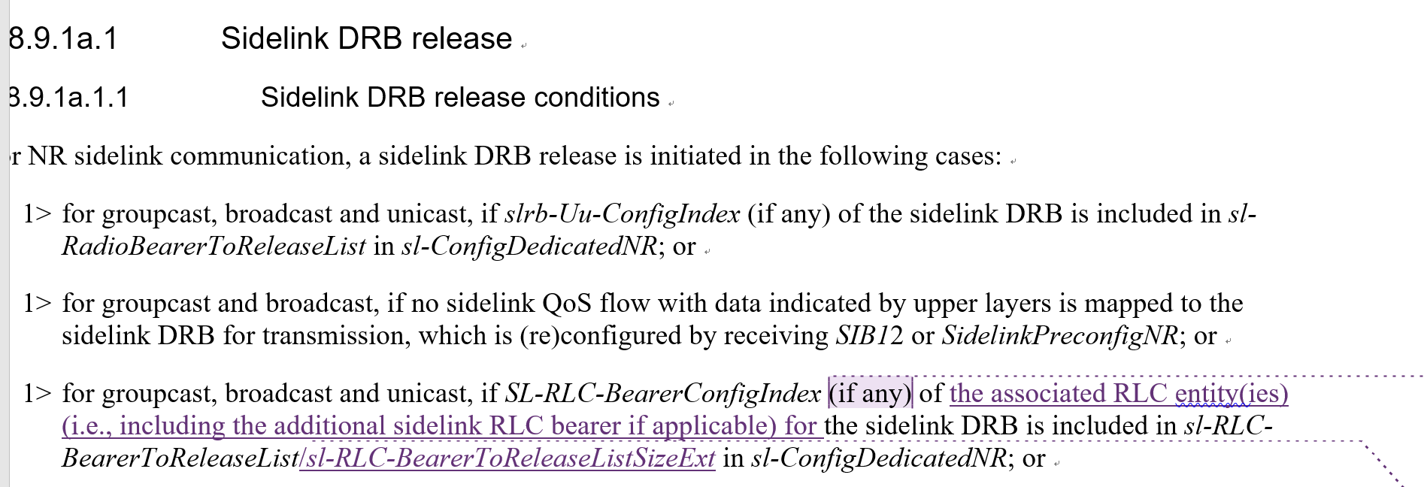  In our understanding if the SL-RLC-BearerConfigIndex indicates the release of the original RLC bearer for the SL DRB, the additional RLC bearer should be released as well. See below. There is no need to emphasize in DRB release procedure that when both RLC legs are released, the SL DRB is released. Also based on the existing text, with “if any” (even there in legacy), it may be interpreted that if either original RLC bearer or additional RLC bearer is released, the DRB is released. So we suggest to withdraw the change on this bullet.  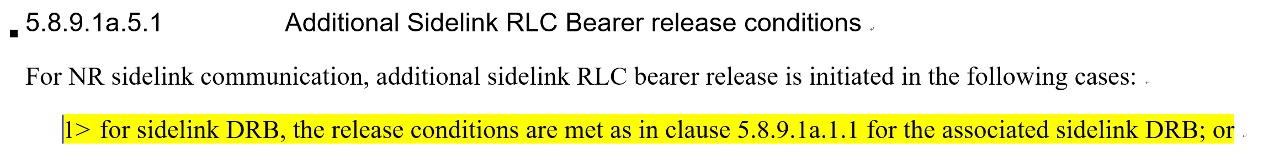  [Rapp] Tend to agree with this point, sorry for the misunderstanding, would change this RIL to PropAgree.
Xiaomi | X004 | If the “and…backwardsincompatible” condition is kept, then how to handle the case when dedicated RRC indicates UE to release the additional RLC bearer but the Tx profile of the QoS flows indicates backwardscompatible? Shall the UE still keep the additional RLC bearer? To us, tx UE needs to follow NW configuration no matter of the tx profile. Please note for SL DRB, even it is backwards compatible, UE can enable PDCP duplication only when there is additional RLC bearer configuration in dedicated RRC/SIB/preconfig.  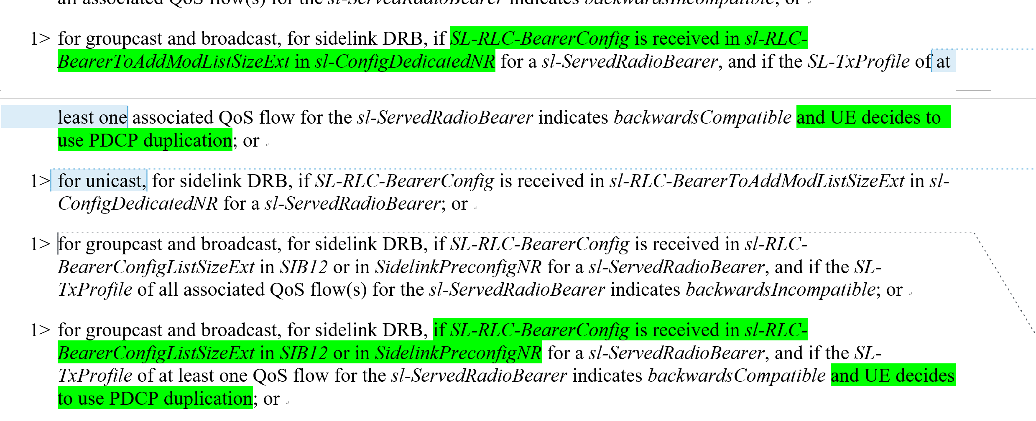  [Rapp] sorry for the misunderstanding, I also share the view that network configuration has to be respected, and thus this RIL is to be changed to PropAgree.
Xiaomi | X006 | According to RAN2 agreement, the case mentioned in this bullet only applies to RRC idle/inactive, for RRC connected, there should be no mixed tx profiles within the same RB since tx profile to qos flow mapping is reported to gNB via SUI. Considering this issue is not critical clear for connected case, we propose RAN2 to further discuss and clarify whether NW ensures no mixed case based on the reported qos flow to tx profile mapping or mixed case is allowed, UE follows the same solution as idle/inactive. Suggest rapporteur to change to ToDo.  If at least one QoS flow having Tx profile with value set to backwards compatible is mapped to the radio bearer, legacy carrier is used for transmission for this radio bearer, for RRC_IDLE/RRC_INACTIVE/OOC case.  [Rapp] There is an indeed selection between whether relying on network to secure it or relying on UE to secure it, and thus OK to change it to ToDo.
Xiaomi | X012/X013 | Based on the updated running CR, we think our RILs should be “propagree”  [Rapp] After offline with Xiaomi, seems I misunderstood the point, OK to change this to PropAgree since already been reflected by Z708/9.
Rapp (on behalf of Ericsson) | E089 | [Rapp] After offline, seems this RIL number was re-defined, and now it is related to a FD correction, suggest to discuss it using a TP for R2 to discuss.

