**3GPP TSG-RAN WG2 Meeting #125** **R2-240xxxx**

**Athens, Greece, 26th Feb. – 1st Mar., 2024**

**Title: [H507] Discussion on CG RACH-less procedure in LTM, NTN, and mIAB in R18**

**Source: Huawei, HiSilicon**

**Agenda item: 7.2.6**

**Document for: Discussion and Decision**

# Background

This paper discusses some potential issues in RRC configuration and MAC procedure for the RACH-less procedure by CG in R18

# 2 Discussions

## 2.1 On the RRC configuration

For the current RRC spec, the following has been configured for the RACH-less CG resource configuration.

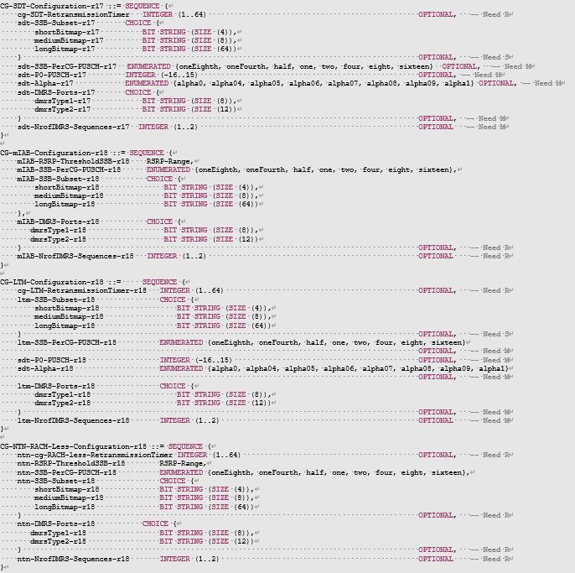

While, it can be observed that the newly added R18 CG configuration is very similar to the legacy CG-SDT configuration, with only the following differences:

* For mIAB configuration, CGRT is not configured
* For SSB RSRP threshold, CG-SDT configuration does not have it (configured in RRCRelease message directly in R17), while there is SSB RSRP threshold configuration for mIAB and NTN.

Based on the above observations, we think it’s not necessary to duplicate so much fields from R17 CG-SDT. Hence, we propose the following:

**Proposal1: Define a new IE for RACH-less CG configuration for LTM, NTN, mIAB by reusing the CG-SDT configuration in R17 with also:**

* **Clarifying that CGRT is not needed for mIAB**
* **Adding a new field for SSB RSRP threshold for SSB selection and clarifying that it is only present for mIAB and NTN.**

## 2.2 On the MAC procedure

Furthermore, in the current MAC procedure, there are also quite a lot of redundancies for the procedures in UL grant reception, the maintenance of CGRT, for example:

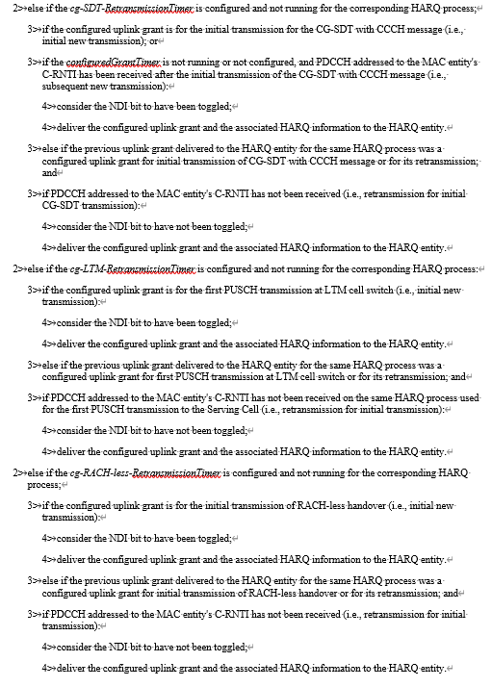

For the issue above, we think that we shouldn’t duplicate the MAC procedure for different cases for two reasons: (a) duplicated text reduces the text readability; (b) if correction needs to be made in the future, duplicated changes need to be made for duplicated text, which increases unnecessary work load.

**Proposal2: Merge the duplicated text in MAC spec related to CG RACH-less transmission in the following sections:**

* **DL assignment reception**
* **UL grant reception**
* **Configured grant uplink**

Regarding the RACH-lessRetransmissionTimer and LTM-RetnrasmissionTimer, currently, they are separately defined while the procedure text for the timers are much duplicated. However, we think these two timers are not possible to run at the same time, i.e., one for LTM transmission of RRCReconfigurationComplete message while another used for NTN. If this is the case, there is no need to define two timers for the same behaviour and we think the LTM, the functionality for the LTM retransmission timer can be merged into the RACH-less retransmission timer such that the procedure text is not duplicated

**Proposal3: Combine the functionality of the *LTM-retransmissionTimer* and *RACH-lessRetransmissionTimer* with the understanding that these two timers cannot run at the same time.**

## 2.3 Administrivials

Since the issue is cross-WI and hard to be merged into a WI specific CR, we also propose to agree on the MAC and RRC CR separately, also to highlight the cross-WI nature of the CR.

**Proposal4: Agree on the separate MAC and RRC CR for CG RACH-less transmission.**

# 3 Conclusions

**Proposal1: Define a new IE for RACH-less CG configuration for LTM, NTN, mIAB by reusing the CG-SDT configuration in R17 with also:**

* **Clarifying that CGRT is not needed for mIAB**
* **Adding a new field for SSB RSRP threshold for SSB selection and clarifying that it is only present for mIAB and NTN.**

**Proposal2: Merge the duplicated text in MAC spec related to CG RACH-less transmission in the following sections:**

* **DL assignment reception**
* **UL grant reception**
* **Configured grant uplink**

**Proposal3: Combine the functionality of the *LTM-retransmissionTimer* and *RACH-lessRetransmissionTimer* with the understanding that these two timers cannot run at the same time.**

**Proposal4: Agree on the separate MAC and RRC CR for CG RACH-less transmission.**