Invitation to F2F meeting on indoor industrial channel modeling

On behalf of Fraunhofer HHI, we are pleased to invite you to a face-to-face meeting on the Industrial IoT Channel Model in Berlin, Germany. The meeting will be held at Fraunhofer HHI premises.

Meeting directions and general information are provided in the following pages.

We are looking forward to seeing you in Berlin!

# Meeting schedule

Monday, July 1st, 9.00 - 18.00

Tuesday, July 2nd, 9.00 - 17.00

# Location

The meeting will take place in the Fraunhofer HHI main building (Einsteinufer 37, 10587 Berlin, Germany).

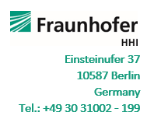

# Wireless LAN

WiFi access will be available in the meeting room.

# Lunches

Lunches will be provided by Fraunhofer HHI. **Please inform us of any dietary restrictions in advance.**

# Registration

**Please register for the meeting by replying with full name and affiliation of any participants, no later than June 26.**

Please be sure to print your name badge prior to the meeting and bring it, along with a holder. Name badges and holders will not be provided at the meeting.

# Remote participation

A conference bridge will be available to allow remote participation at best effort. Details to follow.

# Directions

## By Plane

### Arriving at Tegel Airport (TXL)

* By taxi: 15 minutes.
* By bus 109 to station "S+U Zoologischer Garten", then change to bus 245 (direction: "S Nordbahnhof") to bus stop "Marchbrücke". The main building at Einsteinufer and branch office at Salzufer are both nearby and can be easiliy reached by a footwalk of 1 resp. 3 minutes.
* By bus X9 to bus stop "Ernst-Reuter-Platz", then either walking from Ernst-Reuter-Platz alongside Marchstraße to Einsteinufer (about 5 minutes) or going by bus 245 (direction "S Nordbahnhof") to bus stop "Marchbrücke".

### Arriving at Schönefeld Airport (SXF)

* By taking the (regional) express trains "RE7" or "RB14", operated by Deutsche Bahn (DB), you quickly arrive at the station "Berlin Zoologischer Garten". Then take bus 245 (direction "S Nordbahnhof") to bus stop "Marchbrücke". The sites at Einsteinufer and Salzufer can be reach by a footwalk of one resp. 3 minutes.
* By suburban railway (S-Bahn line S9) to station "Tiergarten", and then walk alongside "Straße des 17. Juni" in direction "Ernst-Reuter-Platz" (westward) about 400 m. After crossing the channel bridge, turn right into "Einsteinufer". Walking time is appr. 12 minutes.

## By Train

"Hauptbahnhof" is Berlin's main station on the route of most of international, regional and inner city trains. From here you just have to take bus 245 (direction "Zoologischer Garten") to bus stop "Marchbrücke", which you arrive in about 15 minutes. The main building of the institute is close to the bus stop (appr. 50 m).

## By Public Transport

### By S-Bahn (Suburban train)

* Take line S5, S7, S75 or S9 to station "Berlin Zoologischer Garten", then take bus 245 (direction "Nordbahnhof") to bus stop "Marchbrücke". The main building of the institute is located near the bus stop (appr. 100 m).
* Take line S5, S7, S75 or S9 to station "Tiergarten", and then walk alongside "Straße des 17. Juni" in direction "Ernst-Reuter-Platz" (westward) about 400 m. After crossing the channel bridge, turn right into "Einsteinufer". Walking time is appr. 12 minutes.

### By U-Bahn (Underground)

* Take line U2 to station "Ernst-Reuter-Platz", then either walking from Ernst-Reuter-Platz alongside Marchstraße to Einsteinufer or going by bus 245 (direction "Nordbahnhof") to bus stop "Marchbrücke". The main building of the institute is close to the bus stop (appr. 50 m).   
  [www.bvg.de](http://www.bvg.de/)

## By Car

Motorway A 115 (AVUS) coming from Hannover, Leipzig, Nürnberg, resp. or motorway A 100 to exit "Charlottenburg, Spandauer Damm" direction city center, straight ahead "Otto-Suhr-Allee" reaching the roundabout "Ernst-Reuter-Platz", then turning into "Marchstrasse" straight ahead. For destination Einsteinufer (main building, TiME Lab) you turn right, just before arriving the bridge (Marchbrücke) and try to park here. The main building is located at the corner Einsteinufer and Marchstrasse. For destination Salzufer you have to cross the bridge first and then turn right at Salzufer. The branch office is at the left hand side.

# Accommodation

**Novum Style Hotel Berlin Centrum \*\*\*** (6 minutes to walk)

Franklinstr. 23, Charlottenburg-Wilmersdorf, 10587 Berlin, Deutschland

<https://www.novum-hotels.com/hotel-berlin-centrum-berlin>

**Novum Hotel Gates \*\*\*** (12 minutes to walk)

Knesebeckstraße 8-9, 10623 Berlin

<https://www.novum-hotels.com/hotel-gates-berlin>

**Hotel Novotel Berlin am Tiergarten \*\*\*\*** (12 minutes to walk)

Straße des 17. Juni 106 - 108, Tiergarten, 10623 Berlin, Deutschland

<https://www.accorhotels.com/de/hotel-3649-novotel-berlin-am-tiergarten/index.shtml>

**Adrema Hotel \*\*\*\*** (7 minutes to walk)

Gotzkowskystraße 20/21, 10555 Berlin

<https://hotel-adrema.de/>

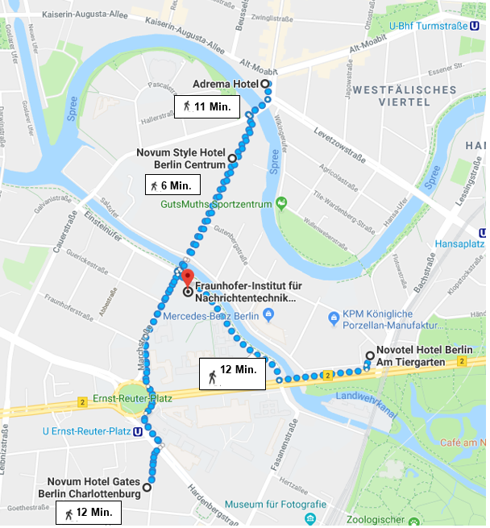 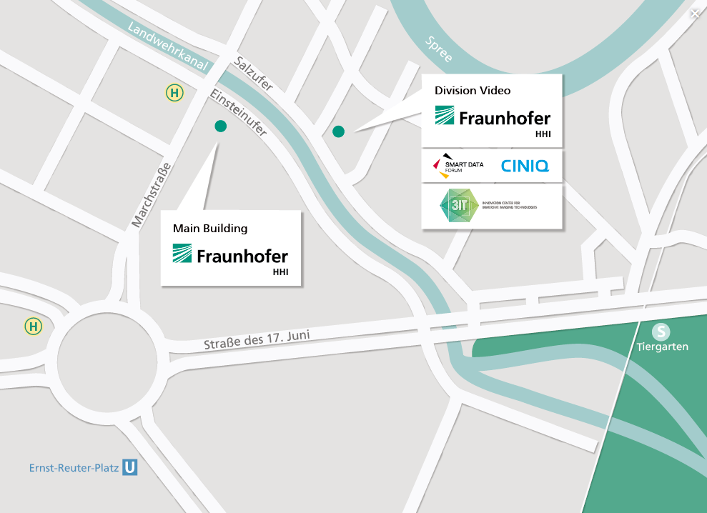

# Dinner

A dinner can be arranged on Monday evening if there is sufficient interest.

# Visa Information

Please make sure, you are allowed to enter the country. In case you need a visa invitation letter please let us know as soon as possible and provide us with the following data:

|  |  |
| --- | --- |
| Surname/Family name (last name): |  |
| Forenames (first names): |  |
| Birth date (day/month/year): |  |
| Passport number and issuing country: |  |
| Gender: |  |
| Company name: |  |
| Occupation/Position: |  |
| Company/mailing address: |  |
| Postal Code: |  |
| Country: |  |
| Telephone number: |  |
| Fax number: |  |
| Email: |  |

# Contact

For further questions, do not hesitate to contact

## Study Item Rapporteur

Henrik Asplund, [Henrik.asplund@ericsson.com](mailto:Henrik.asplund@ericsson.com), Tel.: +46 730 311173

## Meeting Host/Logistics

Leszek Raschkowski, [Leszek.raschkowski@hhi.fraunhofer.de](mailto:Leszek.raschkowski@hhi.fraunhofer.de), Tel.: +49 30 31002-487

Kerstin Reinhardt, [kerstin.reinhardt@hhi.fraunhofer.de](mailto:kerstin.reinhardt@hhi.fraunhofer.de), Tel.: +49 30 31002-702